Date of planning:16/10/2022  Date of teaching: 18/10/2022 | UNIT 2: FAMILY AND FRIENDS  Period 19: Lesson 2.3: Reading and Vocabulary
I. OBJECTIVES:
By the end of the lesson ss will be able to:
- find specific detail in a letter and talk about family activities.
1. Knowledge:
*Vocabulary: an understanding of the vocabulary about family activities and some adjectives.
New words | Vietnamese meaning
- take care of the garden (np) | chăm sóc vườn
- sing karaoke (np) | hát karaoke
- plan for a trip (np) | chuẩn bị cho một chuyến đi
- excited (adj) | cảm thấy hào hứng
- relaxed (adj) | cảm thấy thư thái

* Grammar: Reading skills: the ability to find specific details in a letter.
2. Competence: Understand and know the meaning of the keywords used to talk about family activities, vote for top three exciting activities then do the tasks assigned in the textbook; locate information and find specific details in a letter (scanning skill); identify the main ideas of the paragraphs in the text or the text itself (skimming skill).
3. Quality/ behavior: To teach Ss to be hard-working and attentive in class. Ss have a positive attitude to working in groups, individual work, pair work, cooperative learning and working.
II. TEACHING AIDS:
- Teacher: Grade 7 textbook, Unit 2 (SB p.23, WB p.18), laptop/computer connected to the Internet, loudspeaker, projector/TV, PPT slides…
- Students: Text books, studying equipment…
- Method: Active teach, T-WC; group works; individual ……
III. PROCEDURE:

1. WARM-UP (5’)
* Aim:
- To help Ss review some activities they have known.
- To lead into the next activity.
* Content: Game: Relax Game (about family activities to relax)
* Outcome: Ss can talk about some family activities to relax.
* Organisation: T_ Ss …
Teacher’s &Student’s activities |  | Content
Extra activity 1: Relax Game  - T explains the game rules then checks instructions.  - T uses slide to lead the game.  - T asks Ss the question “What do these families do to relax?” – T elicits the picture and ask student to guess the meaning before they unscramble the word.  - Ss raise their hands if they have the answer.  - T asks students to read aloud the sentence after each play.  - T tells students that they are reading about family activities.  - T writes the title for the new lesson:  Unit 2/Lesson 3: Reading and vocabulary. |  | Game rules:  - Look at the picture  - Unscramble the word to see the activity  - Open the star to get point.
2. PRE-READING (8’)
ACTIVITY 1 + 2:
* Aim:
- To activate Ss’ background knowledge of the topic.
- To get student think about family activities.
- To provide Ss with reasons for reading the text in the next stage.
* Content: To discuss Ss’s family activities by reading and answering T’s questions.
* Outcome: Know new words, and grammar points when talking about one’s family activities.
* Organisation: T, Ss …
Teacher’s & Student’s activities | Content
1. (3’) Look at the photo. What are the family member doing?  (Exercise 1 – SB p.23)  - T shows the slide, reads aloud the questions  1- What are the family members doing?  2- How do they feel?  - T asks a students to look at the photos and find the answers.  - 1- They are doing gardening together.  - 2- They feel happy.  - T emphasizes about the photo “Doing gardening together makes the family members happy.”  - T mentions that doing gardening is one of family activities. | 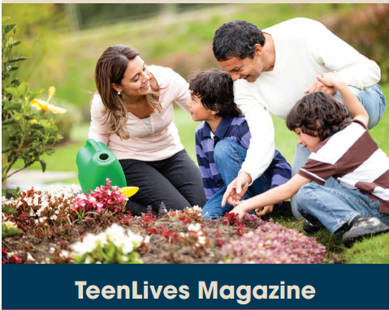
2. (5’): Work in pairs. What do family members do to relax? Compare your answers with another pair.  (Exercise 2 – SB p.23)  - T asks students to recall some family activities that they have known from the warm-up game.  - T tells students to work in pairs to talk about what their family.  - Ss can use the list in warm-up game for reference: what family members often do to relax.  - T invites some students to share their answers with the whole class using the given prompts.  A: What do family members do to relax?  B: We often go hiking together. | 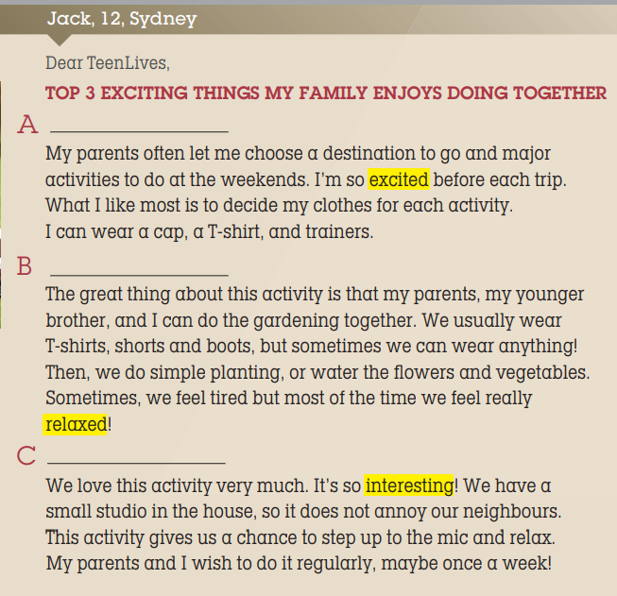
2. WHILE-READING 1 (7’)
ACTIVITY 3:
*Aim:
- To reinforce words of family activities.
- To help students practice identifying the general meaning of each paragraph.
- To help students practice matching the correct heading with each paragraph.
* Content: Read the letter from Jack then choose the best heading for it.
* Outcome: To know more new words about family activities. Understand more about using the words in contexts.
* Organisation: T, Ss …
3. Read the letter from Jack to TeenLives Magazine. Choose the best heading (1-3) for the paragraph (A-C)  (Exercise 3 – SB p.23)  - T asks Ss to look at exercise 3 (SB page 23).  - T calls a student to read the instruction then checks Ss’ understanding of it.  Step 1: Understanding the HEADINGS  - T asks Ss to look at the slide, read and match the heading with the pictures to elicit the Ss’ comprehension.  Step 2: Match the headings  - T and Ss review TIPS for reading and match the headings.  (Ss learnt the TIPS from Unit 1 already)  - T sets a time limit and asks Ss to work in pairs to complete the activity.  - T elicits the ideas from Ss, asks them in which line of the paragraph they see the answers.  - T asks Ss to explain their answers by referring to the clues the text.  - T confirms the answers then drills the pronunciation of the phrases and corrects Ss’ pronunciation if any. | Answer keys: A – B – C stand for the paragraphs.  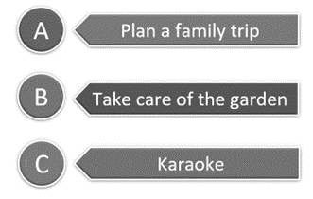
2. WHILE-READING 2 (5’)
ACTIVITY 4:
*Aim: To help students practice reading for specific information in an article.
* Content: To use the vocabulary of family activities grammar points to do the exercises.
* Outcome: To know more new words about family activities to relax. Understand more about using the words in contexts.
* Organisation: T, Ss …
4. Read the letter again. Choose the correct answer.  (Exercise 4 – SB p.23)  - T asks Ss to look at exercise 4 (SB page 23).  - T calls a student to read the instruction then checks Ss’ understanding of it.  - T and Ss review TIPS: reading for specific information.  (Ss learnt the TIPS from Unit 1 already)  - T tells student to read the text again individually to complete Exercise 4.  - When finished, T asks them to compare their answers in pairs and check with them.  - T asks students to point to relevant details in the text. | 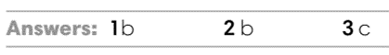
3. WHILE-READING 3 (5’)
ACTIVITY 5:
* Aim:
- To provide more vocabulary in context.
- To help Ss practice reading for specific information.
* Content: Discuss in groups the meanings of the adjectives by understanding the content of the given texts.
* Outcome: Understanding and explaining the meaning of the adjectives about feelings.
* Organisation: T, Ss ….
5. Look at the highlighted adjectives in the text. What do they mean?  (Exercise 5 – SB p.23)  - T asks students to find the highlighted adjectives in the text and discuss in groups of three the meanings of these words.  - T checks the answers with students.  - T uses slide to drill the pronunciations.  - T corrects Ss’ pronunciation if any. | 4. Answer keys:  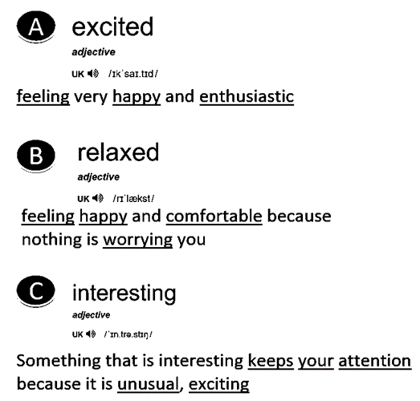
4. POST-READING (7’)
ACTIVITY 6:
* Aim: To encourage students to talk about their family members’ exciting activities.
* Content: To discuss the Ss’s exciting family activities.
* Outcome: Making sentences to talk about their family activities. Commenting about the sentences of others.
* Organization: T, Ss...
6. Work in group of four. Vote for the top three exciting activities that a family can do. Then share with your class.  (Exercise 6 – SB p.23)  - T asks Ss to look at exercise 6 (SB page 23).  - T calls a student to read the instruction then checks Ss’ understanding of it.  - T asks a student to read the example then models the activity in front of the class.  - T asks students to work in groups of four to discuss the  activities a family can do.  - T sets a time limit and monitors Ss while they are working in groups.  - When finished, T asks each group to vote for the three most  exciting activities and share with the class.  - T notes down common mistakes for delayed feedback.  - T asks the rest to give comments on their classmates’ performance.  - T gives feedback on Ss’ work. | 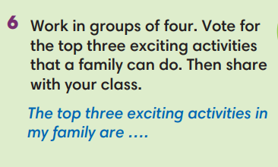
WRAP-UP & HOME WORK (4’)
- T asks Ss to talk about what they have learnt in the lesson.
- Vocabulary of family activities and adjectives.
- Reading a letter about family activities
- Some tips for reading skills
* HOME WORK
- Do exercises in the workbook page 18.
- Prepare for Lesson 2.4: Grammar 2.

************************************************************************

