Date of planning:23/10/2022  Date of teaching: 27/10/2022 | UNIT 2: FAMILY AND FRIENDS  Period 23: Lesson 7: English in Use

I. OBJECTIVES:
By the end of the lesson, Ss are able to:
- use prepositions of time to talk about when something happens.
1. Knowledge:
* Grammar:
- Use correctly prepositions IN – ON – AT in time expressions
- Talk about when something happens
2. Competence: Ss understand and use the vocabulary about after school activities and understand the use of IN – ON – AT in time expressions, then do the tasks assigned in the textbook. use the correct tense of verbs, prepositions of time to form a question and answer to talk about when something happens.
3. Quality/ behavior: To teach Ss to be hard-working and attentive in class. Ss have a positive attitude to working in groups, individual work, pair work, cooperative learning and working.
II. TEACHING AIDS:
- Teacher: Grade 7 textbook, Unit 2 (SB p. 27), laptop/computer connected to the Internet, loudspeaker, projector/TV, PPT slides…
- Students: Text books, studying equipment…
- Method: Active teach, T-WC; group works; individual ……
III. PROCEDURE:
1. WARM UP (5’)
* Aim:
- To create a positive classroom atmosphere to start a new lesson.
- To review after school activities and early introduce IN – ON - AT.
* Content: Game: Space Shuttle Game (about after school activities)
* Outcome: Ss guess and choose the correct picture.
* Organization of implementation
Teacher’s & Student’s activities | Content
Extra activity 1: Space Shuttle Game  - T asks Ss What do they often do after school?  - T tells students that they are playing a game with activities.  - T explains the game rules then checks instructions.  - T uses the slides to lead the game  - Ss join in the game individually.  - T corrects Ss if necessary.  - T tells students to recall all after school activities from the game. | Game rules:  - Look at the picture. Read the sentence  - Guess and choose the correct after school activity.  - 1 correct answer makes the shuttle space move
2. LEAD-IN (3’)
* Aim:
- To lead into the new lesson.
- To provide Ss with reasons for reading the cartoon in exercise 1 (SB p.27).
* Content: Discuss in groups and give the answer about the girl in the pictures.
* Outcome: Guess the correct answers to the questions.
* Organisation: T_ Ss ..….
Teacher’s & Student’s activities | Content
Extra activity 2: See – think – wonder.  - T shows the cartoon pictures on the slide then asks students four questions.  (1) What can you see in the pictures?  (2) Who are in the pictures?  (3) What’s the girl doing in each picture?  (4) Is the girl happy?  - T sets a time limit for Ss’ quick discussion.  - Ss work in pairs to make guesses about the pictures then give answers.  - T calls some Ss to give answers then checks with the whole class.  - T introduces Holly. “This is Holly. She is tired because she has too many extra classes after school.” | 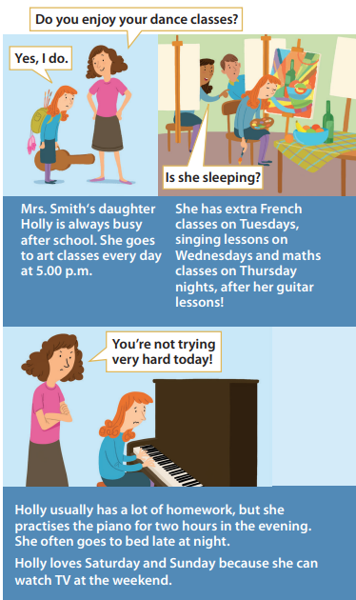
3. PRESENTATION (11’)
ACTIVITY 1 + 2:
* Aim:
- To present the grammar point in context of a cartoon.
- To introduce the Grammar Box through the reading tasks
- To introduce to Grammar Box
- To explain the grammar point for Ss.
* Content: Read the cartoon about Holly to practice grammar.
* Outcome: Do the exercise to improve grammar.
* Organisation : T_ Ss ..….
Teacher’s & Student’s activities | Content
1. (7’) Read the cartoon. How many extra classes does Holly have?  (Exercise 1 – SB p27)  - T asks Ss to open their SB page 27, look at exercise 1.  - T calls a student to read the instruction then checks Ss’ understanding of it.  - T tells Ss that they are going to read the cartoon to find the answers.  - Ss work individually, read, and note down the answers to the given question.  - T calls some Ss to give answers then shows the answers on the slide.  - T tell students that IN – ON – AT are the prepositions of time. | 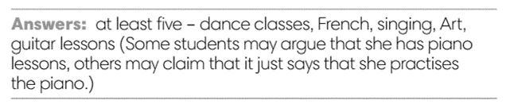
2. (4’) How many examples of prepositions can you find in the cartoon in thirty seconds?  (Exercise 2 – SB p27)  - T asks Ss to open their SB page 27, look at exercise 2.  - T calls a student to read the instruction then checks Ss’ understanding of it.  - T gives students the thirty-second time limit and asks them  how many prepositions they found.  - T elicits the prepositions and the words that come after them the text.  Discuss the Language box with the class  - T uses slide to show the grammar notes again.  - T goes through the Grammar box with students.  - T asks Ss to work in groups of three to read all uses of IN – ON – AT, elicits the meanings if needed. | 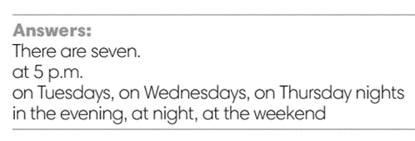  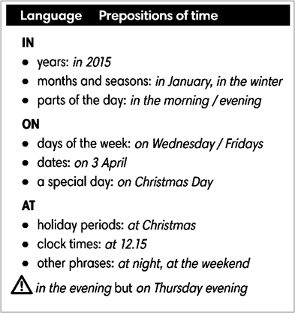
4. PRACTICE 1 (3’)
ACTIVITY 3:
* Aim: To help students identify the use of IN – ON – AT in time expressing.
* Content: Use the prepositions to complete the sentence.
* Outcome: Write correct prepositions using in, at or on.
* Organisation : T_ Ss.. ….

Teacher’s & Student’s activities | Content
3. Write correct prepositions: in, at or on.  (Exercise 2 – SB p27)  - T elicits the example sentence with students.  - T encourages students to discuss the other sentences in pairs,  to decide on the correct form and the reasons for this.  - T calls some students to share their answers.  - T corrects Ss’ pronunciation if any.  - T confirms the answers. | 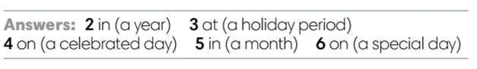
5. PRACTICE 2 (6’)
ACTIVITY 4:
* Aim: To reinforce the use of IN – ON - AT.
* Content: Use the prepositions to complete the sentence.
* Outcome: Write correct prepositions using in, at or on.
* Organisation : T_ Ss.. ….

Teacher’s & Student’s activities | Content
4. Complete the text with in, at or on.  (Exercise 4 – SB p.27)  - T asks Ss to look at exercise 4.  - T calls a student to read the instruction then checks Ss’ understanding of it.  - T asks Ss to work in individually to write.  - Students write the answers in their books.  - T calls students to give answers then shows them on the slide to check as the whole class.  - T corrects Ss if any.  Further practice:  THE STAMP GAME:  How to play:  - Read the sentence  - Fill in the blank with IN, ON or AT  - 1 correct answer gets 2 points | 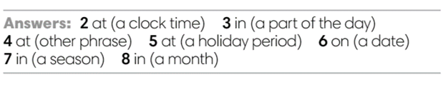
6. PRODUCTION (7’)
ACTIVITY 5:
*Aim: To help students applying the vocabulary items and grammar points related to the topic in communicating.
* Content: Ss ask and answer the questions in pairs.
* Outcome: Cross-check writing pieces and follow the writing rubric.
* Organisation: T_ Ss .…….

Teacher’s & Student’s activities | Content
5. In pairs, ask and answer the questions:  - What do you do after school?  - What do you often do at the weekend?  (Exercise 5 – SB p.27)  - T asks Ss to look at exercise 5 (SB page 27).  - T calls a student to read the instructions then checks Ss’ understanding of it.  - T explains to the students that they are going to work in pair for this task  - T elicits the questions that students may use to ask their friends.  - T models the activity in front of the class.  - T asks some strong students to stand up and recall some after-school activities that they’ve learn from the warm-up game.  - T writes the activities on boards for reference  - Students work in pairs to complete the task.  - T walk around to listen and notes down common mistakes for delayed feedback.  - T invites some students to present their dialogue to the class.  - T asks the other students to give comments on their classmates’ performance.  - T gives feedback on Ss’ work. | 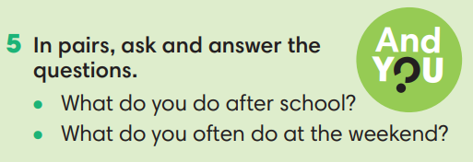
WRAP-UP & HOME WORK (3’)
- T asks Ss to talk about what they have learnt in the lesson.
- Time expressions IN – ON – AT
- Talk about when something happens
* HOME WORK:
- Do exercises in the workbook page 22.
- Prepare for Lesson 2.8: Vocabulary in action and Pronunciation

*************************************************************************

