Date of planning:23/10/2022  Date of teaching:29/10/2022 | UNIT 2: FAMILY AND FRIENDS  Period 24: Lesson 2.8: Vocabulary in Action and Pronunciation
I. OBJECTIVES:
By the end of the lesson student will be able to:
1. Knowledge:
* Vocabulary: review vocabulary
- The lexical items related to: clothes, accessories and adjectives of personalities to describe people
- Present simple and present continuous
* Pronunciation: Correctly pronounce words that contain the sounds /æ/ and /e/
2. Competence: Students develop communication skills, presentation skills, and creativity; being collaborative and supportive in pair work, teamwork, and actively join in class activities.
3. Quality/ behavior: To teach Ss the love of talking about clothes and describing people, and develop self-study skills. Ss have a good attitude to working in groups, individual work, pairwork, cooperative learning, and working
II. TEACHING AIDS:
- Teacher: Grade 7 textbook, Unit 2 (SB p.27), laptop/computer connected to the Internet, loudspeaker, projector/TV, PPT slides… .
- Students: Text books, studying equipment…
- Method: Active teach, T-WC; group works; individual ……
III. PROCEDURE:
1. WARM UP + LEAD-IN (4’)
*Aims:
- To create an active atmosphere in the class before the lesson.
- To lead into the new lesson.
* Content: Game: NAME 3 THINGS CHALLENGE (family and friends)
* Outcome: Students say words relating to the given topic quickly.
* Organisation : Teacher’s instructions…
Teacher’s & Student’s activities | Content
Extra activity 1: NAME 3 THINGS CHALLENGE  * Teacher asks students to spend 1 minutes to quickly review all vocabulary they have learnt in Unit 2 before they play a warm-up game.  - T tells students that they are going to play a game called NAME 3 THINGS CHALLENGE  - T explains the game rules then checks instructions.  - Teacher uses the slides to show the challenge  - Ss join in the game pairs or in small groups.  - Teacher listens to the Ss answers and calls several Ss to check for the whole class.  - T tells Ss that they can remember better with Glossary Table and asks Ss to open their Student Book page 28 – Exercise 1. | Game rules:  - Choose a number to get the challenge  - Read the topic word  - Say 3 words relating to that topic quickly.
2. REVIEW VOCABULARY (14’)
ACTIVITY 1 + 2 + 3:
*Aim:
- To introduce the glossary and its uses.
- To give further practice in making sentences using the Glossary.
* Content: Revise what they have learnt during the unit. Glossary and its uses.
* Outcome: Remember the new words and describe what a person you know usually wears and what he/she is wearing today.
* Organisation : Teacher’s instructions…
Teacher’s & Student’s activities | Content
1. (5’) Use the Glossary to find.  (Exercise 1 – Student Book page 28)  - Teacher introduces the Glossary Table.  - T asks Ss to look at exercise 1 in student book page 28  - T has students use the glossary to find the words which belong to the correct category  - T asks students to work in pairs and quickly do the task.  - T allows students to peer check first.  - T checks and confirms the answers. | Answer key:  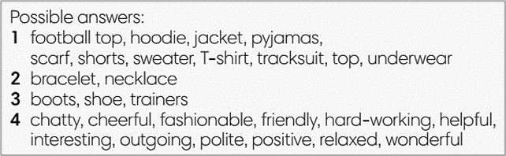
2. (5’) Use the glossary to describe what a person you know usually wears and what he/she is wearing today.  (Exercise 2 – Student Book page 28)  - T reminds students about the model sentences to describe what people are wearing.  - T asks students to do this activity individually. Have students read all the sentences carefully to make sure they check the grammar carefully  - T lets them share their sentences in pairs.  - T invites some students to give the describing sentences.  - T checks the grammar, pronunciation if needed. | e.g.  My best friend usually wears jeans. Today she’s wearing a dress.
3. (4’) Complete the Word Friends..  (Exercise 3 – Student Book page 28)  - T asks students to complete the sentences with suitable words.  - T asks students to work individually and check in pairs.  - T invites students to share their answers.  - T confirms the correct answers.  Extra-Practice  TIME TO TALK: Use the Word Friends and make sentence for you  - T encourage students to make sentences using the word friends in exercise 3  - Ss work in pairs to share true information about themselves | Answer key:  1. well  2. part / money  3. to
3. PRONUNCIATION (14’)
3.1. Presentation (4’)
* Aims:
- To present new sounds
- To help students identify how to pronounce the sounds /æ/ and /e/
* Content: Game: HEAR AND CLAP to practice pronunciation.
* Outcome: Pronoun some sounds after each play.
* Organisation: Teacher’s instructions…
Teacher’s & Student’s activities | Content
Extra activity 2: HEAR AND CLAP GAME  - T tells students that they are going to play a game called HEAR AND CLAP  - T explains the game rules then checks instructions.  - Teacher uses the slides to lead the game  - Ss join in the game pairs or in small groups.  - T listens to the Ss answers and calls several Ss to check for the whole class.  - T asks students to say the word again to practice some sounds after each play. | Game rules:  - Hear the sound  - Read the words  - Clap your hands 1 or 2 times to choose the word you hear.
3.2. Practice (10’)
ACTIVITY 4:
* Aims:
- To help students practice pronouncing these sounds in words.
- To help students pronounce the sounds /æ/ and /e/ correctly in sentences.
- To help students identify the sounds /æ/ and /e/ correctly in words.
* Content: Listen to the sample pronunciation to choose the correct answer.
* Outcome: Read and write the words correctly.
* Organisation : Teacher’s instructions…

Teacher’s & Student’s activities | Content
4a. Listen to the underlined vowel(s) in each word and describe which sound you hear. Write the word in the correct column.  (Exercise 4a– Student Book page 28)  - T calls some students to read out the words first.  - T plays the recording for them to listen and underline vowel(s) in each word.  - T asks Ss to write the word in the correct column.  /æ/ and /e/  - T invites some students to share their answers.  - T confirms the correct ones. | 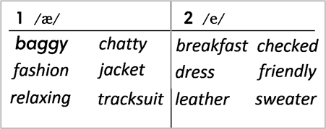
4b. Listen, check and repeat.  (Exercise 4b– Student Book page 28)  - T plays the recording for them to listen and repeat the words they hear.  - T asks Ss to pay close attention to the two sounds.  - T plays the recording again if needed.  - T explains to students the difference between the two sounds if needed.  - T invites some students to say some words they know that include the two sounds.  - T confirms the correct answers. | (Teacher can play the pronunciation guide video of this unit for students to watch and learn).
4. FURTHER PRACTICE (5’)
* Aim: To reinforce the student's recognition of the targeted sounds.
* Content: Game: ODD ONE OUT - practice the pronunciations by choosing the word that has a different sound.
* Outcome: Differentiate the sounds to practice the pronunciations. Saying the sounds correctly.
* Organisation: Teacher’s instructions…
Teacher’s & Student’s activities | Content
Extra activity 3: ODD ONE OUT  - T explains the game rules then checks instructions.  - Teacher uses the slides to lead the activity  - Ss join the activity in pairs or in small groups.  - T listens to the Ss answers and calls several Ss to check for the whole class.  - T asks students to say the word again to practice some sounds after each question. | Game rules:  - Read and choose A, B or C to odd out one word  - Explain by correctly saying the sounds
WRAP-UP & HOME WORK ( 3’) T asks ss to talk about what they’ve learnt .
* HOME WORK
- Find more words relating to clothes, personalities that have the sounds /æ/ and /e/

Date of planning:30/10/2022  Date of teaching: 31/10/2022 | NIT 2: FAMILY AND FRIENDS  Period 25: Lesson 9: Revision
I. OBJECTIVES:
By the end of the lesson, Ss are able to:
1. Knowledge:
* Vocabulary: revise words related to clothes, accessories, personalities, and time expressions.
* Grammar: review present simple, present continuous tense to describe people, talk about after school activities, give and respond to news.
2. Competence: Ss understand and use the vocabulary of the unit, do the tasks assigned in the textbook. Participate in a guided conversation to give and respond to news using given information.
3. Quality/ behavior : To teach Ss to be hard-working and attentive in class. Ss have a positive attitude to working in groups, individual work, pair work, cooperative learning and working.
II. TEACHING AIDS:
- Teacher: Grade 7 textbook, Unit 2 (SB p. 29, WB p.23), laptop/computer connected to the Internet, loudspeaker, projector/TV, PPT slides…
- Students : Text books, studying equipment….
- Method: Active teach, T-WC; group works; individual ……
III. PROCEDURE:

- WARM-UP (4’)

*Aims:
- To create a positive classroom atmosphere to start a new lesson.
- To lead into the review lesson.
* Content: Game: SUPER EYES
* Outcome: Ss understand that they are going to review Unit 2.
* Organisation: Teacher’s instructions…
Teacher’s & Student’s activities |  | Content
Extra activity 1: SUPER EYES  - Set the scene: T asks students to do quick exercises for eyes such as look up and down, look left and right, row the eyes  - T tells students that they are going to play a game called SUPER EYES  - T explains the game rules then checks instructions.  - Teacher uses the slides to show the collages  - Ss join in the game pairs or in small groups.  - Teacher shows the collage again with displayed answers to check for the whole class.  - T tells Ss that they are going to review Unit 2. |  | Game rules:  - Look carefully at a collage of different small pictures  - The collage will disappear in a few seconds  - Recall as many words about the collage as you can remember.
- REVIEW VOCABULARY (17’)

ACTIVITY 1 + 2 + 3:
* Aims:
- To help students reviews topic words and word friends from the unit
- To review vocabulary with critical thinking
- To review vocabulary in context
* Content: Do the exercise to revise the vocabulary of Unit 1.
* Outcome: Understand the vocabulary to do the exercise correctly.
* Organisation : Teacher’s instructions….
Teacher’s & Student’s activities |  | Content
Extra activity 2: (5’) SUPER MIND  - T tells students to open the Glossary box in student book page 28  - T introduce the SUPER MIND game and rules  - T shows the slides of the game  - Ss take turns to choose the numbers for their teams.  - Ss discuss and list out all words related to the topic they get.  - T calls some Ss to give answers and confirms the winner. |  | How to play:  - Play in team  - Choose a number to open a block  - Read the topic word  - Write as many words related to the topic as you can  - The faster finisher gets points
1. (3’) Choose the odd one out  (Exercise 1 – Student Book page 29)  - T asks Ss to look at exercise 1 in student book page 29  - T calls a student to read the instruction then checks Ss’ understanding of it.  - T asks Ss to work in pairs to read then complete the activity.  - T encourages students to give the reason for their answer.  - T checks as the whole class. |  | Answer keys:  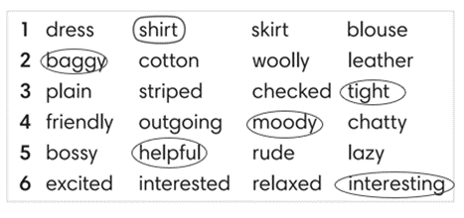
2. (6’) Complete the second sentence so that it means the same as the first one. In pairs, say if the sentences are true for you.  (Exercise 2 – Student Book page 29)  - T asks Ss to look at exercise 2 in student book page 29  - T calls a student to read the instruction then checks Ss’ understanding of it.  - T asks Ss to work in pairs to read then complete the activity.  - Ss work in pair to complete the task and compare the answers.  - T checks as the whole class.  Exercise 2 - Time to talk:  - T asks Ss to work in pairs to share their facts.  - Ss work in pairs to say which statements are true for them. |  | Answer keys:  2. is boring / 3. annoyed / 4. shocking / 5. Relaxed  Example:  Number 1 is true for me. I’m not into fashion.  Number 4 is not true for me.
3. (3’) Complete Word Friend in the text. Use the words in correct form.  (Exercise 3 – Student Book page 29)  - T asks Ss to look at exercise 3 in student book page 29  - T calls a student to read the instruction then checks Ss’ understanding of it.  - T asks Ss to work in pairs to read then complete the activity.  - Ss work in pair to complete the task and compare the answers.  - T checks as the whole class. |  | Answer keys:  2. to 5. brushing  3. getting 6. lose  4. annoyed 7. get
3. REVIEW GRAMMAR ( 24’)
ACTIVITY 4 + 5 + 6:
*Aim:
- To help students revise the form and use of the present simple, present continuous. Preposition of time
- To help students practice the present simple and present continuous
- To help students practice the present simple and time expression in a communicative activity
- To help student practice speaking skill in a task: give and respond to news
* Content: Use the present simple and present continuous to complete the exercises.
* Outcome: Use the present simple and present continuous for communication and writing.
* Organisation : Teacher’s instructions….
Teacher’s & Student’s activities |  | Content
Extra activity 3: (3’) Read the grammar boxes and review the grammar points.  - T asks Ss to look at the grammar box and read the example.  - T shows slides for detail review grammar  - Ss read the review content together before they do some grammar tasks. |  | 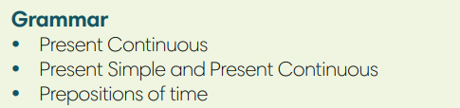
4. (5’) Complete the sentences with Present Simple or Present Continuous form of verbs in brackets.  (Exercise 4 – Student Book page 29)  - T asks Ss to look at exercise 4 in student book page 29  - T calls a student to read the instruction then checks Ss’ understanding of it.  - T asks Ss to work in pairs to read then complete the activity.  - Ss work in pairs to complete the task and compare the answers.  - T checks as the whole class. |  | Answer keys:  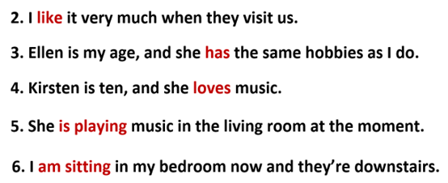
5. (8’) Write answers to the questions.  Use at, in or on with a time expression. Then compare with a partner.  (Exercise 5 – Student Book page 29)  Step 1: Time to write  - T asks Ss to look at exercise 5 in student book page 29  - T calls a student to read the instruction then checks Ss’ understanding of it.  - T elicits an example.  - T sets a time limit for Ss to write sentences  - Ss write their sentences in their notebooks.  Step 2: Time to pair  - T asks Ss to work in pairs and share their sentences by asking and answering.  - T calls a pair of strong students to demonstrate the dialogue in front of the class.  - Ss work in pairs to practice asking and answering.  - T encourages some pairs to roleplay the dialogue in front of the class. |  | 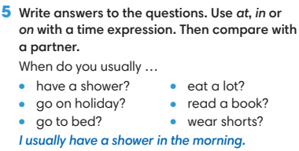
6. (8’) Work in pairs. Student A, use the information below to give and respond to news. Student B, look at page 102.  (Exercise 6 - Student Book page 29)  Student A  1. Greet Student B and ask what’s new in his / her life.  2. Listen and respond to Student B’s news  *you’re learning how to make webpages  *your computer isn’t working at the moment  - T asks Ss to look at exercise 6.  - T calls a student to read the instruction then checks Ss’ understanding of it.  - T asks Ss to work in pairs to prepare for their dialogues  - T sets a time limit and walk around as a monitor while Ss are discussing.  - Ss work in pairs to practice the speaking task  - T moves around and takes notes for any issues that need improving from students work.  - T encourages some strong students to role-play their dialogues in front of the class.  - T gives some general feedback for Ss’ performances. |  | 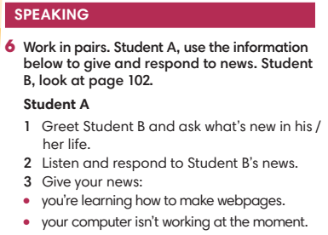
WRAP-UP & HOME WORK ( 2’)
- T asks Ss to talk about what they have learnt in the lesson.
- Review Unit 2 vocabulary and grammar.
- Write a personal introduction for a webpage.
* HOMEWORK
- Do exercises in the workbook page 23
- Prepare for REVIEW 1
************************************************************************

