Date of planning:6/11/2022  Date of teaching: 12/11/2022 | UNIT 3: ANIMALS’ MAGIC  Period 30: Lesson 3.2: Grammar
I. OBJECTIVES:
By the end of the lesson, students will be able to:
- use was and were to talk about the past.
1. Knowledge:
* Grammar:
- form correct sentences in past simple with was/were.
- ask and answer questions with was/were.
- use was/were to talk about the past.
2. Competence: Students understand the main grammar point, then do the tasks assigned in the textbook; use was/were to practice talking about the past.
3. Quality/ behavior: To teach Ss to be hard-working and attentive in class. Ss have a positive attitude to working in groups, individual work, pair work, cooperative learning and working.
II. TEACHING AIDS:
- Teacher: Grade 7 textbook, Unit 3 (SB p.32, WB p.26), laptop/computer connected to the Internet, loudspeaker, projector/TV, PPT slides…
- Students: Text books, studying equipment…
- Method: Active teach, T-WC; group works; individual ……
III. PROCEDURE:
1. WARM UP (3’)
* Aims:
- To create a positive classroom atmosphere.
- To help students review the vocabulary they have learnt in the previous lesson.
- To lead into the next activity.
* Content: Play game: Who am I? to get students involved in the lesson and to set the context for the lesson.
* Outcome: Students know the context of the lesson.
* Organisation : T_ Ss , …
Teacher’s Student’s activities | Content
Extra activity 1: Who am I?  - T explains the game rules then checks instructions.  - T sets the context for the lesson: Write the title on the board Unit 3: Animals’ Magic / Lesson 3.2: Grammar. | Game rules:  - Read the descriptions.  - Guess what animal is it. Read aloud.  - 1 correct answer => get points.
2. LEAD-IN (3’)
* Aims:
- To lead into the new lesson.
- To provide students with reasons for listening to the dialogue in exercise 1 (SB p.32).
* Content: Describe the animals and people in the picture on the slide.
* Outcome: Make guesses about the picture then give answers.
* Organisation: T_ Ss , …
Teacher’s Student’s activities | Content
Extra Activity 2: See – think – wonder.  - T shows a picture on the slide then asks students four questions.  (1) What animal do you see?  (2) How are the chimps?  (3) How many people are there?  (4) Are the kids excited?  - T sets a time limit for Ss’ quick discussion.  - Ss work in pairs to discuss then give answers.  - T calls some Ss to give answers then note them down on the board.  - T tells Ss that they’re going to read the conversation in exercise 1 (SB p.32) to check all the answers. | 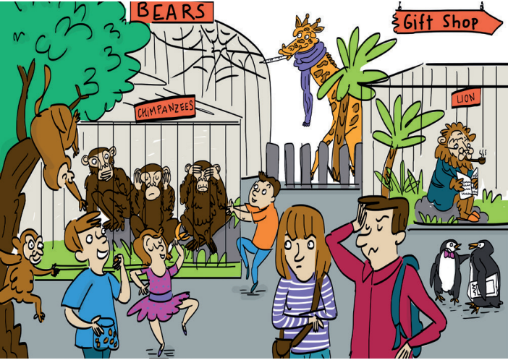
3. PRESENTATION (10’)
ACTIVITY 1 + 2:
Aims:
- To present the grammar point in context.
- To introduce to students the use of TO BE in past simple.
- To lead into the next activities.
- To provide Ss with chances to spot the sentences with was / were.
- To provide Ss with chances to work cooperatively.
- To explain the grammar point for Ss.
* Content: Read the conversation between Kyle and Zadie and find out new words. Learn the Past Simple.
* Outcome: Know more new words. Understanding the reading document; the topic of the lesson, grammar points…
* Organisation: T_ Ss , …
Teacher’s Student’s activities |  |  | Content
1. (5’) Read and listen. What does Kyle say about the twins?  (Ex 1, p.32)  - T asks Ss to open their SB page 32, look at exercise 1.  - T calls a student to read the instruction then checks Ss’ understanding of it.  - T plays the audio, let’s all Ss listen and calls Ss to give answers.  Further discussion:  - T asks one more question to encourage Ss to think and speak.  (1) When did Kyle go to the zoo? – Yesterday.  - T tells Ss that they are going to learn more about the past simple tense. |  |  | Answer key:  The twins weren’t excited. They were crazy.
2. (5’) Find more example of was / were in the dialogue in exercise 1.  (Ex 2, p.32)  - T asks Ss to open their SB page 32, look at exercise 2.  - T calls a student to read the instruction then checks Ss’ understanding of it.  - T asks Ss to work in groups of three to read the complete the activity.  - T calls groups to give answers then shows the answers on the slide to check as the whole class.  - T shows the grammar notes on the slide then explains the grammar points and tells Ss that they’re going to use was / were to talk about the past in next activities. |  |  | 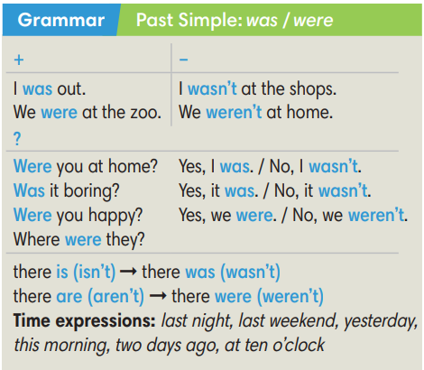
3. PRACTICE (20’)
ACTIVITY 3 + 4:
*Aim:
- To help Ss identify subject-verb agreement.
- To prepare for the next activity.
- To help Ss practice using was / were in context.
- To help Ss prepare for the next activity.
* Content: Complete the text/sentences with the correct form of the verbs.
Understand the text; grammar points; past simple tense.
* Outcome: Know how to form a sentence with the correct form of the verbs. Understand the conversation; the topic of the lesson, vocabulary, grammar points…
* Organisation : T_ Ss …
Teacher’s Student’s activities | Content
Extra activity 3 (6’): Ring the Golden Bell Game.  (Adapted from Ex 3, WB p.26)  - T explains the game rules then checks instructions.  - Ss join in the game individually.  - T corrects Ss if any. | Game rules:  - Read the sentences carefully.  - Choose a word in brackets to fill in the blank.  - 1 correct answer = 1 point.
3. (4’) Complete the dialogue with was / were / wasn’t / weren’t. Listen and check.  (Ex 3, p.32)  - T asks Ss to look at exercise 3 (SB page 32).  - T calls a student to read the instruction then checks Ss’ understanding of it.  - T asks Ss to underline the subject in each sentence and tell if it is singular or plural.  - T sets a time limit for Ss to work in groups and complete the exercise.  - T calls groups to give and explain their answers.  - T corrects Ss’ pronunciation if any.  - T plays the audio, lets Ss listen and check. | Answer key:
  2. was | 4. Were | 6.  Was | 8.  weren’t | 10. was
  3. were | 5. were | 7. wasn’t | 9.  were | 11. was
(5’) Extra activity 4: Lucky Wheel Game.  (Adapted from Ex 4, SB p.32)  - T explains the game rules then checks instructions.  - Ss join in the game individually.  - T corrects Ss if any. | Game rules:  - Read the sentences carefully.  - Find a mistake in each sentence then correct it.  - 1 correct answer => spin the wheel for points.
4. (5’) Use the words below to make sentences about the cartoon. Use there was / there were.  (Ex 4, SB p.32)  - T asks Ss to look at exercise 4 (SB page 32).  - T calls a student to read the instruction then checks Ss’ understanding of it.  - T sets a time limit, asks Ss to work in groups to write as many sentences with there was / there were as they can about the cartoon.  - T calls groups to read their sentences then shows possible answers on the slide.  - T corrects Ss’ grammar on the board if any. | 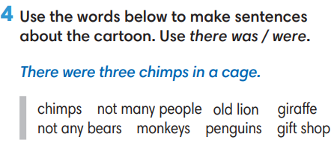
4. PRODUCTION (7’)
ACTIVITY 5:
*Aim: To help Ss to apply the grammar point they have learnt to talk about the past.
* Content: Ss make conversation about animals (where and when they were).
* Outcome: Ss know how to use past simple tense to make a conversations about their place and activities in the past.
* Organisation: T_Ss …

Teacher’s Student’s activities |  | Content
5. Complete the table with the places below. In pairs, guess your partner’s answers.  (Ex 5, p.32)  - T asks Ss to look at exercise 5 (SB page 32).  - T calls a student to read the instruction then checks Ss’ understanding of it.  - T asks a pair to read the sample dialogue on the slide then asks some new pairs to make new dialogues to ask and answer about other places and time.  - T divides Ss into pairs, models the activity in front of the class then asks Ss to make conversations about animals.  - T sets a time limit and monitors Ss while they are working in groups.  - T notes down common mistakes for delayed feedback.  - T calls some pairs to come to the front of the class, make conversations about the past.  - T asks the rest to give comments on their classmates’ performance.  - T gives feedback on Ss’ work. |  | 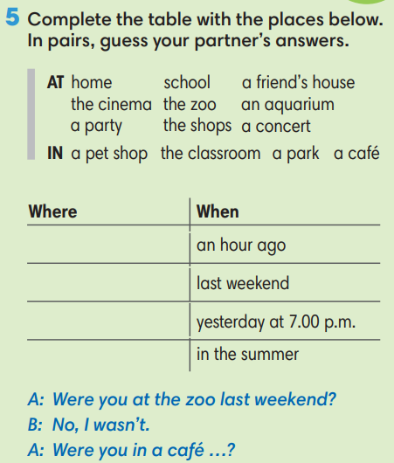
WRAP-UP & HOME WORK (2’)
- T asks Ss to talk about what they have learnt in the lesson.
- Vocabulary of animal names.
- Vocabulary of animal body parts.
* HOME WORK
- Do exercises in the workbook page 26.
- Prepare for Lesson 3: Reading and Vocabulary.

************************************************************************

