Date of planning:10/9/2022  Date of teaching: 14/9/2022 | Period 4: UNIT 0: WELCOME  Lesson 3: Mai’s Home
I. OBJECTIVES:
By the end of the lesson, students will be able to:
- use the vocabulary and grammar points to talk about their possessions.
1. Knowledge:
* Vocabulary:
- Identify key information about Mai.
- Name possessions.
* Grammar: use there is / there are with some / any to talk about their possessions.
2. Competence: Understand and use vocabulary to talk about possessions, and understand the main grammatical points, then do the tasks assigned in the textbook.
3. Quality/ behavior: To teach Ss to be hard-working and attentive in class. Ss have a positive attitude to working in groups, individual work, pair work, cooperative learning, and working.
II. TEACHING AIDS:
- Teacher: Grade 7 textbook, Unit 0 (SB p. 7), laptop/computer connected to the Internet, loudspeaker, projector/TV, PPT slides …
- Students: Text books, studying equipment….
- Method: Active teach, T-WC; group works; individual ……
III. PROCEDURE:

1. WARM UP (4’)
* Aim: To help Ss review information about Mai that they have learnt in the previous lesson.
* Content: Rewind correct information about Mai.
* Outcome: Ss choose 5 correct sentences about Mai.
* Organisation : T_ Ss …
Teacher’s &Student’s activities | Content
Read and tick 5 correct sentences about Mai.
(Extra activity)
- T asks Ss to read the instruction on the slide then check their understanding.
- T calls students to read the sentences about Mai.
- T sets a time limit and asks Ss to work in pairs to complete the activity.
- T calls some pairs to give answers then shows the answers on the slide.

2. VOCABULARY( 20’)
2.1 PRESENTATION (10’)
ACTIVITY 1
* Aims: To present vocabulary of possessions in context.
* Content: Read about Mai’s bedroom to mark the sentences T (true), F (false).
* Outcome: Know more some new words, how to combine a verb and a noun.
* Organisation : T_ Ss …
Teacher’s & Student’s activities |  | Content
1. Read about Mai’s bedroom. Mark the sentences T (true), F (false)  (Ex 1, p. 7)  - T asks Ss to open their SB page 7, look at exercise 1.  - T calls a student to read the instruction then checks Ss’ understanding of it.  - T lets Ss read the short text and all the sentences.  - T calls Ss to give answers and asks them to explain their answers.  - T checks as the whole class. |  | Answer keys:  2. F 4. T  3. T 5. T
Guessing Game  (Adapted from ex.1 WB p.4)  - T explains the game rules then checks instructions.  - Ss join in the game individually.  - T corrects Ss if any. |  | Game rules:  ✔ Look at the picture.  ✔ Guess the thing.  ✔ Choose 1, 2 or 3 then read the word  ✔ 1 correct answer = 1 point
2.2 PRACTICE ( 10’)
ACTIVITY 2 + 3
*Aim: - To help Ss identify and name possessions.
- To help Ss correct their pronunciation of target vocabulary.
- To provide Ss with a chance to talk about their possessions.
* Content: To use the possessions to do the exercises. Pronounce new words correctly.
* Outcome: To understand more about using possessions in contexts;
* Organisation : T_ Ss …

2. Listen and underline the things you can see in the photo.  (Ex 2, p. 7)  - T asks Ss to open their SB page 7, look at exercise 2.  - T calls a student to read the instruction then checks Ss’ understanding of it.  - T lets Ss listen and underline things they see in the photo.  - T calls Ss to give answers.  - T correct Ss’ pronunciation if any. |  | Answer keys:
  book, camera, dictionary, headphones, helmet, keys, laptop, photo, poster, sports bag, sunglasses, trainers.
3. In pairs, use vocabulary box to tell your partner three things you have / haven’t got / would like to have.  (Ex 3, p. 7)  - T asks Ss to open their SB page 7, look at exercise 3.  - T calls a student to read the instruction then checks Ss’ understanding of it.  - T sets time limit and asks Ss to work in pairs to complete the activity.  - T calls some pairs to practice speaking in front of the class.  - T correct Ss’ pronunciation if any. |  | 
3. GRAMMAR (12’)
3.1 PRESENTATION ( 5’)
ACTIVITY 4:
* Aim: To present the use of there is / there are with a / an / some / any.
* Content: To use there is / there are with a / an / some / any to write sentences about bedrooms..
* Outcome: Use there is / there are with a / an / some / any correctly.
* Organisation: T_ Ss ….
4. Study the grammar box. Use there is / there are with a / an / some / any to write sentences about your bedrooms.  (Ex 4, p. 7)  - T asks Ss to look at exercise 4 (SB page 7).  - T calls a student to read the instruction then checks Ss’ understanding of it.  - T lets Ss work in groups, study the grammar box, read the model sentences then make some new sentences about their bedrooms.  - T elicits answers from groups then shows some suggestions. |  | 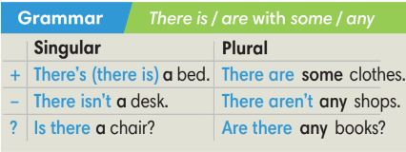
3.2 PRACTICE (7’)
EXTRA ACTIVITY:
*Aim: To help Ss practice building sentences about hobbies and interests.
* Content: Play Bomb Stars Game to understand the structure of the sentences about hobbies and interests.
* Outcome: Use grammar points correctly in the sentences
* Organisation: T_ Ss …
Teacher’s &Student’s activities |  |  |  | Content
Bomb Stars Game  (Adapted from ex4 WB p.4)  - T explains the game rules then checks instructions.  - Ss join in the game individually.  - T corrects Ss if any. |  |  |  | Game rules:  ✔ Make sentences with There is / There are  ✔ 1 correct answer => choose a star for point(s).
4. PRODUCTION (7’)
ACTIVITY 5
* Aim: To help Ss apply what they have learnt to talk about their possessions.
* Content: Work in pairs to ask and answer questions about your bedrooms.
* Outcome: Students use the items from the vocabulary box or their own ideas to talk about their bedrooms.
* Organization:
5. In pairs, ask and answer questions about your bedrooms. Use the items from vocabulary box or your own ideas.  (Ex 5, p. 7)  - T asks Ss to look at exercise 5 (SB page 7).  - T calls a student to read the instruction then checks Ss’ understanding of it.  - T asks a student to read the sample dialogue.  - T divides Ss into new pairs, then sets a time limit for them to complete the activity.  - T walks around to listen and notes down common mistakes for delayed feedback.  - T calls some pairs to come to the front of the class and make conversations.  - T asks the rest to give comments on their classmates’ performance.  - T gives feedback on Ss’ work. |  |  | 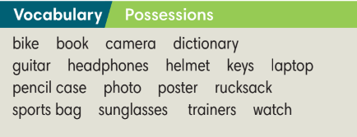  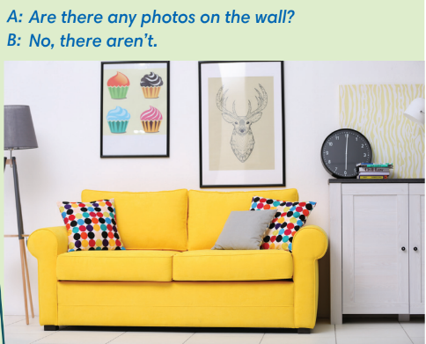
WRAP-UP & HOME WORK (2’)
- T asks Ss to talk about what they have learnt in the lesson.
✔ Possessions.
✔ There is / There are with some / any.
* HOME WORK
- Do exercises in the workbook page 4.
- Prepare for Lesson 0.4: Introducing Kim.
*********************************************************

