Preparing date: 14/5/2023
Teaching date: 18/5/2023

Period 103 – REVIEW UNIT 6 - 10
I. Objectives: Students will be able to revise and practise all the vocabulary and grammar in Unit
9 + 10.
1. Knowledge:
Vocabulary and grammar of Unit 6 - 10
2. Competences:
Groupwork and independent working, pair work, linguistic competence, cooperative learning and communicative competence
II. Teaching aids:
1. Materials: textbooks, worksheet, Teacher’s Resource Book Unit 6-10
2. Equipment: TV, projector, loudspeaker
III. Procedure:
1. Checking: integrated into the warm-up activity.
2. New lesson:
Teacher’s and students’ activities | Contents
1. Warm-up
Aims: to attract Ss’ attention to the lesson and review the previous lesson.
T asks Ss to work in 4 groups and give each group a small board.  T asks Ss to remember the words about jobs and places.  T gives topic 1: “Two places where people work” and asks Ss to name them.  Groups have to quickly write the words on their small boards.  The fastest group with correct answers will get 1 point for their group.  T continues with other topics. | Exercise 1 (SB p.108) Use the glossary to find:  Possible answers:  1. Two places where people work: call centre, college, …  2. Three jobs you need to be creative: architect, artist, chef, …  3. Four jobs for which you have to wear a uniform: firefighter, pilot, police officer, postman, …  4. Five jobs in which you spend a lot of time working outdoors: builder, farmer, fruit picker, tour guide, postman, …
2. Vocabulary Revision
Aims: to review vocabulary in Unit 9 + 10.
T asks Ss to read the sentences in the exercise.  T asks Ss to work in pairs to do the exercise.  T calls some Ss to give their answers and checks for them.  After that, T asks Ss to work in pairs again to tell how to get to school.  T calls some pairs to talk about each other. | Exercise 1 (SB p.99): Complete the text with one word in each gap. Tell your partner how to get to school.  Answers:  2. by  3. stop  4. on  5. for  6. for  7. off
T uses Teacher’s Resources Unit 10_1 for Ss to do.  Ss work in groups of 6.  T gives each group 2 sets of cards: Work cards and Jobs cards.  T sets a time limit and asks Ss to match the jobs and the work correctly.  The first group that finishes the matching with correct answers will win the game.  After that, T elicits the correct answers and asks Ss to discuss some jobs. | Teacher’s Resources Unit 10_1  Which job?  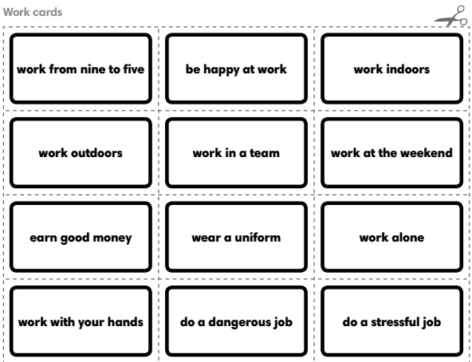
3. Grammar Revision
Aims: to revise and practise all the grammar points in Unit 9 + 10.
Before doing the exercise, T asks Ss to review the Present Continuous for future arrangements and “be going to” for plans.  T asks Ss to read all the words and underline the signals of future tenses.  T and Ss do number 1 as an example.  SS discuss and do the exercise on their own.  After that, T asks some Ss to give their answer and check for them.  T asks Ss to work in pairs to ask and answer the questions in the exercise.  Then T calls some pairs to talk in front of the class. | Exercise 7 (SB p.99): Order the words to make questions. In pairs, choose five questions to ask your partner.  Answers:  2. Are you getting a lift home from school this afternoon?  3. How are you going to celebrate your next birthday?  4. Are you going to do homework this evening?  5. Where are you going on holiday this year?  6. Who in your family is celebrating a birthday soon?  7. What are your parents doing this weekend?  8. Are you going to learn to drive in the future?
T asks Ss to review the First Conditional before doing the exercise.  T and Ss do number 1 as an example.  Ss do the exercise on their own.  Ss compare answers in pairs before checking.  After that, T asks Ss to give their answers on the board.  T elicits the correct answers. | Exercise 5 (SB p.104): Complete the sentences with the correct form of the verbs in brackets.  Answers:  2. will buy  3. gets  4. don’t get  5. doesn’t feel  6. won’t lend.
3. Guides for homework:
Finish Exercise of Unit 6 - 10 in the workbook.
Prepare for the Examination 2.
*******************************************

