Preparing date: 27/09/2021
Teaching date: 29/09/2021
UNIT 1: PEOPLE ARE PEOPLE
Period 12 - Lesson 1.6: Speaking
I. OBJECTIVES
By the end of the lesson, students are expected to achieve the following objectives:
1. Knowledge:
Understanding of the keywords or word collocations below:
- What about her?  - Excuse me.  - Really cool!  - No worries.  - Hello! / Hi!  - How are you? / How’s it going? | - I’m fine/ good, thanks.  - My name’s … / I’m …  - Pleased/ nice to meet you.  - This is my friend, Sol.  - Bye. / Goodbye. / See you (later).
2. Competencies:
a. General competencies:
Form and improve group work and independent working, pair work, and cooperative learning.
b. Specific competencies:
Improve communicative competence related to speaking skills and use of language (vocabulary, phonetics, grammar)
- For a language lesson: Students are expected to know the meaning of the key phrases in a greeting dialogue and understand the main grammatical points, then do the tasks assigned in the textbook.
- For a skills lesson: Students are expected to use their speaking skills to practice greeting and introducing each other in groups.
3. Qualities:
- Have a positive attitude towards the lesson
- Understand and actively respond to relevant matters or situations
- Be polite and friendly when greet and introduce people
II. PREPARATIONS
Teacher: Textbooks, PowerPoint slides, worksheet 1, TV, projector, loudspeaker
Students: Textbooks, notebooks
III. PROCEDURE
ACTIVITY 1: WARM-UP (5’)
- Aim: To recall words to describe people that they’ve learned in this unit.
- Content: Students work individually with instruction from Teacher
- Products: Students are able to greet each other using the words that they’ve learned.
- Implementation:
Teacher’s and Ss’ activities | Content
Dating (Worksheet 1)  Step 1: Task delivering  - Teacher gives each student a clock without hands and asks them to circle numbers 2, 4, 6, 8, 10, 12.  - Teacher explains that they’re going to meet their friends, greet and introduce their names. They have to write the name of a friend they meet at a circled time. The rule is you cannot meet the same people at different times. It means each student needs to greet 6 people in total.  i.e., At 2 o’clock, I meet Jane. I will write her name next to number 2.  Step 2: Task performance  - Students do the activity as guided by Teacher.  Step 3: Judgment  - The winner is the first one who meets 6 people at the circled time. | Example:  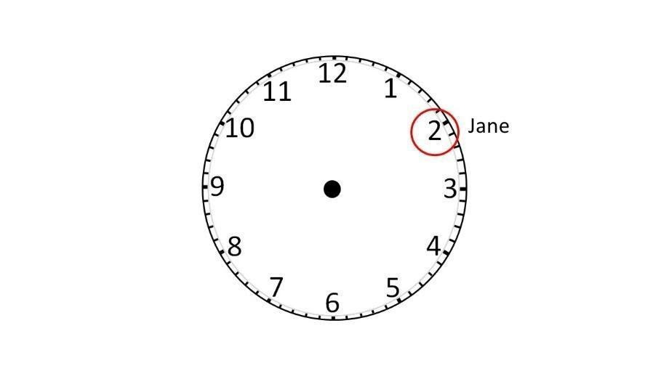  A: Hi, my name is A. Nice to meet you.  B: Hi A. I’m B. Nice to meet you too.
ACTIVITY 2: KNOWLEDGE FORMATION (10’)
- Aim: To introduce the objectives of the lesson with a can-do statement.
- Content: The objective of the lesson is listed below
- I can greet and introduce people.
- Products: Students acknowledge the lesson’s objectives
- Implementation: Teacher introduces objectives to students
ACTIVITY 3: PRE-SPEAKING (15’)
- Aim: To analyze the speaking samples.
- Content: Students work individually and in groups under the instruction of Teacher to learn key phrases used in greeting and introducing people.
- Products: Students know the meaning of phrases and grammatical structures used to greet and introduce people
- Implementation:
Teacher’s and Ss’ activities | Content
Step 1: Task delivering  - Teacher asks students to look at the photo on page 16 of Student’s Book and describe it in groups of 4 in 3 minutes.  Step 2: Task performance  - Competition: each group has 2 minutes to describe the photo. The teacher counts how many correct sentences they have made. The winner group is the one who has more correct sentences.  Step 3: Judgment  - Teacher plays the recording 1.13 to check the answers. | Exercise 1: Look at the photo and choose the correct option. Read or listen and check. (Adaptation)  Example:  - They’re in the park.  - The boy with light brown hair is asking the woman something.  Answers:  1 in the park  2 isn’t  3 isn’t
Step 1: Task delivering  - Teacher explains that they can find lots of expressions to introduce names and greet people. Teacher asks them to find the phrases in the Speaking box in the dialogue and tell how much they know about when they use these phrases.  Step 2: Task performance  - Teacher plays the audio again and asks them to focus on the stress of the phrases they’ve found and the phrases in the ‘OUT of class’ box. i.e., the stress in “What about her?” is on the word “about”.  - Teacher explains that we use this phrase to ask why the person you are speaking with has mentioned someone or something  - Teacher explains that we say “Excuse me.” to get someone’s attention before we start talking to them.  - Teacher explains that (e.g., really good, really bad). | Exercise 2: Study the Speaking box. Find the phrases in the dialogue.  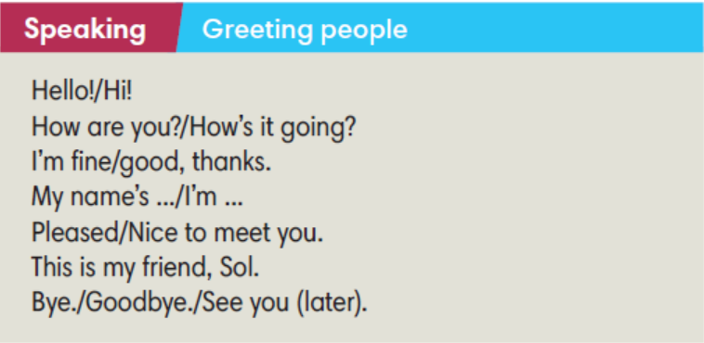
ACTIVITY 4: WHILE SPEAKING (10’)
- Aim: To practice using words and phrases to greet people and introduce their names.
- Content: Students work individually and in pairs to complete exercises as instructed by Teacher.
- Products: Students are able to use descriptive phrases appropriately to describe people
- Implementation:
Step 1: Task delivering  - Teacher tells students to complete exercise 3 on their own and to check their answers in pairs.  Step 2: Task performance  - Students complete exercise 3 on their own.  Step 3: Judgment  - Students check their answers in pairs. | Exercise 3: Complete the sentences with the words below.  Answers:  b I’m c How d meet  e fine f Hi g Bye h it
Step 1: Task delivering  - Teacher has students work in pairs to complete exercise 4.  Step 2: Task performance  - Students work in pairs to complete exercise 4.  Step 3: Judgment  - Teacher plays audio track 1.13 to check the answers. | Exercise 4: Complete the dialogue with sentences from Exercise 3. Listen and check.  Answers:  2 c 3 e 4 b 5 f 6 d 7 g
ACTIVITY 5: POST SPEAKING (5’)
- Aim: To apply expressions in the Speaking box in real situations.
- Content: Students work in groups for further practice.
- Products: Students’ conversations get out of the given sample and contain interesting situations.
- Implementation:
Step 1: Task delivering  - Teacher asks students to work in groups of 3 to make a conversation for the meeting at the school canteen.  Step 2: Task performance  - Teacher encourages the groups to think of ways of making their conversations more Teacher walks around to help if necessary. | Exercise 6: In groups of three, have a conversation. Follow these steps. Then swap roles. Example:  A: Hello.  B: Hi.  A: Are you a new student?  B: Yes. Today is my first day.  A: My name’s Bill.  B: Hi Bill. I’m Bond. And this is my best friend, Charlie.  A: Hi Charlie. Nice to meet you.  C: Hi Bill. Me too.  B: We have to go and see the teacher. Talk later.  A: No worries. See you later.  B and C: See you.
HOME ASSIGNMENT  - T assigns the home assignments.  - Ss copy their home assignments.  - T explains it carefully. | - Do exercises 1, 2, 3, 4, 5 on Workbook page 12.  - Prepare Unit 1 Lesson 7 Writing.

**********************************************************

