Preparing date: 16/10/2022
Teaching date: 17/10/202
UNIT 2: IT’S DELICIOUS!
Period 19 - Lesson 2.4: Grammar
I. OBJECTIVES
By the end of the lesson, students are expected to achieve the following objectives:
- Knowledge:
- Grammar: Quantifiers
- Vocabulary: food and drink
2. Competencies:
- General competencies:
Form and improve such competencies as group work and independent working, pair work, and cooperative learning.
- Specific competencies:
Improve communicative competence related to the use of language (vocabulary, phonetics, grammar)
- For a language lesson: Students are expected to understand the main grammatical points, then do the tasks assigned in the textbook.
- For a skills lesson: Students are expected to use the main grammatical structure to practice talking about quantifiers.
3. Qualities:
- Being hard-working and attentive in class
- Have a positive attitude towards the lesson
II. PREPARATIONS
Teacher: Textbooks, PowerPoint slides, TV, projector, loudspeaker
Students: Textbooks, notebooks
III. PROCEDURE
ACTIVITY 1: WARM-UP (5’)
- Aim: To attract Ss’ attention to the lesson and review the previous lesson.
- Content: Ss work in groups to play the game under the guidance of T.
- Products: Ss are able to give the word about food correctly to win a point for their team.
- Implementation:
Teacher’s and Ss’ activities | Content
Hidden words  Step 1: Task delivering  - T shows Ss the rules of the game.  - T divides the class into 4 teams and asks them to guess the food under the pictures.  Step 2: Task performance  - T removes each picture for Ss to guess.  - The first group to guess the food correctly wins a point for their team.  - T continues the game with other food. | Review of cooking vocabulary  Suggested words: bread, egg, bacon, fish, pork, ….
ACTIVITY 2: KNOWLEDGE FORMATION (10’)
- Aim: To introduce the objectives of the lesson with a can-do statement.
- Content: The objective of the lesson is listed below
- I can use countable and uncountable nouns and talk about quantities of food.
- Products: Ss acknowledge the lesson’s objectives
- Implementation: T introduces objectives to Ss
ACTIVITY 3: PRESENTATION (15’)
- Aim: To teach how to use countable and uncountable nouns and quantifiers to talk about food.
- Content: Ss work individually and in groups of 4 to complete the given exercises respectively under the instruction of T.
- Products: Ss are able to accomplish the given exercises, improve their pronunciation, grasp the meaning of new words, and usage and form of target grammar structures.
- Implementation:
Teacher’s and Ss’ activities | Content
Set the scene  Step 1: Task delivering  - T shows the picture in the dialogue and introduces 2 characters (Sol and Max) and the context (They’re in the kitchen and talking about what to eat.)  Step 2: Task performance  + T tells Ss to find the ingredients in exercise 1 in the photo in groups of 4.  - T asks Ss to read aloud all the words and explains new words if necessary. (celery)  - T leads to the lesson. | Exercise 1: In pairs, look at the photo. Which of the ingredients below can you see?  Answers:  celery, ketchup, oil, onions, potatoes, eggs
Step 1: Task delivering  - T puts words in exercise 1 in 2 columns and asks Ss to give reasons for the separation.  Step 2: performance  - T sums up ideas about Countable and Uncountable Nouns.  - Ss separate words in exercise 1 into C and U nouns.  Step 3: Judgment  - T checks the answers for the whole class. | Exercise 2: Study the Grammar A box. Mark the words in Exercise 1 C (countable) or U (uncountable)  Grammar:  - Countable nouns: The items we can count. They have both singular and plural forms.  - Uncountable nouns: They are singular. They don’t have plural forms.  Answers:  - Countable: biscuits, crisps, eggs, onions, potatoes  - Uncountable: celery, cheese, ketchup, oil
Step 1: Task delivering  - T asks Ss to read the dialogue again and find out the quantifiers.  Step 2: Task performance  - Ss work in groups of 4 to study the Grammar box B to find out how to use these quantifiers.  Step 3: Report and discussion  - T explains the grammar points.  Step 4: Judgment  - T checks by letting them choose the correct option for a statement/ question. | Exercise 3: Study the Grammar B box. Find examples of quantifiers in the dialogue.  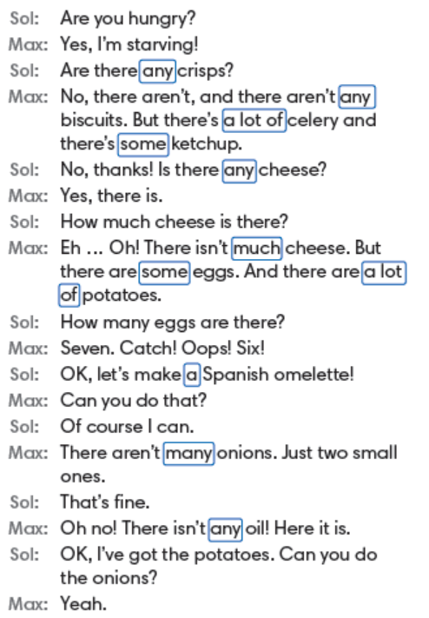  Quiz: choose the correct answer  - There is …… celery in the fridge.  - There aren’t …… biscuits to eat.  - Are there …. crisps?  - How …… juice is there?
ACTIVITY 4: PRACTICE (10’)
- Aim: To practice the usage of quantifiers.
- Content: Ss work individually and then in groups of 4 to complete the given task and answer questions as well as to play games.
- Products: Ss are able to accomplish each task with correct answers.
- Implementation:
Step 1: Task delivering  - T asks Ss to do the exercise individually.  Step 2: Task performance  - T calls some Ss to give answers and explains why they choose them.  Step 3: Judgment  - T gives feedback. | Exercise 4: Choose the correct option. Listen and check.  Answers:  - Is 2. much  - a lot of  - are  - there are  - How  - Many
Quiz  Step 1: Task delivering  - T shows a quiz on the screen. Each question has 4 options.  Step 2: Task performance  - Ss work in groups of 4 to write the best options on paper and show them to everyone.  Step 3: Report and discussion  - T shows answers and asks Ss to explain. | Example:  There ___ onions in the fridge.  - are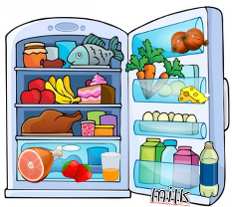  - isn’t  - any  - some
ACTIVITY 5: FURTHER PRACTICE (5’)
- Aim: To write about the food and drinks in the kitchen.
- Content: Ss work individually and in pairs under the guidance from T to gather the information they need to collect in order to do a given task.
- Products: Ss are able to write about food and drinks in their kitchen and then discuss in pairs using the grammar structure and vocabulary in the lesson.
- Implementation:
Step 1: Task delivering  - T gives Ss time to think about the food and drinks in their kitchens, and helps them if necessary.  - T looks around and helps if necessary  Step 2: Report and discussion  - T calls some pairs to make dialogues. | Exercise 5: Write about the food and drinks in your kitchen. Then, in pairs, ask and answer to find out what’s in your partner’s kitchen.  Suggestion:  in my kitchen, there’s some milk but there isn’t …  Is there any … in your fridge?  How much … is there?
HOME ASSIGNMENT  - T assigns the home assignments.  - Ss copy their home assignments.  - T explains it carefully. | - Do exercises on Workbook page 19.  - Prepare Unit 2.5 – Listening and Vocabulary.

******************************************************************

