Preparing date: 04/09/2022
Teaching date: 07/09/2022

UNIT 0: MY WORLD
Period 2 - Lesson 0.1: I’M............

I. OBJECTIVES
By the end of the lesson, I can talk about possession and spell names.
- Knowledge: Review
- Vocabulary: alphabet
- Grammar: possessive adjectives
- Competences:
- General competencies:
Form and improve group work and independent working, pair work, and cooperative learning.
- Specific competencies:
Improve communicative competence related to the use of language (vocabulary, phonetics, grammar)
- For a language lesson: Students are expected to use the English alphabet correctly and understand the main grammatical points of the lesson, then do the tasks assigned in the textbook.
- For a skills lesson: Students are expected to use grammar structures about possessive adjectives to practice talking about the state of having/owning something.
- Qualities:
- Being hard-working and attentive in class
- Being collaborative while doing in-class exercises
II. PREPARATIONS
Teacher: Textbooks, PowerPoint slides, TV, projector, loudspeaker
Students: Textbooks, notebooks

- PROCEDURE
ACTIVITY 1: WARM-UP (5’)
- Aim: To attract Ss’ attention to the lesson and to lead in the new lesson.
- Content: Ss play the game called Slap the board under the instruction from T.
- Products: Ss are able to recognize and match the proper names with the corresponding subject pronouns in order to win points for their group.
- Implementation:
Teacher’s and students’ activities | Contents
Step 1: Task delivering  -T asks Ss to retell subject pronouns then play the game “Slap the board”.  -T writes 7 Subject pronouns in 7 circles on the board.  -T divides the class into 2 groups and tells the rules of the game: Each member of each group will go to the board, listen to the teacher saying proper names. Ss listen and slap the correct subject pronouns. Who is faster will get 1 point. Which groups get more points will be the winner.  Step 2: Task performance  -Each member of each group will go to the board, listen to the teacher saying proper names. Ss listen and slap the correct subject pronouns. Who is faster will get 1 point. Which groups get more points will be the winner.  Step 3: Judgment  -T sums up the point and leads in the new lesson. | Game: Slap the board  They  I  It  We  You  She  He
ACTIVITY 2: KNOWLEDGE FORMATION (10’)
- Aim: To introduce to Ss what they can do after the lesson.
- Content: The objective of the lesson is listed below
- I can talk about possession with possessive pronouns and spell names.
- Products: Ss acknowledge the lesson’s objectives.
- Implementation: T introduces objectives to Ss.
ACTIVITY 3: POSSESSIVE ADJECTIVES (15’)
- Aim: To teach how to use possessive adjectives to talk about the ownership of something.
- Content: Ss work individually to complete the assigned exercises and then play the game called “Spinning the wheel” in groups under the instruction from T.
- Products: Ss are able to understand the grammar rules of possessive adjectives to accomplish the given tasks.
TEACHER AND STUDENTS’ ACTIVITIES | CONTENTS
Presentation  Step 1: Task delivering  Lead-in: link subject pronouns or structure “have/has …” to possessive adjectives.  - T asks Ss to match Subject pronouns with suitable possessive adjectives.  Step 2: Task performance  - Ss match Subject pronouns with suitable possessive adjectives.  Step 3: Judgment  T checks and corrects if Ss have mistakes. | Matching
  I | You | We | They | He | She | It
  Their | its | My | His | Her | Our | Your
  I | You | He | She | It | We | They
  My | Your | His | Her | Its | Our | Their
Practice 1  Step 1: Task delivering  - T asks Ss to read sentences in exercise 6 and do the exercise individually.  Step 2: Task performance  - Ss read sentences in exercise 6 and do the exercise individually.  Step 3: Report and discussion  - T calls some Ss to stand up and read the whole sentence and answer.  Step 4: Judgment  T checks and corrects mistakes. | Exercise 6: Study the Grammar C box. Choose the correct option.  Answers for Exercise 6:  1. Her  2. Our  3. Your  4. Their  5. His  6. Its
Practice 2  Step 1: Task delivering  - T introduces the game named “Spinning the wheel”  Step 2: Task performance  - Ss join in an interactive game named “Spinning the wheel” in groups.  T uses Exercise 5 in WB page 2 as material for the game. Ss choose a number, do the task then spin the wheel to get the points. | Exercise 5 (WB p2) Complete the sentences with possessive adjectives.  Answers:  2. our  3. your  4. their  5. His
ACTIVITY 4: ALPHABET AND SPELLING (15’)
- Aim: To review alphabets and how to spell names.
- Content: Ss work in pairs individually and in groups of 4 to do the assigned exercises under the instruction from T.
- Products: Ss are able to find similar sounds and different sounds between English and Vietnamese and then use their listening skills to correctly spell the names given in the exercises.
- Implementation:
Step 1: Task delivering  - T instructs Ss how to do Exercise 7  Step 2: Task performance  - Ss work in pairs to find similar sounds and different sounds between English and Vietnamese.  - T guides them to illustrate their answers with the Venn diagram. | Exercise 7. Go around the class saying the letters of the English alphabet. Which sound is not available in Vietnamese?  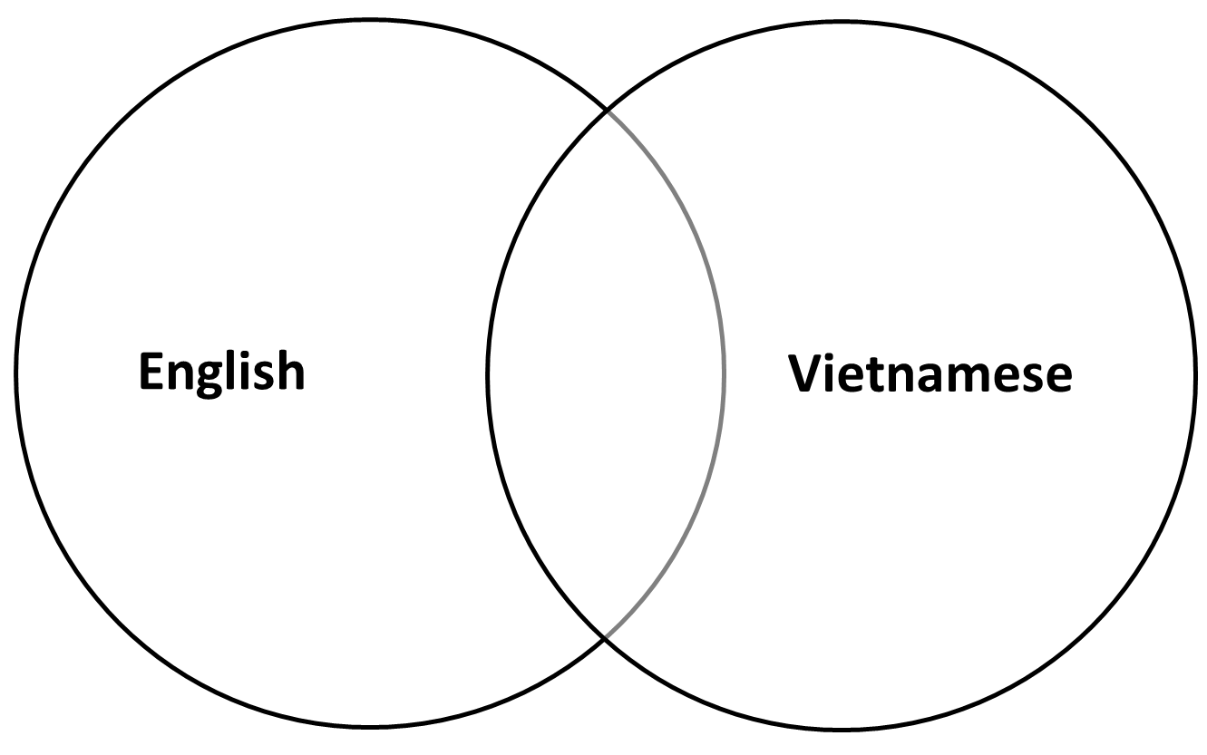
Step 1: Task delivering  - T asks Ss to look at Watch out! Box.  - T guides Ss on how to spell a word and asks Ss to repeat spelling the words in the box.  - T asks Ss to guess the name then calls some Ss to say their predictions.  Step 2: Task performance  - Ss guess the name then say their predictions as called by T.  - Ss listen to audio track 0.1 and check their predictions.  Step 3: Report and discussion  - T invites Ss to spell the answers.  - T gives each Ss a number then asks Ss to spell their names.  - T says randomly 2 numbers. Who has these numbers must stand up and spell their name immediately. Who finishes first will be the winner. | Exercise 8. Study the Watch-out box. Listen and write down the names. Then spell your first name and your surname.  Answers:
  1. Javier | 3. Emma | 5. Gillian
  2. Krzys | 4. Harley | 6. Eleanor
Step 1: Task delivering  - T asks Ss to add an English name to their name. T makes a model: Thao Nancy.  - T asks Ss to work in a group of four. One asks and others answer questions.  Step 2: Task performance  - Ss work in a group of 4. One asks and others answer questions.  - T goes around and checks.  Step 3: Report and discussion  - T calls some groups to go to the board and practice. | Exercise 9: Ask three of your friends to spell their names.  B: How do you spell your name?  L: L-A-N B-E-L-L. How do you spell your name?  B: B-I-N-H J-O-H-N.
HOME ASSIGNMENT  - T assigns the home assignments.  - Ss copy their home assignments.  - T explains it carefully. | - Do exercises 5, 6 on Workbook page 2.  Prepare Unit 0 – Lesson 0.2.

********************************************************************

