Preparing date: 20/11/2022
Teaching date: 21/11/2022

Period 34 - CLIL 1 (Literature): Poetry
I. Content objectives: By the end of the lesson, students will be able to:
- read a poem about an old man watching the countryside scene through a window.
- identify components of a poem: title, writer, verses, context, content, repetition, punctuation, rhymes.
II. Language Objectives: By the end of the lesson, students will be able to:
- use poetry-related words to talk about components of a poem and in writing a verse for a poem.
III. Target language:
Vocabulary:
- poetry-related words: title, writer, verse, repetition, punctuation, rhymes
- rhymes in the poem: frame – again – plain – rain – lane
IV. Anticipated problems:
- Students may find it difficult to create a new verse for the poem.
- Students may struggle with rhymes.
V. Proposed solutions
- T prepares some ideas and prompts in advance to support students when writing a new verse for the poem
VI. Assessment: Students will be assessed through two comprehension exercises:
- choose the best title.
- answer the questions about the poem.
- They will also create a new verse for the poem.
VII. Teaching aids:
- Materials: textbooks, worksheet, PowerPoint slides, some Vietnamese poems
- Equipment: TV, projector, loudspeaker
VIII. Procedure:
- Checking: integrated into Warm-up activity
- New lesson:
Teacher’s and students’ activities | Contents
Warm-up
Aims: to help students revise Unit 3 and get them be ready and excited about the lesson
- Let Ss play snake game: T gives students a word. Students find the next word which starts with the last letter of the previous word.
- - For each word related to Unit 3, students get 1 point.
Pre-reading
Pre-reading questions
Aims: to activate Ss’ prior knowledge about the topic.
- The teacher asks Ss to think of a Vietnamese poem that they remember.  - Ask them to work in groups of 4 and each student says some lines in the poem they have in their mind for the others to guess.  - Invite some students from different groups to say the lines again for the whole class to guess the names of the poem and the poets.  - Introduce the topic of the lesson. | Example: Mẹ đi làm  - Nguyễn Bao -  Mẹ đi làm  Từ sáng sớm  Dậy thổi cơm,  Mua thịt cá  Em kề má  Được mẹ yêu  Ơi mẹ ơi  Con yêu mẹ lắm.
Pre-teaching of vocabulary  - The teacher gives students a handout to label parts of a poem.  - Present the words from the handout and introduce other words: repetition, rhymes, punctuation that appear in the poem.  - Teacher check Ss’ pronunciation of the words and check the answers of the task.  - Students read through the poem and underline the words they do not know.  - The teacher explains the words if necessary. | 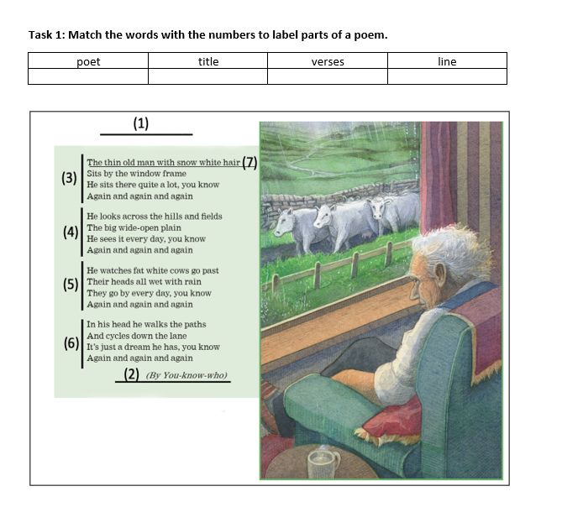
While – reading
Task 1
Aims: to provide Ss with the main idea of the poem and give them a reason/ motivation to read.
Activity 2 (Student’s Book page 114)
- Students read the poem and choose the best title.
- Ask them to underline some keywords that support their choice.
- Tell Ss that the title tells the main idea of a poem.
Task 2
Aims: to get Ss to practice their comprehensive reading skills and help them understand more deeply the content and structure of the poem.
Activity 3 (Student’s Book page 114)  - Students work in groups of four. Students read the poem again and discuss the questions in the task.  - Ask them to underline the information they found in the poem and take notes their ideas in the notebooks.  - Invite some students to present their ideas.  - Check with the whole class.  Graphic Organizer  - Give students a graphic organizer in the form of a mindmap with blanks to fill in. Students work in pairs to complete the task.  - Have Ss do group check after they finish. Encourage them to present the content in their own words.  - Check with the whole class. |  | 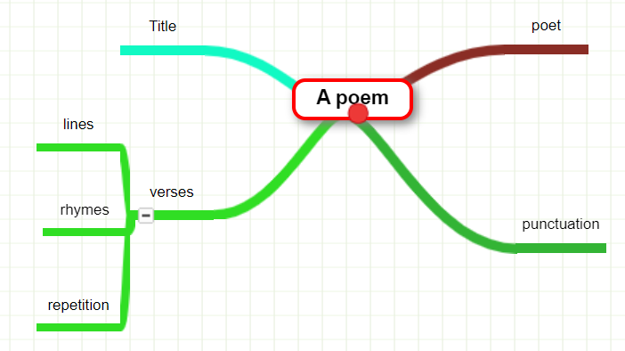
Post – reading
Aims: To help Ss reflect on what they’ve learnt and what they’ve known about poetry.
Activity 4 (Student’s Book page 114)
- Students work in pairs to discuss the questions. Ask them to take note their answers on the notebooks.
- Facilitate the pairwork.
- Call on some pairs to answer.
Activity 5 (Student’s Book page 114)  - Students work in pairs to find the rhymes.  - Check with students and/ or provide more words.  - Ask them to write another verse for the poem.  - Facilitate the pairwork.  - Form groups of 4 for Ss to share their verse.  - Invite some Ss to read their work. |  | Suggestions:  gain – plane – rain – drain – main – vain – train – chain – stain – Jane – cane  flame – name – frame – came – same – fame – game – blame – shame – became
Activity 6 (This one can be left as their homework)
- Students work in groups of 4 to complete this task.
- Ask them to discuss and choose 1 poem they like then copy it onto a piece of paper.
- Follow the instructions of the task.
***T should ask Ss to prepare this content in advance so their presentation can be better.
Activity 7 (If time allows)
The teacher invites some groups to come and present their discussion.
- 1 student reads the poem.
- 1 student explains what it means.
- 1 student elicits the rhymes, repetition and punctuation in the poem.
- 1 student explains why the group chooses the poem.
Wrap – up
- Students take note of the homework: Activity 6 (Project)
- The teacher gives students’ homework.
- Guides for homework:
- Prepare Unit 4 Lesson 1.
****************************************************************

