Preparing date: 11/12/2022
Teaching date: 12/12/2022
UNIT 4: LOVE TO LEARNT
Period 43 – REVIEW 2 Unit 3 & 4
- Objectives: By the end of the lesson, students will be able to revise and practise all the vocabulary and grammar in Unit 3 + 4.
- Knowledge:
- Vocabulary and grammar of Unit 3 + 4
- Competences:
- Groupwork and independent working, pair work, linguistic competence, cooperative learning and communicative competence
- Teaching aids:
- Materials: textbooks, PowerPoint slides
- Equipment: TV, projector, loudspeaker
- Procedure:
- Checking: integrated into the warm-up activity
- New lesson:
Teacher’s and students’ activities | Contents
1. Warm-up
Aims: to attract Ss’ attention to the lesson and review the previous lessons.
- T asks Ss to work in 4 big groups and gives each group an A4 paper.  - Ss in each group take turns to write the words they know.  - After 3 minutes, the group with the most words wins the game.  - T asks Ss to read aloud all the words. | Review of Classroom objects, subjects and prepositions of place vocabulary
  Classroom objects | Subjects | Daily routines
2. Set objectives
Aims: to introduce the objectives of the lesson with a can-do statement.
- I can name classroom objects and school subjects. I can talk about habits and what is happening now.
3. Activity 1
Aims: to identify the words that have the opposite meaning and practice Present simple forms.
- T asks Ss to read the sentences in the exercise.  - Ss replace the words in bold with the words in the list.  - T calls some Ss to give their answers and checks for them.  - Ss work in pairs to make these sentences true for them. | Exercise 2 (p.38) Replace the word in bold with the words below to make sentences with the opposite meaning. In pairs, say which sentences are true for you.  Answers:  2. never  3. bored  4. early  5. worried  6. unhappy  7. work  - A: I don’t enjoy sleeping in a sleeping bag. What about you?  - B: Me too. I don’t enjoy sleeping in a sleeping bag.
4. Activity 2
Aims: to recall Word Friends and practice Present simple forms.
- T elicits the word forms for each blank.  - Ss work individually to fill one word in the blank. Then they can compare the answers with friends.  - T checks with the whole class.  - Challenge: Ss work in groups of 4 to change sentences 1, 3, 6 into negative and interrogative forms. | Exercise 1 (p.39): Complete the sentences with ONE word.  - Answers for Exercise 1:  - Text 2. have/ eat  3. fall 4. watch/ listen  5. can’t 6. Have 7. don’t  - Answers for Challenge activity:  - Sentence 1:  (-) I don’t text my friends all the time.  (?) Do you text your friends all the time?  - Sentence 3  (-) My parents don’t often fall asleep in front of the TV.  (?) Do your parents often fall asleep in front of the TV?  - Sentence 6  (-) I don’t always have a party on my birthday.  (?) Do you always have a party on your birthday?
5. Activity 3
Aims: to recall Word Friends and practice Present simple forms.
- Before doing the exercise, T asks Ss to review the Present Continuous.  - T asks Ss to read all the diary entries and work in groups of 4.  - Ss discuss the tenses they have to use in each gap and put the verbs in the correct forms.  - After 3 minutes, T calls some groups to give their answers  - T checks and gives marks. | Teacher’s resources Unit4_11:  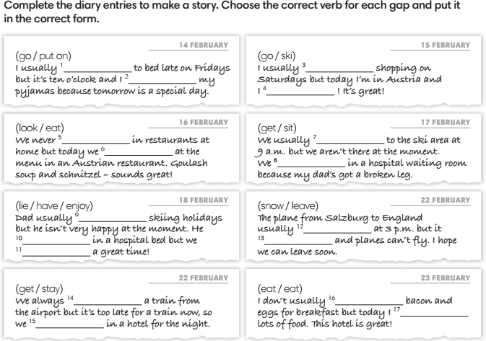
6. Activity 4
Aims: to recall the usage of prepositions.
Quiz corner  - T shows the sentences one by one on the screen.  - Ss work in pairs to write the answers on mini-boards or paper.  - T shows the answers on the screen.  - Ss get the point for correct answers. | Exercise 6 (WB p.41): Complete the sentences with prepositions. (Adaptation)  - in/ on  - behind  - next to/ next to  - in front of  - between
3. Guides for homework:
- Do exercises in Self-check Unit 3 and 4 in Workbook.
- Prepare for Unit 5 lesson 1
**************************************************************

