Preparing date: 25/12/2022
Teaching date: 29 /12/2022

UNIT 5: THE MUSIC OF LIFE
Period 50 - Lesson 5.7: Writing

- Objectives: By the end of the lesson, students will be able to write short messages (texts and tweets).
- Knowledge:
- Vocabulary: common internet abbreviations
- Grammar: Present simple
- Competences:
- Group work and independent working, pair work, linguistic competence, cooperative learning and communicative competence.
- Teaching aids:
- Materials: textbooks, PowerPoint slides, handouts of Teacher’s Resource Book 63
- Equipment: TV, projector, loudspeaker
- Procedure:
- Checking: integrated into Warm-up activity
- New lesson:

Teacher’s and students’ activities | Contents
      - Warm-up
Aims: Attract Ss’ attention to the lesson and lead in the new lesson.
Think-Pair-Share  T prepares the handouts of Teacher’s Resource Book 63. Before the lesson, T should cut the handouts into small paper cards. Each handout is divided into 20 small cards.  T has Ss work in pairs. Each pair receives a pack of 10 cards. They need to use comparatives or superlatives to complete the sentences in the cards with the most suitable words.  After finishing, one student in each pair takes turns to pick up a card and read it. The other gives the answer.  T sets 30 seconds for each round so that Ss can make as many sentences as possible.  After 30 seconds, Ss swap their partners when T says ‘SWAP’.  The game lasts 3 minutes. | Examples:  Name the most relaxing day of the week for you.  Sunday is the most relaxing day of the week for me.  Name someone who usually gets better marks than you in tests.  Minh Anh usually gets better marks than me in tests.

2. Set objectives
Aims: introduce the objectives of the lesson with a can-do statement.
- I can write short messages (texts and tweets).

3. Pre-writing
Aims: activate students’ knowledge about texts and tweets.
Lead-in:  T shows picture A, B and C in SB p. 57.  T asks Ss to work in pairs and answer the questions in Exercise 1.  T tells Ss that they are going to learn how to write short messages (texts and tweets). | Exercise 1. Look at the pictures and answer the questions.  Answers:  He’s/She’s texting.  Text and tweet comparison.  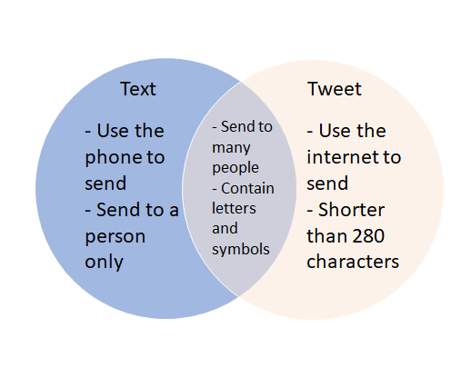
- T lets Ss open SB p. 57 and look at Exercise 2.  - T tells Ss to raise their hands to answer question 1.  - T has Ss work in groups of 3 to discuss questions 2 & 3.  - T calls some groups to share their ideas. | Exercise 2. Answer the questions.  - Answers:  - Yes, I am./No, I’m not.  - I write texts every day.  - Tweeting is better because it doesn’t cost much, and you can talk to a lot of people at the same time.
- T lets Ss open SB p. 57 and look at Exercise 3.  - T has Ss work in pairs to discuss questions 1, 2 & 3.  - T and Ss check their answers. | Exercise 3. In pairs, read the texts and tweets in B and C and answer the questions.  Answers:  - It’s on Friday, April 3rd at 7.30.  - The tickets are £25.  - Isabel Ford likes Alpha Boys. Benjo doesn’t like them.

4. While-writing
Aims: Help Ss practice writing short messages (texts and tweets).
The lucky wheel  - T tells Ss to read the Writing box in Exercise 4 in SB p. 57.  - T shows one text or tweets from pictures B or C at a time.  - Ss work in pairs. They take turns to write out the texts and the tweets in their notebook.  - Two fastest pairs that show the correct sentence get the chance to spin the wheel and get the points. | Exercise 4. Study the Writing box. In pairs, write out the text and the tweets in pictures B and C with all the words.  Answers:  Great news. There’s an Alpha Boys concert at the Brighton Centre on Friday, April 3rd at 7.30. The tickets are £25. You can buy them online. Do you want to go?  Yes! Can you get the tickets for me and my sister, please?  Ok, I can get them later tonight. Bye for now!  Thanks! You are the best. See you tomorrow.  The new Alpha Boys tour starts in April. The first concert is in Brighton. Be there!  I can't wait. Alpha Boys are the best band ever. I love you guys.  I’m laughing out loud. Are you OK? You’re joking, right? Alpha Boys are boring. One Direction are better.
- T tells Ss to read Exercise 5 in SB p. 57.  - Ss work individually to complete the tasks. Then they work in pairs to compare the answers.  - T and Ss check the answers.  - T shows the emojis for Ss to guess the meanings. | Exercise 5. Match emojis 1-5 in the Writing box with meanings a-e.  - Answers: a. 4, b. 2, c. 5, d. 3, e. 1.
- T tells Ss to read Exercise 6 in SB p. 57.  - Ss work individually to complete the tasks. Then they work in pairs to compare the answers.  - T and Ss check the answers. | Exercise 6. Make the sentences shorter. Use the Writing box to help you.  - Answers:  - Want 2 come here l8r?  - Get tickets 4 concert.  - W8 4 me @ bus stop.  - RU OK 2 C us @MORO?  - GR8! THX. BFN.  - CU 2NITE!  - Y RU L8?

Further practice
Aims: Help Ss write more short messages (texts and tweets).
- Ss work in groups of 4 to take turns to write texts and tweets to other groups about the given ideas on paper within 2 minutes.  - All groups swap their texts and tweets. Then they write their reply to the messages they’ve received.  - T monitors and notes the common mistakes to give Ss feedback. | Exercise 7. Write texts and tweets to other groups about the ideas below. Reply to the messages you receive.  - Suggested answers:  A: RU there? U done project yet?  B: Nope.  C: Me2 😞  A: Want 2 go 2 cinema 2MORO?  B: Yes! CU there @ 2.30.  A: OK 😀
- Guides for homework:
- Do exercises 1,2,3 on Student’s Book p.58.
******************************************************************

