Preparing date: 15/1/2023
Teaching date: 18/1/2023

UNIT 6: A QUESTION OF SPORT
Period 56 - Lesson 6.2: Grammar
- Objectives: By the end of the lesson, Ss will be able to use was/ were to talk about events in the past.
  - Knowledge:
- Grammar: was/ were
- Competences:
- Groupwork and independent working, pair work, linguistic competence, cooperative learning and communicative competence
- Teaching aids:
  - Materials: textbooks, PowerPoint slides
  - Equipment: TV, projector, loudspeaker
- Procedure:
- Checking: Integrated into the warm-up activity
- New lesson:
Teacher’s and students’ activities | Contents
1. Warm-up
Aims: to review the previous lesson and lead in the new lesson.
- T writes the word SPORTS vertically on the board and adds words to the first 2 letters.  Examples:  baseball Play O R T S  - T puts Ss into pairs and tells them to add words to the rest of the letters. | Review of Food, drinks and meals vocabulary  Suggested words:  O - score  R - race  T - tennis  S - swimming.
- Set objectives
Aims: introduce the objectives of the lesson with a can-do statement.
- I can use was/ were to talk about events in the past.
- Presentation
Aims: to teach how to use was/ were to talk about events in the past.
Lead-in  T asks Ss to keep their books closed and asks Ss to discuss some questions related to football.  T asks Ss who likes watching football on TV and asks about the World Cup and the names of the current world champions.  After that, T tells Ss they are going to listen to a recording about the first World Cup for women’s football.  T puts Ss into pairs and asks them to look at the words in the table and identify the word forms they need (a number, a month …) | Exercise 1: Read and listen to the interview. Complete the following table.  Answers:  2. China  3. 12  4. Norway vs the USA  5. 63,000  6. the USA
Set the scene  - T says: You’ve read an interview about women’s football. Study the Grammar box and find examples of “was/ were” and “there was/ there were” in the interview.  - When Ss have found the examples in the interview, T asks which verb “was/ were” comes from.  - Ss answer: the verb “to be”  - T points out that “was” is the past form of “is” and “am” and “were” is the past form of “are”. T elicits the correct forms for “I, he, she, it, you, we, they”. | Exercise 2: Study the Grammar box. Find examples of “was/ were” and “there was/ there were” in the interview.  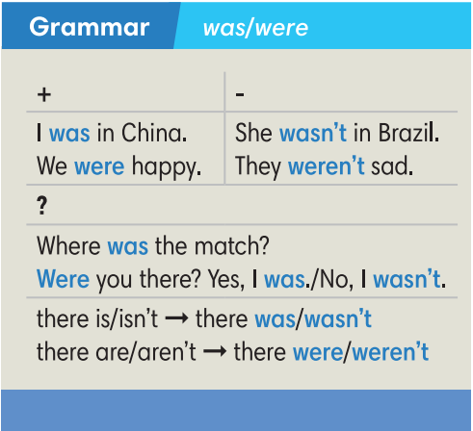
- Practice
Aims: to practice using “was/were” to talk about events in the past.
- T asks Ss to work in pairs to complete the second part of the interview with the correct forms of “was” or “were”.  - T calls some pairs to read the interview.  - T plays audio track 6.03 to check their answers. | Exercise 3: Complete the second part of the interview with the correct forms of “was” or “were”. Listen and check.  Answers:  2. was 3. wasn’t 4. was 5. were  6. weren’t 7. Were 8. was 9. was
- Ss work individually to complete exercise 4. They may swap the books to check with their partners.  - T calls some Ss to go to the board to check their answers. | Exercise 4: Complete the dialogue between Lisa and her gran with the correct forms of “there was” or “there were”.  Answers:  2. there wasn’t 3. there was  4. Were there 5. there weren’t  6. there weren’t 7. there was  8. Was there 9. there was.
- Further practice
Aims: to apply “was/were” in a situation.
- Ss work in pairs to roleplay: one is a grandchild and one is grandpa/ grandma.  - Context: grandchild makes at least 4 questions to ask about grandpa/ grandpa schooldays.  - T walks around to help where necessary.  - T invites some pairs to roleplay in front of the class.  - T and other Ss give comments. | Exercise 6: In pairs, use the questions in Exercise 5 to ask and answer about time when you were a player in a sports match. (Adaptation)  Suggested answers:  A: Were there 50 students in your class?  B: No, there weren’t.
3. Guides for homework:
- Do exercises on Workbook page 53.
- Prepare Lesson 6.3 – Reading and Vocabulary.
******************************************************************

