Preparing date:29/1/2023
Teaching date: 30/1/2023

UNIT 6: A QUESTION OF SPORT
Period 57 - Lesson 6.3: Reading & Vocabulary

    - Objectives: By the end of the lesson, Ss will be able to find specific details in a text and talk about places to play sport.
  - Knowledge:
- Vocabulary (Places to play sport): basketball court, tennis court, football field/pitch, swimming pool, running track.
  - Competences:
- Groupwork and independent working, pair work, linguistic competence, cooperative learning and communicative competence
    - Teaching aids:
  - Materials: textbooks, PowerPoint slides, worksheet
  - Equipment: TV, projector, loudspeaker
III. Procedure:
  - Checking: integrated into the warm-up activity
  - New lesson:
Teacher’s and students’ activities | Contents
  - Warm-up
Aims: to attract Ss’ attention to the lesson and review the previous lesson.
Find the differences  - T shows 2 pictures on Resource 67 worksheet on the screen.  - Ss work in pairs to make as many sentences using was/were to show the differences between 2 pictures as they can in 3 minutes.  - T calls some pairs to share their ideas. | RESOURCE 67 Unit 6 Lesson 2  - 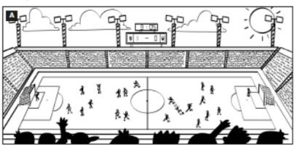  - 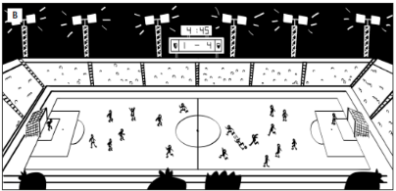  Answers (in any order):  - In picture A it was five past three, but in picture B it is a quarter to five.  - In picture A there were lots of/a lot of people/fans, but in picture B there aren’t (many).  - In picture A the lights were off, but in picture B they are on.  - In picture A there were eleven players on both teams, but in picture B one team has only nine players.  - In picture A the score was 1–0 but in picture B it is 1–4.
- Set objectives
Aims: introduce the objectives of the lesson with a can-do statement.
- I can find specific details in a text and talk about places to play sport.
- Pre-reading
Aims: to get students’ interest in the topic “sports star”.

Set the scene  - T raises the question: What kinds of sports are you interested in?  - Ss discuss with friends to vote for the most popular sports stars in Vietnam. | Exercise 1: Who is the most popular sports star in your country?  The answers may vary.
- While-reading
Aims: to help students practice reading skills with some reading comprehension tasks.
- T elicits the sports shown in the photos before Ss do the exercise.  - T asks Ss to read the texts and complete the exercise individually.  - Ss swap to compare the answers.  - T checks their answers. | Exercise 2: Read the texts and complete the table. If you can’t find the information in the texts, try to guess the answers from the photos.  Answers:  *Age of sportspeople is due to the year the lesson is taught.
   | Country | Sports | Age
  Lan’s mother | Vietnam | swimming | Vary
  Garnine Muguruza | Spain | tennis | Vary
  Dina Asher Smith | Britain | running | Vary
  Kristaps Porzingis | Latvia | basketball | Vary
- T asks Ss to read the texts again and tell Ss that they should look for information in the texts which shown whether the sentences are true or false.  - T explains that if they can’t find the information in the texts, the correct answers are probably “doesn’t say”.  - After that, T elicits the answers and the references from the texts. | Exercise 3: Read the texts again. Match the sentences ✓ (right), X (wrong) or ? (doesn’t say)  Answers:  1. X 2. ✓ 3. ? 4. ✓  5. X 6. ? 7. ✓ 8. ?
- T asks Ss to read all the words in the Vocabulary Box.  - T asks Ss to match the words with the photos.  - T checks by a game: Ss match the definitions to the words. | Exercise 4: Study the Vocabulary Box. Which places can you see in the photos?  Answers:  A. swimming pool  B. tennis court  C. running track  D. basketball court.
Quiz  - T adapts this exercise into a quiz.  - T shows sentences one by one, give some minutes to write the answers in pairs.  - T shows the answers to check. | Exercise 5: In pairs, complete the text with one word in each gap.  Answers:  2. track  3. courts  4. court  5. pool
- Post-reading
Aims: to practice speaking in pairs to talk about favourite sports and sportspeople.
Interview  - Ss find 3 partners to ask and answer the questions in exercise 6, then fill in the table.  - T elicits some expressions to answer the questions.  - Ss complete the task within about 5 minutes.  - T calls some to report to the class. | Exercise 6: In pairs, ask and answer the questions below.  Suggestion:  - My favourite sport is … and my favourite star is …  - Sports stars earn a lot of money. They are very popular.  - Sports stars work very hard. They can get injured.
  Questions | F1 | F2 | F3
  1.
  2.
3. Guides for homework:
- Do exercises on Workbook page 54.
- Prepare Lesson 6.4 – Grammar 2.
******************************************************************

