Preparing date: 29/1/2023
Teaching date: 1/2/2023

UNIT 6: A QUESTION OF SPORT
Period 58 - Lesson 6.4: Grammar

- Objectives: By the end of the lesson, Ss will be able to use Past Simple to talk about events in the past.
  - Knowledge:
- Grammar: Past Simple affirmative ( regular and irregular forms )
- Competences:
- Groupwork and independent working, pair work, linguistic competence, cooperative learning and communicative competence
- Teaching aids:
  - Materials: textbooks, PowerPoint slides
- Equipment: TV, projector, loudspeaker
- Procedure:
  - Checking: integrated into the warm-up activity
- New lesson:
Teacher’s and students’ activities | Contents
  - Warm-up
Aims: to attract Ss’ attention to the lesson and review the previous lessons.
Hot seat  - T shows things related to some sports.  - 4 Ss from 4 big groups play at a time. They are not allowed to see the pictures on the screen. The others do actions as clues for them to guess. | Review of the Sport Vocabulary  Suggested answers: basketball, tennis, football, swimming, running, …
  - Set objectives
Aims: introduce the objectives of the lesson with a can-do statement.
- I can use Past Simple to talk about events in the past.
- Presentation
Aims: to teach Past simple forms with regular and irregular verbs and how to pronounce “V-ed”.
Set the scene  - T shows the photo in the book and introduces the context.  - T plays the audio track 6.05 for Ss to read and listen to find out the sport Sol is doing.  - T goes through the Out of class Box with Ss.  - T asks Ss to explain the expressions in the box. | Exercise 1: Look at the photo. What sport is Sol doing? Listen and check.  - Answers: Sol is jogging/ running.  - Out of class box explanation:  - “Good shot!” is used when someone kicks or hits a ball very well (i.e in football).  - “What’s wrong?” is asked when you see someone sad or ill.  - “Poor you!” is used to show sympathy.  - “When’s it on?” is used to find out about the time of a film at the cinema, a program on TV or a show on the radio.
- T asks Ss to find the verbs in the dialogue: ask, happen, move, start, stop, try, walk, want.  - T elicits regular verbs from these examples.  - T explains to Ss that to put the sentences into Past simple tense we add “-ed” at the end of regular verbs.  - T goes through the examples in the Grammar box with Ss.  - T asks Ss to write the past form of the verbs in the list on the board.  - T asks Ss to try to work out how to spell the past form in the exercise without looking at the dialogue.  - When they are ready, T goes through the correct spelling for each past form and elicits the spelling rules they correspond to. | Exercise 2: Study the Grammar A box. Write the Past Simple form of the verbs below. Find them in the dialogue and check.  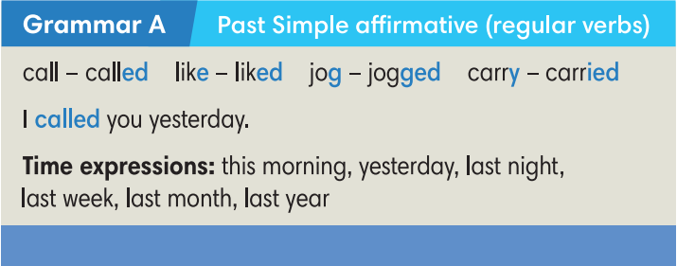  Answers: asked, happened, moved, started, stopped, tried, walked, wanted.
- T discusses the pronunciation rules with Ss.  - T asks Ss to put their fingers against the throat to feel the difference between the vibrations that accompany voiced consonants and the lack of vibrations that accompany voiceless consonants.  - T uses drilling and correction to help Ss to remember the correct pronunciation for the different past form verbs.  - T plays audio track 6.06 for Ss to listen and repeat the words.  Try Me  - T asks Ss to apply spelling rules to change some verbs into Past simple forms.  - Ss work in pairs to sort these regular verbs into 3 categories and practice pronouncing them.  - T checks by odd one out activity. | Exercise 3: Look at the table. Listen and repeat.  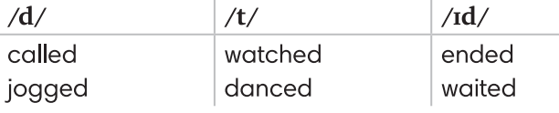  - Verb list: play, cook, work, study, stop, want, arrive, learn, add, look, ask, smile, start, brush, listen, love
- T shows a sentence and asks Ss to decide if it’s true or false and why.  - T elicits irregular verbs.  - T explains that there are no real patterns for irregular verbs, they just need to learn them as individual vocabulary items.  - T asks Ss to try to find the past forms of these irregular verbs in the dialogue. It’s OK if they can’t find them.  - T plays audio track 6.07 for Ss to listen and check. | Exercise 4: Find the Past Simple form of these verbs in the dialogue and complete the Grammar B box. Listen and check.  - Sentence to elicit can be: My dad comed home late yesterday.  - Answers:
  come - came  do - did  get - got  go - went  have - had | put - put  run - ran  see - saw  take - took  win - won
- Practice
Aims: to practice completing sentences with Past simple forms of the verbs.
- T asks Ss to do the exercise individually.  - T tells Ss that if there are any verbs they don’t know the past forms, they can refer to the irregular verbs list on page 110.  - T explains that if they can’t find the verbs in that list, so they are regular verbs.  - T calls some Ss to go to the board and write their answers.  - T plays the audio track 6.08 for Ss to check.  - T elicits the correct answers and checks the pronunciation. | Exercise 5: Complete Lily’s story with the Past Simple form of the verbs in brackets. Listen and check.  Answers:  2. stopped  3. started  4. found  5. saw  6. asked  7. said  8. gave  9. smiled
Pelnalism  - The class play in 4 groups.  - Ss take turns to turn over 2 random cards: one infinitive card and one past form card. If they match, Ss get a point. If they can make a sentence with that verb, they get an extra point. | Teacher Resource’s Book Unit 6_4: Resource 69  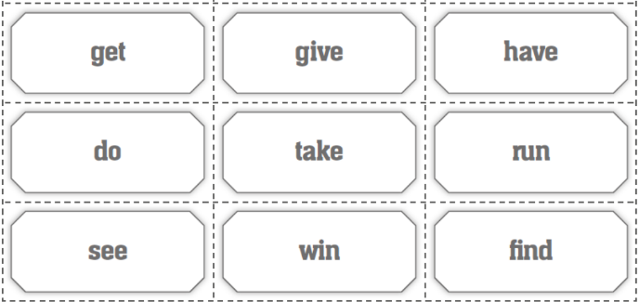  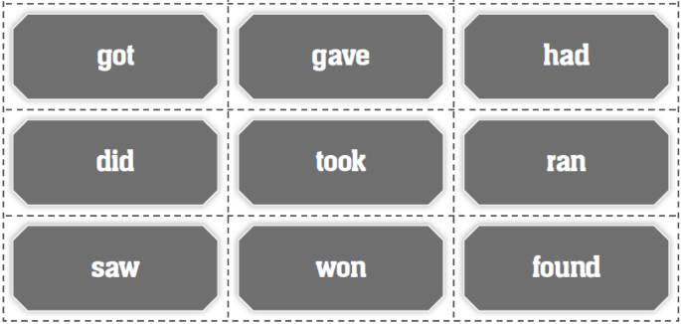
- Further practice
Aims: to write sentences in Past simple forms.
- Each student writes 2 sentences about themselves using Past Simple tense. One sentence is true and one sentence is false.  - T does a demo about how to make wrong sentences.  - Ss walk around the class and read their two sentences for their friends to decide which is true and which is false and identify the wrong information.  - Students get 1 point when their friends make wrong guesses.  - T monitors and helps where necessary. | Exercise 6: Let’s play the truth game! Work in pairs. Go to page 111.  Student A: Write two sentences about yourself in the Past Simple. Make sure one sentence is true. One sentence is false. Read them aloud to Student B.  Student B: Guess the false one. Then change the role.  Suggestion:  A: I went jogging in the park yesterday. I had Pho this morning  B: “You went jogging in the park yesterday” is true. “You had Pho this morning” is false. You had bread.
3. Guides for homework:
- Do exercises on Workbook page 55.
- Prepare Unit 6.5 – Listening and Vocabulary.
******************************************************************

