Preparing date: 5/2/2023
Teaching date: 6/2/2023

UNIT 6: A QUESTION OF SPORT
Period 60 - Lesson 6.6: Speaking

- Objectives: By the end of the lesson, Ss will be able to talk about hobbies and interests.
- Knowledge:
- Vocabulary: sports
- Grammar: Present simple
- Speaking: talk about hobbies and interests
- What are your hobbies and interests?
- What do you do in your free time?
- I go running/cycling.
- I do a lot of judo/sport/dancing.
- I play video games/football.
- I hang out with my friends.
- Are you into sport?
- I’m a big fan of skateboarding/mountain biking.
- I love/I’m interested in/I’m really into extreme sports.
- Not really./I’m not very keen on/I’m not really into sport.
- Competences:
- Groupwork and independent working, pair work, linguistic competence, cooperative learning and communicative competence
- Teaching aids:
- Materials: textbooks, PowerPoint slides, RESOURCE 71 (Teacher’s resource book unit 6_6)
- Equipment: TV, projector, loudspeaker
- Procedure:
- Checking: integrated into the warm-up activity
- New lesson:
Teacher’s and students’ activities | Contents
1. Warm-up
Aims: to attract Ss’ attention to the lesson and review the previous lesson.
Add three  - Ss work in groups of 4.  - T gives each group a Worksheet (RESOURCE 71).  - T guides how to complete the worksheet.  - Ss discuss in groups and complete the task.  - T and Ss check together. | Teacher’s resource book Unit 6_6: Resource 71  Match two of the words below with each verb. Then write three more words of your own for  each verb.  Answers:  play: football, ice hockey (basketball, tennis, golf, cricket, rugby, badminton)  do: aerobics, gymnastics (karate, judo, exercise, archery)  go: cycling, swimming (sailing, jogging, running, walking, climbing, skiing, skateboarding)  win/lose: 3–0, the cup (the tournament, 2–1, 34 points to 17, in the final)  play for: the school team, England (your local club, your country, a new team)  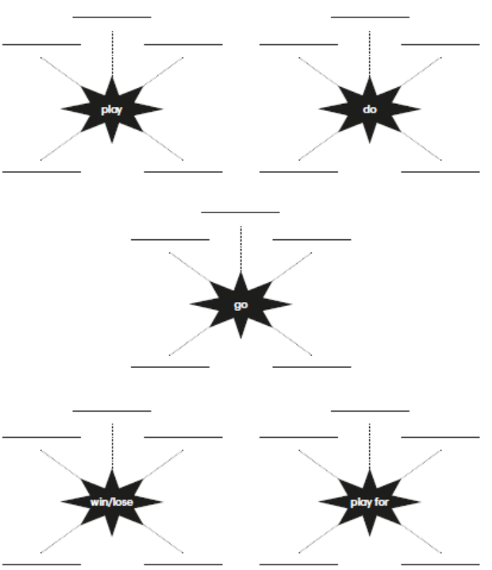
2. Set objectives
Aims: introduce the objectives of the lesson with a can-do statement.
- I can talk about hobbies and interests.
- Pre-speaking
Aims: to learn some phrases to talk about hobbies and interests.
Set the scene:  - T asks Ss if anyone in the class has ever been interviewed for a radio show or by a newspaper reporter.  - Ss answer.  - T asks Ss how they felt when they have been interviewed.  - T asks Ss to look at the photo and answer the questions.  - T elicits the correct answers for Ss. | Exercise 1: Look at the photo and answer the questions. Go to page 112 and check.  Answers:  1. Max is in the skateboard park.  2. He’s talking to a reporter from South radio.
- T asks Ss to listen and read the interview.  - T plays audio track 6.13 for Ss to listen to answer the question in exercise 2.  - T confirms the answer.  - T goes through the Out of class box, explains that we use “to be honest, ...” when we are giving our opinion and know that it might not be what the other person wants to hear. | Exercise 2: Read or listen. What does Max do in his free time?  Answer:  He hangs out with friends, dances, plays football, goes cycling and goes skateboarding.
- T asks Ss to study the Speaking box and underline examples of the phrases in the dialogue.  - T asks Ss to read aloud all the sentences and phrases in the box.  - T points out the meanings of the phrases in the box. | Exercise 3: Study the speaking box. Find examples of the phrases in the dialogue.  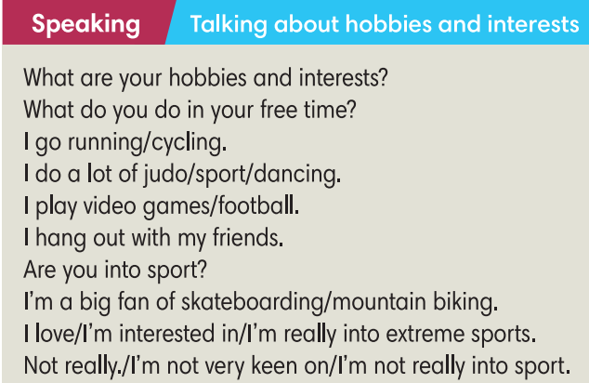
4. While-speaking
Aims: to practise using the phrases to talk about hobbies and interests in context.
- T asks Ss to work in pairs to complete the text.  - T calls some Ss to give their answers and checks for them.  - T asks Ss if anyone in the class is a sports fanatic and explains that word for them. | Exercise 4: In pairs, complete the text with one verb in each gap.  Answers:  2. does  3. goes  4. is  5. is  6. hangs
- T guides Ss how to do this exercise and asks them to do it individually.  - Ss swap their books to compare the answers.  - T confirms the answers.  - T puts Ss into pairs and tells them to roleplay: one plays as Jay and the other gives their own response.  - T calls some pairs to share their unique dialogue. | Exercise 5: Complete the dialogue with sentences a-h. There are 3 extra sentences. Listen and check.  Answers: 2-d, 3-h, 4-a, 5-g
5. Post-speaking
Aims: to act out a dialogue of hobbies and interests.
- T asks Ss to work in pairs to ask and answer questions in a similar way to what was done in Exercise 5.  - T brainstorms some questions they may use in their dialogues.  - T walks around and helps if necessary.  - After 5 mins, T calls some pairs to act out the dialogue.  - T gives feedback. | Exercise 5: In pairs, talk about your hobbies and interests. Tell the class about your partner.  Suggested questions:  - What do you do in your free time?  - Do you do a lot of exercise?  - Do you play for a school team?
3. Guides for homework:
- Do exercises on Workbook page 76.
- Prepare Lesson 6.7 – English in use.
******************************************************************

