Preparing date: 5/2/2023
Teaching date: 8/2/2023

UNIT 6: A QUESTION OF SPORT
Period 61 - Lesson 6.7: English in use

  - Objectives: By the end of the lesson, Ss will be able to use “ago” to talk about events in the past.
  - Knowledge:
- Grammar: the Past Simple.
- Competences:
- Groupwork and independent working, pair work, linguistic competence, cooperative learning and communicative competence
  - Teaching aids:
  - Materials: textbooks, PowerPoint slides
- Equipment: TV, projector, loudspeaker
  - Procedure:
  - Checking: integrated into the warm-up activity
- New lesson:
Teacher’s and students’ activities | Contents
1. Warm-up
Aims: to attract Ss’ attention to the lesson and review the previous lesson.
- T gives Ss a task: compare when you were 7 and you are now.  - Ss work in groups of 4 to brainstorm ideas.  - T elicits the tense to use when they talk about the past and present.  - T walks around to take notes.  - T calls some volunteers to present in the class. | Example:  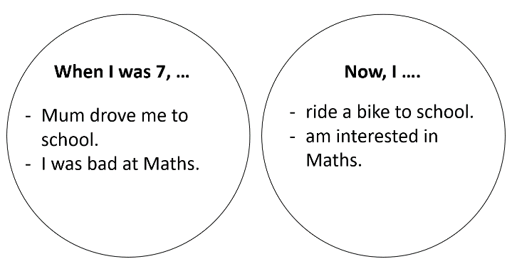
2. Set objectives
Aims: introduce the objectives of the lesson with a can-do statement.
- I can use “ago” to talk about events in the past.
3. Presentation
Aims: to teach how to use “ago” to talk about events in the past.
Set the scene  - People in the past were big fans of sports. Lots of sports today started thousand years ago.  - T shows 2 sets of pictures for Ss to match: set 1 concludes 4 pictures in Exercise 1. Set 2 are there corresponding pictures nowadays.  - T gives 4 phrases to match these pictures: motor racing, team sports, running, weight training.  - T checks if Ss know the meanings of the words “prehistoric”, “Ancient Romans” and “Ancient Egyptians”.  - T asks Ss to open their books and tells them that they are going to find out some interesting events in the past. T asks them to describe the pictures. | Exercise 1: Match pictures A-D with captions 1-4.  Answers:  1. C  2. D  3. A  4. B
- T asks when the events in these pictures took place and elicits the time expressions for Past simple.  - T checks the meaning and use of “ago”. | Exercise 2: Study the Language Box. How do you say the phrases in your language?  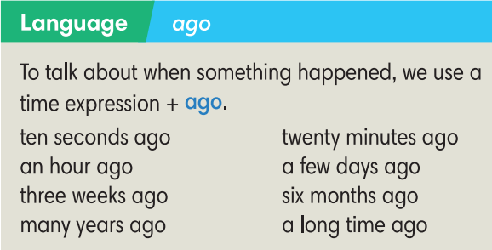
4. Practice
Aims: to practice making sentences with “ago”.
- T guides how to complete Exercise 3.  - Ss work individually then in pairs to compare the answers.  - T confirms. | Exercise 3: In pairs, work out how long ago these things happened.  Answers depend on the year the lessin is taught.
- T puts Ss into pairs and tells them to work together to think of the missing words.  - T explains that the missing words could be grammatical or prepositions or vocabulary items relating to the topic of sports.  - T calls some Ss to go to the board and write their answers.  - T plays audio track 6.15 to check the answers on the board. | Exercise 4: Complete the text with one word in each gap. Listen and check.  Answers:  2. do 3. Ago 4. medal  5. Last 6. Court 7. was  8. for 9. Match 10. Goals 11. of
5. Further practice
Aims: to write sentences about a sports game that students played recently.
- T elicits questions as clues for Ss to write.  - T sets a time limit for the writing and walks around to help if necessary.  - After that, T asks Ss to exchange their writings with their partners.  - Ss check the grammar and vocabulary for their partners.  - T asks some Ss to read aloud their writings.  - T gives feedback. | Exercise 5: Write 5-8 sentences about a sports game that you played recently. You can use the text in Exercise 4 as an example. You may answer these questions:  - How long ago did you play that sport?  - Who did you play with?  - Did you win or lose the game?  - Why did you stop playing that sport?
3. Guides for homework:
- Do Exercise 1,2 Students’ Book page 68; Workbook page 58.
- Prepare Lesson 6.8 – Pronunciation and Review vocabulary.
******************************************************************

