Preparing date: 5/2/2023
Teaching date: 9/2/2023

UNIT 6: A QUESTION OF SPORT
Period 62 - Lesson 6.8: Pronunciation & Review Vocabulary

  - Objectives: By the end of the lesson, students will be able to pronounce 2 sounds /ɪ/ and /aɪ/ and also revise all the vocabulary in Unit 6.
  - Knowledge:
- Pronunciation: 2 sounds /ɪ/ and /aɪ/
- Vocabulary: sports, sportspeople, places to play sports, sports competitions
- Competences:
- Groupwork and independent working, pair work, linguistic competence, cooperative learning and communicative competence
- Teaching aids:
  - Materials: textbooks, PowerPoint slides
- Equipment: TV, projector, loudspeaker
- Procedure:
  - Checking: Integrated into warm-up activity
- New lesson:
Teacher’s and students’ activities | Contents
1. Warm-up
Aims: to attract Ss’ attention to the lesson and review the previous lesson
Quiz  - T adapt exercise 1 into an interactive activity.  - T shows 8 sentences in turns for Ss to write the answer in pairs.  - T shows the correct answers on the screen. | Exercise 3 (p.68): In pairs, complete the sentences with one word. (Adaptation)  Answers:  2. in 3. On 4. of  5. go 6. Does 7. For 8. match
2. Set objectives
Aims: introduce the objectives of the lesson with a can-do statement.
- I can pronounce and distinguish 2 sounds /ɪ/ and /aɪ/ and reinforce the vocabulary in Unit 6.
3. Pronunciation
Aims: to learn how to pronounce 2 sounds /ɪ/ and /aɪ/.
Presentation  - T elicits the sounds of the letter I.  - T shows 2 videos about how to pronounce 2 sounds /ɪ/ and /aɪ/.  - T asks Ss to watch the video and practise the sounds.  Practice  - T plays audio track 6.16 of Exercise 4 twice and asks Ss to listen and find one word in each group with a different pronunciation from the others.  - T elicits the correct answers.  - T plays audio track 6.17 of Exercise 5 and asks Ss to listen and repeat  - T checks for pronunciation.  Further Practice: Cross the river  - T shows a word and Ss decide how the letter “i” is pronounced.  - Ss raise their right hands for /ɪ/ sound and left hands for /aɪ/ sound. | Exercise 4 (p.68): In pairs, listen and find one word in each group with a different pronunciation from the others. Use the underlined letters to help you.  Answers:  1. fit  2. the Olympics  3. biking  Exercise 5 (p.68): Listen, check and repeat.  Wordlist:  - T may choose any words from the list below.  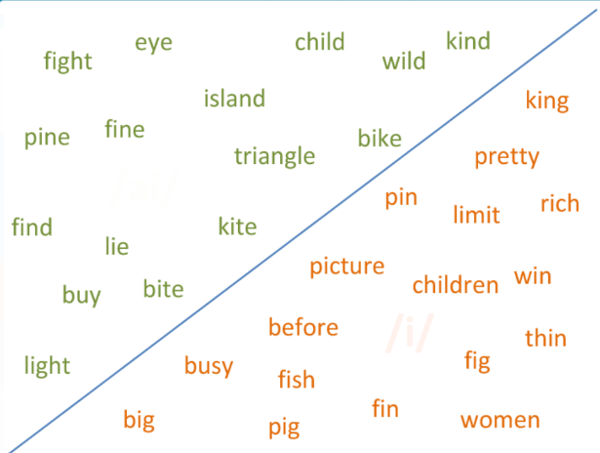
4. Vocabulary
Aims: to reinforce the vocabulary in Unit 6.
- T asks Ss to read the events and the definitions in the exercise and helps them with new words if necessary.  - Ss match the events with the definitions.  Checking: Matching  - T checks by showing 2 rows of words: one is the events and one is their definitions. They are both covered by something else.  - Ss pick up 2 numbers from 2 rows. If they match Ss get points.  Class vote  - T holds a vote for their interest in these events by asking: Do you find these events boring, OK or exciting?  - Ss answer. | Exercise 1 (p.69): In pairs, match the events 1-4 with definitions a-d. Do you find these events boring, OK or exciting?  Answers:  1. b  2. d  3. c  4. a
- T asks Ss to read the sentences in the exercise.  - Ss work individually to do the exercise.  - After 3 minutes, T calls some Ss to give their answers.  - T checks for Ss. | Exercise 2 (p.69): Choose the correct options.  Answers:  1. crowd 2. Team 3. pool  4. score 5. Won 6. Play 7. race
- Guides for homework:
- Do exercise 1,2,3 Workbook page 59.
- Prepare Lesson 6.9 Review grammar.
******************************************************************

