Preparing date: 12/2/2023
Teaching date: 13/2/2023

UNIT 6: A QUESTION OF SPORT
Period 63 - Lesson 6.9: Review Grammar

  - Objectives: By the end of the lesson, students will be able to make sentences with the Past Simple affirmative accurately and talk about hobbies and interests fluently.
  - Knowledge:
- Vocabulary: sports
- Grammar: the Past Simple affirmative, ago
- Competences:
- Groupwork and independent working, pair work, linguistic competence, cooperative learning and communicative competence
- Teaching aids:
- Materials: textbooks, PowerPoint slides, RESOURCE 71 worksheets (Teacher’s resource book unit 6_9)
- Equipment: TV, projector, loudspeaker
- Procedure:
- Checking: Integrated into warm-up activity
- New lesson:

Teacher’s and students’ activities | Contents
1. Warm-up
Aims: to attract Ss’ attention to the lesson and review the previous lesson.
- Ss play in groups of 4.  - Each picks up an event card and a time card, then makes a sentence. The rest of the group decide whether it’s a truth or a lie. If they get correctly, they get points.  - T walks around to help where necessary. | Teacher’s Resource Book Unit 6_9: RESOURCE 74  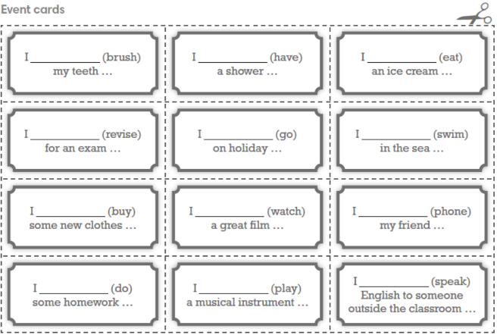  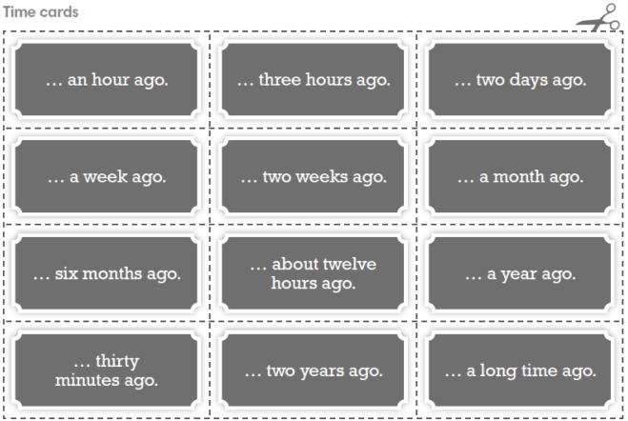
2. Set objectives
Aims: introduce the objectives of the lesson with a can-do statement.
- I can make sentences with the Past Simple affirmative accurately and talk about hobbies and interests fluently.
- Grammar
Aims: to help Ss revise making sentences with the Past Simple affirmative accurately.
- Before doing the exercise, T asks Ss to review the forms of the word “to be” in the past.  - T asks Ss to choose the correct option.  - When the time is up, T asks Ss to swap their answers with their partner to check.  - T elicits the correct answers. | Exercise 3 (p.69): Choose the correct option.  Answers:  2. was 3. were  4. Were there 5. There were  6. Was 7. there  8. wasn’t 9. were  10. was 11. weren’t
Writing race  - T explains the rules of the game: write sentences using word cues in pairs.  - Ss write on their notebooks. They say BINGO when they finish writing a sentence. | Exercise 4 (p.69): Make sentences in the past simple, using the given words. (Adaptation)  Answers:  1. I got up five hours ago.  2. I watched TV this morning.  3. I ran 5 kilometres yesterday.  4. I called a friend last night.  5. I found some money a few days ago.  6. I saw a good film last week.
- T asks Ss to work in groups of 4 to do the exercise.  - T gives examples.  - T asks the groups to race between each other to find out the three fastest groups that can finish the exercise correctly.  - When they have found the three fastest groups, T asks them to write their answers on the board to check.  - T gives feedback and asks Ss to read all the verbs in the past again. | Exercise 5 (p.69): Complete the text with the Past Simple form of the verbs in brackets.  Answers:  2. took 3. won  4. did 5. tried  6. loved  7. jogged  8. played  9. came  10. walked  11. made  12. ate
4. Speaking
Aims: to make a role-play about hobbies and interests.
- T asks Ss to complete the sentences about themselves.  - After that, T asks Ss to work in pairs in 3 minutes to make conversations.  - T walks around to help them if necessary.  - After that, T calls some pairs to act out the role-play in front of the class.  - Other Ss comment, T gives feedback. | Exercise 6 (p.69): Complete the sentences below about yourself. Then work in pairs. Ask and answer about each other’s hobbies, using the following sentences.  A: What do you do in your free time?  B: I often go swimming. What are you interested in doing in your free time?  A: I’m into playing chess.
3. Guides for homework:
- Do exercises 4,5,6 in the workbook on page 59.
- Prepare for Review 3 (Unit 5 + 6).
Teaching date: 14/03/2022
******************************************************************

