Preparing date: 12/2/2023
Teaching date: 15/2/2023

Period 64: REVIEW 3 ( UNIT 5+6 )

- Objectives: Students will be able to revise and practise all the vocabulary and grammar in Units 5 + 6.
- Knowledge:
- Vocabulary and grammar of Unit 5 + 6
- Competences:
- Groupwork and independent working, pair work, linguistic competence, cooperative learning and communicative competence
- Teaching aids:
- Materials: textbooks, worksheet, PowerPoint slides
- Equipment: TV, projector, loudspeaker
- Procedure:
- Checking: integrated into the warm-up activity
- New lesson:
Teacher’s and students’ activities | Contents
1. Warm-up
Aims: to attract Ss’ attention to the lesson and review the previous lesson.
Hangman  - T shows the words with blank one by one.  - Ss guess the letters to find the words. | Complete the types of music (Exercise 2 – SB p.58)  - It’s a kind of music. (hip-hop)  - It’s a musical instrument. (accordion)  - It’s a type of sport. (ice hockey)  - It’s a sportsperson. ( cyclist)
2. Vocabulary
Aims: to review vocabulary in Units 5 and 6.
- T asks Ss to work in 4 groups and give each group a small board.  - T asks Ss to remember the words about sports, types of music and musical instruments.  - T gives the topics one by one and asks Ss to write the words.  - The fastest group with correct answers will get 1 point for their group.  - T continues with other topics. | Possible topics and examples:  1. Three sports with races: motor racing, mountain biking, running, …  2. Four ball sports: basketball, football, hockey, table tennis, tennis, volleyball, …  3. Five sportpeople: champion, footballer, reporter, sports fan, sports star, …  4. Six sport places: football field/ pitch, gymnasium, running track, sports center, stadium, tennis court, …  5. Six types of musical instruments: piano, guitar, saxophone, trumpet, accordion, drum, harmonica,…  6. Four types of music: rap, classical, rock, ballad, jazz,…
- T asks Ss to read the sentences in the exercise.  - T asks Ss to work in pairs to do the exercise.  - There may be more than one correct answer for each sentence. | Exercise 2 (WB p.50) Complete the words in the review.  Answers:  - Fantastic 2. brilliant  3. gorgeous/ great 4. terrible  5. bad/ boring 6. Cool 7. alright
3. Grammar
Aims: to revise and practise all the grammar points in Unit 5 + 6
- Before doing the exercise, T asks Ss to review the superlative forms of the adjectives.  - T asks Ss to read all the adjectives in the brackets and decide which adjectives are short/long adjectives.  - SS discuss and do the exercise on their own.  - After that, T asks some Ss to give their answer and check for them.  - T asks Ss to work in pairs to ask and answer the questions in the exercise.  - Then T calls some pairs to talk in front of the class. | Exercise 5 (SB p.59): Complete the question with the superlative forms of the adjectives in the brackets. In pairs, ask and answer the questions.  Answers:  2. the funniest  3. the most talented  4. the nicest  5. the fittest  6. the most interesting  7. the best  8. the most successful.
- T tells Ss that they are going to play a board game with a coin and a counter (a small piece of paper would be fine).  - The rules are that students flip the coin and if it lands ‘heads’ up, they move two places on the board; if it lands ‘tails’ up, they move one place.  - Explain that if a player lands on a numbered square, they have to choose the correct option and then ask the completed question to the other two students in the group, who both have to answer. If a player lands on an unnumbered square, they have to use their imagination to complete the sentence.  - The student to the player’s left has to start from that same square, not from the start, and the process is repeated.  - Rather than being a competitive game to see which student can finish first, the idea of the game is that students take turns to move the whole group through the board.  - Put students into groups of three, and hand out a worksheet, a coin and a counter to each group.  - When the groups have reached ‘FINISH’, invite them to ask and answer some of the questions in front of the class. | Teacher’s Resource Book Unit 6_11: RESOURCE 76  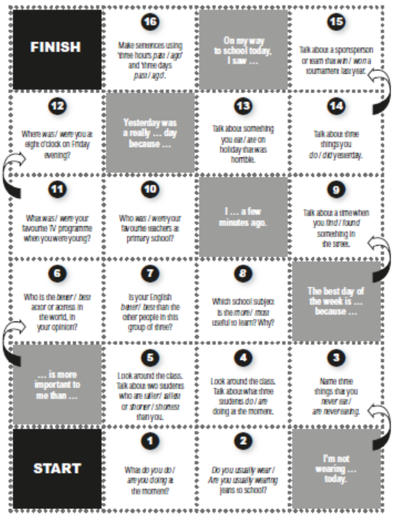
3. Guides for homework:
- Do Exercises of Unit 6 in Workbook pages 50 and 59.
- Prepare for the next Unit.
******************************************************************

