Preparing date: 12/2/2023
Teaching date: 16/2/2023
UNIT 7: THE TIME MACHINE
Period 65 - Lesson 7.1: Vocabulary

I. Objectives: By the end of the lesson, Ss will be able to talk about technology and important moments in the past.
1. Knowledge:
- Vocabulary: talking about history, computers and Information Technology.
2. Competences:
- Groupwork and independent working, pair work, linguistic competence, cooperative learning and communicative competence
II. Teaching aids:
1. Materials: textbooks, PowerPoint slides, worksheets
2. Equipment: TV, projector, loudspeaker
- Procedure:
1. Checking: integrated into the warm-up activity
2. New lesson:
Teacher’s and students’ activities | Contents
1. Warm-up
Aims: to attract Ss’ attention to the lesson and review the previous unit.
- T gives Ss a set of time cards and asks them to put these cards in order of time.  - Ss work in groups of 8 and make sentences with the time cards.  - The winner is the team that finishes fastest with the most correct sentences.  - For stronger class: T may require the numbers of words in a sentence, for example, there are at least 7 words in a sentence. | 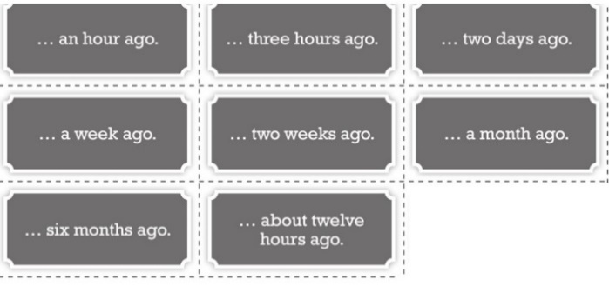  - Example: I had a big breakfast an hour ago.
2. Set objectives
Aims: introduce the objectives of the lesson with a can-do statement.
- I can talk about technology and important moments in the past.
3. Presentation
Aims: to teach some dates phrases to talk about the history and phrases about computers and Information and Technology.
Set the scene  - T says: “We have just discussed what we did some times ago, now we are going to find out more phrases in the past.”  - T asks Ss to read the words in the box chorally and gives them more background knowledge about the years and century.  - T asks Ss to order the phrases from the oldest to the most recent.  - T elicits the correct answers. | Exercise 1: Study the Vocabulary A box. How do you say the phrases in your language? Order the phrases (1-the oldest, 6-the most recent).  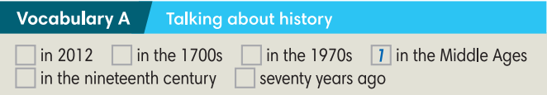  Answers:  1. in the Middle Ages 2. in the 1700s  3. in the nineteenth century  4. seventy years ago 5. in the 1970s  6. in 2012
4. Practice
Aims: to help Ss practice the Past Simple and teach words about Computer and Information Technology.
- T asks Ss to read the texts on the website and underline the time mentioned.  - Ss order the events on the timeline.  - T elicits the correct answers and provides the exact years the events happened.  - T asks Ss to work in pairs to discuss which they think was the most important event.  - When they have finished, T invites pairs to share their ideas and give reasons why. | Exercise 2: Read the texts on the website and put the ideas on this timeline. In pairs, say which idea you think was the most important.  Answers:  A. 3 (1543)  B. 1 (1865)  C. 2 (1910)  D. 4 (1981)
- T asks Ss to look at the highlighted irregular Past Simple forms in the texts and match them with the infinitives in Exercise 3.  - T sets a time limit for Ss to answer.  - T elicits the correct answers. | Exercise 3: Look at the highlighted irregular Past Simple forms in the texts. Match them with the infinitives below. How do you say the verbs in your language?  - Answers:
  become-became  begin-began  buy-bought  write-wrote | sell-sold  think-thought  understand-understood
- T asks Ss to work in pairs to complete the blog post with the Past Simple forms of the verbs in brackets.  - T calls some pairs to give their answers.  - T elicits the answer.  - T asks Ss to discuss which date they think is the most important and give reasons why.  - T calls some Ss to give their ideas.  Challenge  - T divides the class into 2 big groups and gives each student a piece of paper.  - Ss in group 1 write sentences using infinitive verbs in exercise 3 and Present simple. The rest write sentences using the Past simple forms of the verbs in exercise 3. Each St writes one sentence with a random verb.  - After they have finished, T lets Ss swap paper and change the sentences into Past/ Present simple.  - Ss find partners to share their sentences when they finish. | Exercise 4: Complete the blog post with the Past Simple form of the verbs in brackets. Which of the dates was most important in your opinion?  Answers:  2. became 3. Became 4. began  5. wrote 6. Could 7. sold  8. bought 9. could  - T’s guidance for the Challenge game:  - I/She/ … usually …….  - Today I/she/…. …….
- T asks Ss to study the words in the Vocabulary B box and read the words chorally.  - T asks Ss to guess the meanings of the words, using the words/phrases in the blog post.  - T explains more for Ss if necessary.  - Ss discuss and explain. | Exercise 5: Study the words in Vocabulary B box. These words are highlighted in the blog post in Exercise 4. Find the words/ phrases in the blog post that can help you guess the meanings of these words.  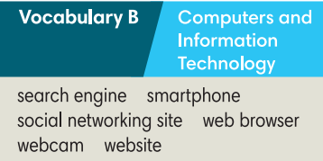  The words/phrases can help Ss find the meanings of the words:  - Web browser: the World Wide Web  - Webcam: a camera  - Search engine: Google  - Website: Wikipedia  - Social networking site: Facebook  - Smartphones: phones to get on the web, play games, take photos and watch videos.
- Further practice
Aims: to talk about favourite search engine, website to study English and social networking site.
- T explains the activity “Class survey” to Ss.  - Ss interview three students in the class using the questions in the table and write the names and answers in the columns.  - T encourages Ss to interview 3 friends who don’t sit next to them.  - T may make an example for Ss.  - T sets a time limit for Ss to the activity.  - T asks Ss to report the results of their survey.  - T corrects for Ss.  - Then the whole class finds out the most interesting answers at the end of the task. | Exercise 6: Interview three students in your class using the questions below. Write the names and answers in the column. Then report to the class.  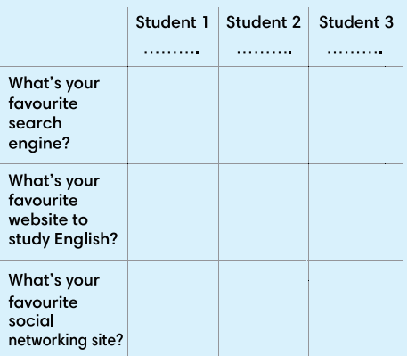
- Guides for homework:
- Do exercises on Workbook pages 60-61.
- Prepare Lesson 7.2 – Grammar 1.
******************************************************************

