Preparing date: 19/2/2023
Teaching date: 23/2/2023
UNIT 7: THE TIME MACHINE
Period 68 - Lesson 7.4: Grammar

I. Objectives: By the end of the lesson, Ss will be able to use Past Simple to ask and answer questions about the past.
  - Knowledge:
- Grammar: Past Simple (questions and short answers)
2. Competences:
- Groupwork and independent working, pair work, linguistic competence, cooperative learning and communicative competence
II. Teaching aids:
  - Materials: textbooks, PowerPoint slides
2. Equipment: TV, projector, loudspeaker
III. Procedure:
  - Checking: integrated into the warm-up activity
2. New lesson:
Teacher’s and students’ activities | Contents
1. Warm-up
Aims: to attract Ss’ attention to the lesson and review the previous lesson.
What should I use?  - T uses Teacher’s resources Unit 7_3 as reference.  - T shows the questions or situations on the screen.  - Ss raise their hands to give the answers. | Review of Everyday technology Vocabulary  Teacher’s resources Unit 7_3.  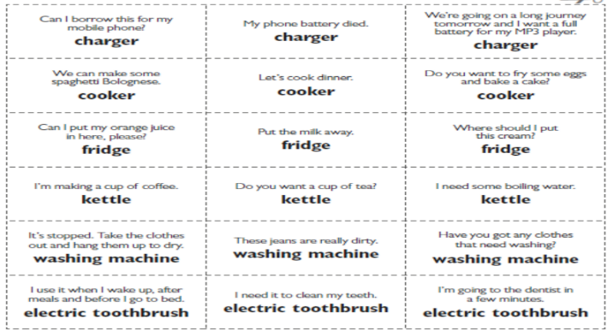
  - Set objectives
Aims: introduce the objectives of the lesson with a can-do statement.
- I can use Past Simple to ask and answer questions about the past.
3. Presentation
Aims: to teach how to make questions and answer them using Past simple.
Set the scene  - T shows the photo in the book and asks Ss to look at the photo to find out what Max’s dad is saying.  - Ss quickly find the answers by skimming the dialogue. | Exercise 1: In pairs, look at the photo. What do you think Max’s dad is saying?  Answers:  Dad is probably annoyed that Max and Lily are having breakfast late.
- T keeps Ss in pairs and asks them to discuss the question.  - T plays the audio track 7.02 and asks them to read the dialogue and listen carefully to answer the question in exercise 2.  - T checks that Ss know the meaning of “exaggerate”.  - T asks Ss if their parents ever exaggerate about what life was like when they were young. | Exercise 2: Listen. Why did Max’s dad get up early when he was a teenager?  - Answer: Max’s dad got up early because he had a job.  - exaggerate: to make something seem larger, better, worse or more important than it really is.
- T asks Ss to study the Grammar box and find examples of Past Simple questions and short answers in the dialogue.  - T elicits how we form Past Simple questions and short answers.  - T explains the forms of the questions and short answers.  - Ss listen and write down the forms. | Exercise 3: Study the Grammar box. Find examples of Past Simple questions and short answers in the dialogue.  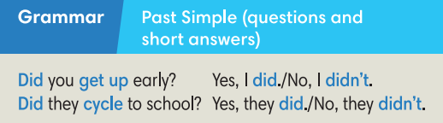
3. Practice
Aims: to practice making Past Simple questions and short answers.
Writing race  - T reviews the order of the words in Yes/ No questions.  - Ss work in pairs to reorder the words they see on the screen to make questions. They may say BINGO when they finish.  Paper – Rock – Scissors  - Ss ask and answer the questions they’ve written in pairs.  - They play paper – rock – scissors after a turn. The winner gets 1 point.  - The students who finish asking and answering 6 questions within 2 minutes are the winner of the game. | Exercise 4: In pairs, order the words to make questions. Ask and answer questions about your mornings.  Answers:  2. Did you get up early?  3. What did you have for breakfast?  4. Did you have a shower?  5. Did you walk to school?  6. What time did you arrive at school?
- T asks Ss to work individually to do the exercise.  - T reminds Ss to use the form of Past Simple questions and short answers to do it.  - After that, T calls some Ss to give their answers on the board.  - T checks for them and explains more if necessary. | Exercise 5: Complete the questions with the Past Simple forms of the verbs below.  Answers:  2. did, go  3. Did, have  4. Did, live  5. did, do  6. did, come.
Pelnalism  - T explains the rule of the game: there are 12 squares which are named from 1 to 6 and a to f. Ss pick up a number and a letter. If they match, Ss get points. | Exercise 6: Match questions 1-6 in Exercise 5 with answers a-f.  Answers:  2-a, 3-c, 4-e, 5-f, 6-d.
4. Further practice
Aims: to ask and answer questions in Past Simple forms.
Find someone who…  - T gives each student a worksheet.  - T elicits how to make questions from the table.  - T explains that Ss add 2 more questions to ask their friends.  - T walks around to help where necessary.  - Ss report when they finish. | Exercise 7: In pairs, ask and answer the questions in Exercise 5. Tell the class about your partner.  Minh learnt English at primary school. Huyen lived in HCM city when she was little….
  Find someone who…
  1. learn English at primary school?
  2. live in a different place when he/she was little?
  3. his/ her mum drive him/her to school when they were at primary school?
  4.
  5.
3. Guides for homework:
- Do exercises on Workbook page 64.
- Prepare Unit 7.5 – Listening and Vocabulary.
******************************************************************

