Preparing date:12/3/2023
Teaching date:13/3/2023

UNIT 8: TALKING TO THE WORLD
Period 75 - Lesson 8.2: Grammar

- Objectives: By the end of the lesson, students will be able to use have to/don’t have to and mustn’t to talk about cultural rules.
- Knowledge:
- Vocabulary: cultural rules and customs
- Grammar: have to/don’t have to and mustn’t
- Competences:
- Group work and independent working, pair work, linguistic competence, cooperative learning and communicative competence

Teaching aids:
- Materials: textbooks, PPT slides, Teacher’s Resource Book 92
- Equipment: TV, projector, loudspeaker
- Procedure:
- Checking: integrated into Warm-up activity
- New lesson:
Teacher’s and students’ activities | Contents
- Warm-up
Aims: Attract Ss’ attention to the lesson and lead in the new lesson.
Brainstorm  - T gives Ss the topic “Geography” and elicits the subtitle “weather, countries, nature, continents”.  - Ss work in groups of 4. Each group receives an A4 sheet of paper.  - Ss work together to write as many words related to the topic. T gives Ss the suggested categories (weather, countries, natures, continents).  - T gives Ss 3 minutes to complete the task.  - All groups swap their answers. T and Ss check. | - Suggested answers:  - weather: cold, snowy, hot  - countries: Japan, Germany, UK  - nature: mountains, rivers, lake  - continents: Asia, Europe
- Set objectives
Aims: introduce the objectives of the lesson with a can-do statement.
- I can use have to/don’t have to and mustn’t to talk about cultural rules.
- Presentation
Aims: teach Ss how to use have to/don’t have to and mustn’t to talk about rules.
- T shows the picture in Exercise 1 in SB p. 82  - T asks Ss to work in pairs to answer some questions to elicit information.  - T might explain the words ‘Culture shock’.  - T shows the phrases in Exercise 1 in SB p. 82.  - T and Ss explain the meanings of these phrases.  - T has Ss listen to audio track 8.02 and read paragraph A of the text. T might explain the word ‘siesta’.  - T asks Ss to name the countries mentioned in paragraph A then decide which has the most surprising rule | Exercise 1. Check if you understand the phrases below. Read Paragraph A of the text. Which country has the most surprising rules?  - Suggested questions and answers.  - What do you see in the picture?  → I see a bus and a lot of people.  - What are the people doing?  →They are lining up to get on the bus.  - What is the young man with an orange bag doing?  → He is not waiting in line.  - How do other people feel? How do you know about that?  → I think they are surprised. Because the man might do something different and I also see the words ‘Culture shock’.  - Culture shock: an (unpleasant) experience a person may have when one moves to a cultural environment that is different from one's own.  - Phrases explanation:  - accept a present: receive a present from someone else  - jump the queue: move to the front of a line of people who are waiting for something, so that you are served before them.  - wait in a queue: line up to wait for something  - siesta: nap (a short sleep, especially during the day)  - Countries: China, the USA, Spain, Britain, Germany, Australia, Egypt.
- T asks Ss to study the Grammar box in Exercise 2, SB p. 82.  - T shows the differences of usages in a Venn diagram.  - use have to and must to express obligation  - use don’t have to to show that there is no obligation (a lack of obligation)  - use mustn’t to express prohibition.  - T asks Ss to find more examples in paragraph A.  - T elicits the forms from Ss. | Exercise 2. Study the Grammar box.  - The usages:  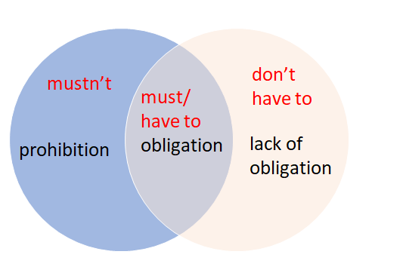  - The forms:  - must/mustn’t + V (infinitive)  - have to/don’t have to + V (infinitive)
- Practice
Aims: Help Ss practise making sentences with have to/don’t have to and mustn’t to talk about cultural rules.
- T tells Ss to look at Exercise 3 in SB p. 82.  - Ss work in pairs to complete the sentences in paragraph B of the text.  - T has Ss listen to the audio 8.03 to check the correct answers. | Exercise 3. Read paragraph B of the text and choose the correct option. Listen and check.  - Answers:  - have to  - don’t have to  - mustn’t  - have to  - don’t have to  - mustn’t
Keep or give the box  - T shows suggested words on the slide and asks Ss to complete sentences with have to, don’t have to or mustn’t.  - Ss work in pairs to write the answers on their paper.  - The first pair finishes can read the answer for the T. T and other Ss check the answer.  - Then the winners can decide to keep or give the box to their friends.  - The points in the box can be plus or minus. | Exercise 4. Adaptation.  - Answers:  - You don’t have to queue at the bus stop when you’re the only person there.  - You have to say ‘please’ and ‘thank you’ a lot.  - You mustn’t forget to say ‘thank you’ when someone opens a door for you.  - You don’t have to say ‘please’ and ‘thank you’ in a cafe’.  - You have to give a friend two kisses when you meet.  - You mustn’t forget to kiss everyone goodbye.
- T tells Ss to look at Exercise 5 in SB p. 82.  - Ss work individually to match the sentences with the notices. Then Ss work in pairs to check.  - After the time is up, T and Ss check the answers together.  - THINK BIG: T asks Ss to list where or when they can use modal verbs (mustn’t, have to, don’t have to) to talk about the rules. Ss give 1 or 2 rules for each situation. | Exercise 5. Match sentences 1-5 with notices A-E.  - Answers:  - B  - C  - D  - A  - E  - Suggested dialogue:  A: My turn. Number 1 - You have to walk here. What notice is it?  B: It’s notice B.  A: Yes. It’s correct.  - Situation: at school, on the street, in the park, in the supermarket, in the museum…
- Further practice
Aims: Help Ss apply ‘have to’, ‘don’t have to’ and ‘mustn’t’ to talk about their rules in real life.
Pair work  - Ss work individually to complete the sentences in Exercise 6 in SB p. 82.  - Ss work in pairs to talk about what they must/have to or don’t have to in daily life.  - Ss can swap their partners several times.  - T monitors and gives feedback. | Exercise 6. In pairs, complete the sentences with ‘have to’, ‘don’t have to’ and ‘mustn’t’ so they are true for you. In pairs, compare your answers.  - My turn. My school is very strict. I mustn’t be late for school. What about you?  - Me too. I have to take a bus to school at 6.30 every day.
- Guide for homework:
- Do exercises on Workbook page 71.
- Prepare Unit 8 Lesson 3 - Reading & Vocabulary.
***************************************

