Preparing date: 19/3/2023
Teaching date: 23/3/2023

UNIT 8: TALKING TO THE WORLD
Period 80 - Lesson 8.7: Writing

- Objectives: By the end of the lesson, students will be able to use should/shouldn’t + V to give advice about online safety.
- Knowledge:
- Vocabulary: online safety rules
- Grammar: should/shouldn’t + V (infinitive)
- Competences:
- Group work and independent working, pair work, linguistic competence, cooperative learning and communicative competence.
- Teaching aids:
- Materials: textbooks, paper, PowerPoint slides
- Equipment: TV, projector, loudspeaker
- Procedure:
- Checking: integrated into Warm-up activity
- New lesson:

Teacher’s and students’ activities | Contents

Warm-up
Aims: Attract Ss’ attention to the lesson and lead in the new lesson.
Think – Pair – Share  - T prepares some small pieces of paper.  - T gives each student a piece of paper. He/she uses ‘have to/don’t have to/mustn’t’ to write 4 rules to follow at his/her home.  - After finishing, students in each pair take turns to share their ideas.  - T sets 30 seconds for each round.  - After 30 seconds, Ss swap their partners when T says ‘SWAP’.  - The activity lasts 1-2-3 minutes. | - Examples:  - I have to wash my hands before eating.  - I have to feed the dog every day.  - I don’t have to get up early at weekends.  - I mustn't visit my friends without telling my parents beforehand.

Set objectives
Aims: introduce the objectives of the lesson with a can-do statement.
- I can use ‘should/shouldn’t’ to give advice about online safety.

Presentation
Aims: teach Ss how to use should/shouldn’t in sentences.
2 – 1 – 1  - T introduces 3 questions in Exercise 1.  - Ss answer themselves then find 2 boys and 1 girl to ask and answer. Then they should take note of information of one of them.  - T tells Ss to explain the reason for question 3.  - T calls some Ss to share their ideas. | Exercise 1. In pairs, ask and answer the questions.  - Suggested answers:  - I use the Internet every day.  - My favourite website is Wikipedia.  - Yes, I do. Because I want my friends to see how cool my life is./ No, I don’t. Because I don’t want any stranger to know where I live or what I’m doing. It’s too dangerous.
- T elicits the topic “Staying safe online”.  - T lets Ss open SB p. 87 and look at Exercise 2.  - T tells Ss to work individually to complete the task.  - T asks Ss to give reasons for their choices.  - T and Ss check the correct answers.  - T lets Ss read the Language box. From the examples in Exercise 2 and the Language box, T elicits the meaning, usage and the form of ‘should/shouldn’t + V’ structure.  - T should remind Ss of the correct pronunciation of the words ‘should’ and ‘shouldn’t’. | Exercise 2. Read the advice form Safety Net Kids website and decide whether the following statements are True or False.  - Answers:  - True  - False  - True  - True  - False  - Phrases to give advice:  - You should tell your parents …  - You should make friends …  - You should think …  - You shouldn’t tell …  - You should only post ...  - The usage: We use should/shouldn’t to tell someone what he/she is expected to do or not to do.  - The form: S + should/shouldn't + V (infinitive)  - Note: shouldn’t = should not

Practice
Aims: Help Ss practice making sentences with “should/shouldn’t”.
- T lets Ss look at Exercise 3.  - T use either should or shouldn’t + verb to complete the task individually.  - T and Ss check the correct answers.  - T has Ss work in pairs to practice reading the conversations. | Exercise 3. Read and complete the following conversations with either should or shouldn’t + verb.  - Answers:  - shouldn’t befriend  - shouldn’t provide
Mario game  - T shows a picture and some suggested words.  - Ss work in pairs. They take turns to use either should or shouldn’t + verb to write the correct advice for each picture. | Exercise 4. Look at the pictures and write some advice about Internet safety under each picture using either should or shouldn’t + verb.  - Answers:  - You should think before you post.  - You should keep your personal information private.  - You should be nice to people.  - You should keep your password safe.  - You shouldn’t meet someone you’ve met online in person.

Further practice
Aims: Help Ss practice giving advice using ‘should/shouldn’t + V’.
- Ss work in groups of 4 to create a poster to give advice about Internet safety.  - Ss have to draw and use the structure ‘should/shouldn’t + V’ to write at least 4-6 pieces of advice.  - T lets all groups present their posters in front of the class.  - T monitors and notes the common mistakes to give Ss feedback. | Exercise 5. Work in groups of four. Create a poster to give advice about Internet safety. present your poster to class.  - Suggested answers:  - You should keep your personal information private.  - You should check your privacy settings.  - You should know how to report posts.  - You shouldn’t meet anyone you’ve met online in person.  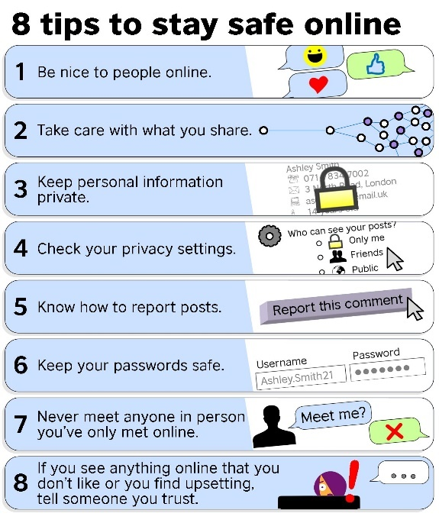
- Guides for homework:
- Do exercises 1&2 on Student’s Book p.88.
- Prepare Unit 8 Lesson 8.8.
**************************************************

