Preparing date: 16/4/2023
Teaching date: 18/4/2023

UNIT 9: GREETING AROUND
Period 89 - Lesson 9.6: Speaking
I. Objectives: By the end of the lesson, Ss will be able to ask for and give directions.
1. Knowledge:
Excuse me. Where’s the….? How do I get to…..?
Is there a ….. near here? There is a ….in ….street.
Go to the end of the road. Go straight on.
Go past the… Turn left/right…
It’s next to/opposite the…
2. Competences:
Groupwork and independent working, pair work, linguistic competence, cooperative learning, and communicative competence
II. Teaching aids:
1. Materials: textbooks, PowerPoint slides
2. Equipment: TV, projector, loudspeaker
III. Procedure:
1. Checking: integrated into Warm-up activity
2. New lesson:
Teacher’s and students’ activities | Contents
1. Warm-up
Aims: to recall words to describe people that they've learned in this unit.
Guessing game  T divides the class into 2 groups and lets them play a small game: Guessing game  T gives 3 pictures related to London (one by one) and asks “Which city is this?  Ss guess the name of the place and explain their guess. | - It’s London.
2. Set objectives
Aims: To introduce the objectives of the lesson with a can-do statement.
I can ask for and give directions.
3. Pre-speaking
Aims: to get students’ interest in the topic.
T leads students into the lesson by showing a photo of Max, Sol, and Eva and asks Ss some questions:  Where are they?  What are they looking for?  Why are they worried?  Why aren’t they in the car?  T checks that Ss understand the meaning of audition.  T plays the audio.  When the Ss have listened to the audio, T elicits the answers to the questions and what is happening in the photo. | Exercise 1: Listen to Part 1. Why do Max, Eva  and Sol decide to get out of the car?  - They are in London.  - They are looking for theater.  - They could be late.  - They decide to get out of the car because the sat-nav isn’t working.
T asks Ss one more question: Are they near the theater?  T asks Ss to read the dialogue and checks that they understand left, right, and traffic lights.  T elicits the answer.  T discusses the Out of class box with students, asks if they can guess what sec is short for (second). T elicits other phrases that are similar to this. (Just a minute, Just a moment)  T asks Ss when they think they would say Good thinking! to someone. (when someone has had a good idea). | Exercise 2: Read or listen to Part 2. Are they  far from the theatre?  - Answer: No, they aren’t.
T goes through the different phrases in the Speaking box.  T asks Ss to find an example of the phrases in the dialogue.  T discusses what each of the phrases means and the use of prepositions (Turn left at the crossroads, turn left into…, on the left)  T points out that we say Take the first turning on the left but Turn left.  Finding friends  T tells Ss to look at the map in Exercise 5 and read instructions in the dialogue.  T asks Ss to work in groups and asks Ss where Max, Sol, and Eva could be.  Which the first group to have the correct answer wins the game. | Exercise 3: Study the Speaking box. Find the phrases in the dialogue.  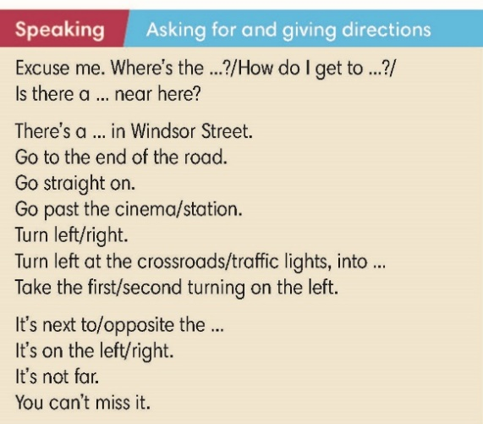  - They are on Tufnell Park Road.
- While speaking
Aims: to practice using words and phrases to ask for and give directions.
T tells Ss to complete exercise 4 on their own.  T asks Ss to listen to audio track 9.11 and check their answers.  T invites a student to come to the board and gives an instruction: Go to the end of the road. The student draws a road that comes to an end at a T-junction.  T asks the student to draw arrows to show the direction of movement.  T invites the second student to come to the board and gives another instruction: Turn left. The student draws an arrow turning left from the first road into the second one.  T repeat the process with different students and these instructions in Exercise 4:  Go past the library (the student draws a library and an arrow going past it)  Take the third turning on the left. (the student draws three roads on the left and an arrow pointing down on the third)  On the left. (the student should draw a cross on the left of the road they are in) | Exercise 4: Complete the dialogue with words from the Speaking box. Listen and check.  Answers:  end  Turn  past  Take  on  not  3  4 2  5   1
T asks Ss to find National Youth Theater on the map in Exercise 5.  T plays audio track 9.12 and asks Ss to follow instructions on the map to find where Dad parked his car.  T elicits the answers. If any Ss have a different answer, T asks a student with the correct answer to use the phrases in the Speaking box to explain how they found Dad’car. | Exercise 5: You’re outside the National Youth  Theatre. Find it on the map. Listen again. Where did Dad park his car?  Answer: The car is on Tavistock Terrace
- Post speaking
Aims: to apply expressions in the Speaking box in real situations.
T asks students to work in pairs and look at the map in Exercise 5.  Before the pairs begin, T tells the Ss that as they are giving the instructions, they should rotate their books so that their direction of travel is always upwards.  T explains that this will make it easier for Ss to decide whether to use left or right.  T invites pairs to give individual instructions and tells the rest of the class to follow the instructions on the maps in their books. |  | Exercise 6: In pairs, look at the map in Exercise 5. You’re at the school on Manor Gardens.  Ask for and give directions. Use the Speaking box to help you.  Possible answers:  To the swimming pool: Come out of the school and turn left. Go to the end of the road and turn left into Holloway Road. Go past the supermarket. The swimming pool is on the left opposite the Odeon Cinema.  To the Indian restaurant: Come out of the school and turn left. Go to the end of the road and turn right into Holloway Road. Take the second turning on the left. The Indian restaurant is on the right.  To the bookshop: Come out of the school and turn left. Go to the end of the road and turn right into Holloway Road. The bookshop is on the left. It is after the first turning on the left.  To the bank: Come out of the school and turn left. Go to the end of the road and turn left into Holloway Road. Take the second turning on the right then turn right into Tufnell Park Road. Go past the bus stop. The bak is on the left.  Ss may have different answers.
3. Guides for homework:
Do exercises on Workbook page 84.
Prepare Unit 9 Lesson 9.7 Writing.
********************************************************

