Date of planning: 14/11/2022  Date of teaching: 15/11/2022 | UNIT 3: ANIMALS’ MAGIC  Period 31: Lesson 3.3: Reading and Vocabulary
I. OBJECTIVES:
By the end of the lesson ss will be able to:
- find specific details in an article and talk about behaviours.
1. Knowledge:
* Vocabulary: an understanding of the vocabulary about family activities and some adjectives.
New words | Pronunciation | Vietnamese meaning
- adolescent (n) | /ˌæd.əˈles.ənt/ | A teenager
- adolescent (a) | /ˌæd.əˈles.ənt/ | Describe a time just before becoming an adult.
- adventure (n) | /ədˈven.tʃɚ/ | An unusual, exciting and possibly dangerous activity.
- aggressive (a) | /əˈɡres.ɪv/ | Behave violently towards other people.
- unthinking (n) | /ʌnˈθɪŋ.kɪŋ/ | Not base on careful thought.
- teenage (a) | /ˈtiːn.eɪdʒ/ | Aged between 13 and 19.

* Grammar: Reading skills:
- the ability to find specific details in a text (scanning skill).
- the ability to guess the meaning of new vocabulary in context.
2. Competence: Understand and know the meaning of the keywords used to talk about teenage behaviours, and understand the main grammatical points, then do the tasks assigned in the textbook; locate information and find specific details in an article (scanning skill); guess the meaning of new vocabulary in context.
3. Quality/ behavior: To teach Ss to be hard-working and attentive in class. Ss have a positive attitude to working in groups, individual work, pair work, cooperative learning and working.
II. TEACHING AIDS:
- Teacher: Grade 7 textbook, Unit 3 (SB p.33, WB p.27), laptop/computer connected to the Internet, loudspeaker, projector/TV, PPT slides…
- Students: Text books, studying equipment…
- Method: Active teach, T-WC; group works; individual ……
III. PROCEDURE:

1. WARM-UP (5’)
* Aim:
- To help Ss review the grammar point they have learnt in lesson 3.2.
- To create a positive classroom atmosphere.
* Content: Game: The Secret Chest Game (about watching habits)
* Outcome: Ss can talk about their watching habits.
* Organisation: T_ Ss …
Teacher’s &Student’s activities |  | Content
Extra activity 1: The Secret Chest Game  - T explains the game rules then checks instructions.  - T asks Ss the question “Do you often watch TV?” after the last question of the game.  - Ss raise their hands if the answer is “Yes”.  - T will ask Ss to tell more about their watching habits in the next activity. |  | Game rules:  - Read the sentences.  - Show fingers for answers.  - A gold coin = 2 points; A silver coin = 1 point.
2. PRE-READING (10’)
ACTIVITY 1:
* Aim:
- To activate Ss’ background knowledge of the topic.
- To pre-teach vocabulary.
- To prepare for the next activity.
- To prepare for the next activity.
* Content: To discuss Ss’s activities by reading and answering T’s questions.
* Outcome: Know new words, and grammar points when talking about teenage behaviours.
* Organisation: T, Ss …
Teacher’s & Student’s activities | Content
Extra activity 2 (5’):  (Extra exercise)  - T explains the game rules then checks instructions.  - T checks Ss’ understanding of each verb phrase after every question.  Further discussion:  - T tells Ss that they are going to read more about teenage behaviours.  - T sets the context for the lesson: Write the title on the board Unit 3: Animals’ Magic / Lesson 3.3: Reading and Vocabulary. | Game rules:  - Read the given word / phrase.  - Choose the correct picture.  - 1 correct answer = 2 points.
1. (5’) In pairs, look at the words and phrases below. Which things do teenagers typically do?  (Ex 1, p.33)  - T asks Ss to look at exercise 1 (SB page 33).  - T calls a student to read the instruction then checks Ss’ understanding of it.  - T sets a time limit and asks Ss to work in pairs to complete the activity.  - T calls some pairs to give ideas then writes them on the board.  - T tells Ss that they are going to find the answers in the reading text in the next activity. | 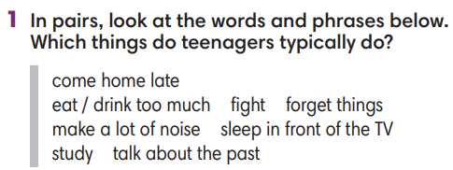
2. WHILE-READING 1 (20’)
ACTIVITY 2 + 3 + 4:
*Aim:
- To help Ss practice scanning skill.
- To teach topic-related vocabulary in context.
- To help Ss pull out tips for finding specific information in a text.
- To help Ss practice finding specific information in a text.
* Content: Read about the teenage behaviours.
* Outcome: To know more new words about teenage behaviours. Understand more about using the words in contexts.
* Organisation: T, Ss …
2. (5’) Which of the activity in exercise 1 does it mention?  (Ex 2, p.33)  - T asks Ss to look at exercise 2 (SB page 33).  - T calls a student to read the instruction then checks Ss’ understanding of it.  - T sets a time limit and asks Ss to work in pairs to complete the activity.  - T elicits the ideas from Ss, asks them in which line of the paragraph they see the answers.  - T confirms the answers then drills the pronunciation of the phrases and corrects Ss’ pronunciation if any.  Further discussion:  - T and students discuss tips for finding specific information in a text. | Answer keys:  1. make a lot of noise / 2. Do dangerous things / 3. Fight
3. (8’) Read the text again. Mark the sentences right, wrong or doesn’t say.  (Ex 3, p.33)  - T asks Ss to look at exercise 3 (SB page 33).  - T calls a student to read the instruction then checks Ss’ understanding of it.  - T elicits from Ss tips to find specific information in the text.  - T sets a time limit and asks Ss to work in groups to complete the exercise.  - T calls groups to give answers and the reasons for them.  - T confirms the answers.  - T corrects Ss’ pronunciation if any.  Further discussion:  - T and students reinforce tips for finding specific information in a text. | Answer keys:  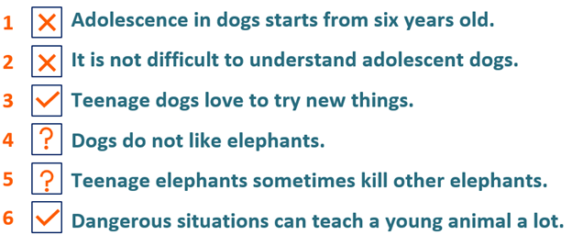
4. (7’) Choose the meaning of the highlighted words in the text.  (Ex 4, p.33)  - T asks Ss to look at exercise 4 (SB page 33).  - T calls a student to read the instruction then checks Ss’ understanding of it.  - T elicits from Ss tips to guessing the meaning of new vocabulary in a text.  - T sets a time limit and asks Ss to work in groups to choose the meaning.  - T calls groups to give answers and the reasons for them.  - T confirms the answers.  - T corrects Ss’ pronunciation if any.  Further discussion:  - T and students discuss on the tips to guess the meaning of new vocabulary in a text. | Answer keys:  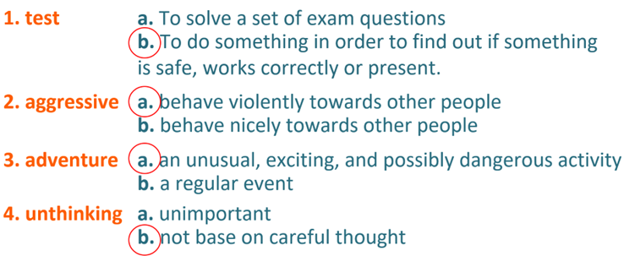
4. POST-READING (7’)
ACTIVITY 5:
* Aim: To encourage Ss to talk about teenage behaviours using the topic-related vocabulary.
* Content: To discuss the teenage behaviours.
* Outcome: Making sentences to talk about a teenager they know. Commenting about the sentences of others.
* Organization: T, Ss...
5. In pairs, tell about a teenager you know. Ask and answer questions using the verbs in exercise 1.  (Ex 5, p.33)  - T asks Ss to look at excersise 5 (SB page 33).  - T calls a student to read the instruction then checks Ss’ understanding of it.  - T asks a student to read the example then models the activity in front of the class.  - T asks Ss to work in pairs and talk about one of the teenagers they know.  - T sets a time limit and monitors Ss while they are working in pairs.  - T notes down common mistakes for delayed feedback.  - T calls some students to come to the front of the class to speak.  - T asks the rest to give comments on their classmates’ performance.  - T gives feedback on Ss’ work. | 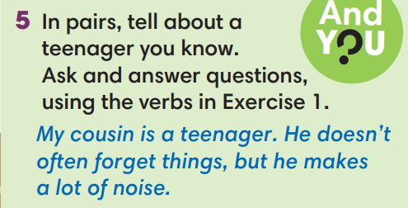
WRAP-UP & HOME WORK (3’)
- T asks Ss to talk about what they have learnt in the lesson.
- Vocabulary of teenage behaviours.
- Reading skills.
* HOME WORK
- Do exercises in the workbook page 27.
- Prepare for Lesson 3.4: Grammar 2.
************************************************************************

