Date of planning:  Date of teaching: | ENGLISH 7  UNIT 8: FESTIVALS AROUND THE WORLD  Period 84: Vocabulary
I. OBJECTIVES:
By the end of the lesson, Ss are able to gain: an understanding of the meaning of keywords below:
- describe festival activities.
1.. Competence:
3. Quality/Behavior:
- Being hard-working and attentive in class.
-Being confident when presenting in front of the class.
- Have a positive attitude towards the lesson.
II. TEACHING AIDS:
- Grade 7 textbook, Unit 8 (SB p.80-81, WB p.68-69)
- Computer (connected to the Internet is the best)
- Projector / TV/ PPT slides / Active teach
III. PROCEDURE:
1. WARM UP( 5’)
* Aims:
- To activate Ss’ prior knowledge and get students involved in the lesson.
- To set the context for introducing new words.
* Organisation: T-Ss, Ss-T
Teacher’s & Student’s activities | Content
Activity 1: 3 seconds  - T divides the class into 4 teams, explains the game rules then checks instructions.  - T tells Ss that they are learning about festival around the world.  - T sets the context for the lesson: Write the title on the board Unit 8: Festivals around the world / Lesson 8.1: Vocabulary | Game rules:  - 2 minutes for preparation (list all cities/ provinces in Vietnam that they know)  - Each team takes turn to say one city/ province.  - The team can’t say the word in 3 seconds or repeat the word is out of the game.
2. PRESENTATION 1 (10’)
ACTIVITY 2+3:
* Aims:
- To teach more new words
- To lead in to the next activity.
* Organisation: T-Ss, Ss-T, Pair work,Ss-Ss.
Teacher’s & Student’s activities |  | Content
VOCABULARY  Activity 2: Exercise 1 (SBp80)  Match the pictures with the names of the festivals around the world. Write the names on the pictures.  - Before the activity, ask students to name some Vietnamese festivals and write these on the board. For each festival ask students where it is celebrated, when it is celebrated, and some common activities found at this festival.  - T asks Ss to open their SB page 80, look at exercise 1.  - T calls a student to read the instruction then checks Ss’ understanding of it.  - T asks some Ss to describe the pictures.  - Ss work individually to finish Exercise 1.  - T check Ss answers.  Activity 3: Game: Word chain.  - T divides the class into group of ten. |  | 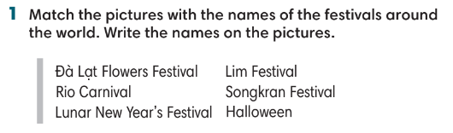  - Game rule:  - Ss take turns to say activities in festival.  - The following student needs to remember that activity and then add 1 more activity.  - Continue until 1 student says incorrectly.
3. PRESENTATION 2 (7’)
ACTIVITIES 4 & 5:
* Aims:
- To study festival activities.
* Organisation: T-Ss, Ss-T, Pair work
Teacher’s & Student’s activities | Content
Activity 4: Exercise 2 (SBp80)  Listen and tick () the activities you hear.  - T asks students to look at the pictures on page 80.  - T goes through all phrases and provides meaning of all words.  - T plays the audio. Ss listen and finish Exercise 2. | Answer keys:  - T plays the audio again and asks Ss to repeat the evidence from the audio.
Activity 5: Exercise 3 (SBp81)  Read the quiz and choose the best option.  - T ask Ss to read the instructions and the quiz.  - Ss work in pairs and do the quiz.  - T checks Ss answers and ask Ss if they have been to these festivals. | Answer keys:
4. PRACTICE (10’)
ACTIVITY 6 & 7:
* Aims:
- To provide students with Word friends.
- To provide more words related to the topic
- To help Ss use the new vocabulary in collocations.
* Organisation: T-Ss, Ss-T, Individual work.
Teacher’s & Student’s activities | Content
Activity 6: Exercise 4 – SB p.81  Circle the best option in the following sentences.  - Ss work individually to finish Exercise 4 and then check in pairs.  - T check students answer.  Activity 7: Game  - T divides the class into 2 groups. | Answer keys:  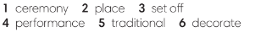  Game rules  2 Ss from 2 groups come to the board to receive one word from word friends. These Ss need to make one sentence using that word.  - 1 correct answer = 1 point.  - The faster student receives 1 more point.
5. PRODUCTION (10’)
ACTIVITY 8 + 9:
* Aims: To help Ss practice applying the vocabulary items and grammar points related to the topic in speaking.
* Organisation: T-Ss, Ss-T
Teacher’s & Student’s activities | Content
Activity 8: Exercise 5 – SB p.81  Work in groups. Choose one festival from Exercise 1 or your favorite festival. Make notes about the activities in this festival. Use the notes to tell the class about the festival.  - T asks Ss to look at Exercise 5 (SB page 81).  - T checks Ss understanding and provides one example.  - T asks Ss to work in groups of four to discuss their favorite festivals.  - T invites some volunteer to share their ideas in front of the class and receive feedbacks.  Activity 9: Interview  - T set a time limit of 4 minutes. Ss interview each other to find Ss with the same favorite festival. | 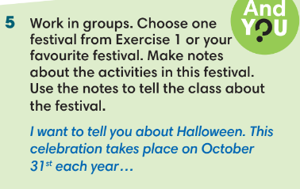

WRAP-UP & HOME WORK (3’)
- T asks Ss to talk about what they have learnt in the lesson.
- Vocabulary of festivals and festival activities.
Grammar points: how to describe a festival
* HOME WORK
-Do exer- Prepare for Lesson 2: Grammar 1.

