Period 10  Date of planning:  Date of teaching: | UNIT 1: CULTURE INTERESTS  Lesson1.4: Grammar 2
I. OBJECTIVES:
By the end of the lesson students will be able to:
- ask and answer questions about habits and routines.
1. Knowledge:
* Vocabulary: about habits and routines.
* Grammar:
- write the questions and answers of the Present Simple tense correctly.
- use the Present Simple tense to ask and answer about habits and routines.
2. Competence: Understand and use vocabulary about habits and routines, and understand the main grammatical points, then do the tasks assigned in the textbook. Use the questions and answers in the present simple tense correctly to talk about habits and routines.
3. Quality/ behavior: To teach Ss to be hard-working and attentive in class. Ss have a positive attitude to working in groups, individual work, pair work, cooperative learning and working.
II. TEACHING AIDS:
- Teacher: Grade 7 textbook, Unit 1 (SB p. 14), laptop/computer connected to the Internet, loudspeaker, projector/TV, PPT slides…
- Students: Text books, studying equipment…
- Method: Active teach, T-WC; group works; individual ……
III. PROCEDURE:

1. WARM UP (5’)
* Aim:
- To create a positive classroom atmosphere to start a new lesson.
- To help Ss review the Present Simple tense they have learnt in Lesson 1.2.
* Content: Game: Tom & Jerry (with the simple present)
* Outcome: Ss use the correct form of the verb in the Present Simple tense.
* Organisation: T_ Ss ..….

Teacher’s & Student’s activities |  | Content
Extra activity 1: Tom & Jerry Game  - T asks Ss to prepare 3 letter cards A, B and C (T may ask Ss to prepare them before the lesson.)  - T explains the game rules then checks instructions.  - Ss join in the game individually.  - T corrects Ss if necessary.  - T set the scene for the new lesson: T tells Ss that they are going to learn the questions and answers in the Present Simple tense.  - T writes the title on the board Unit 1: Cultural interests / Lesson 1.4: Grammar 2. |  | Game rules:  - Read the sentence  - Put the verb into the correct verb form in the Present Simple tense.  - Show the letter card A, B or C to give answers.  - 1 correct answer = 1 point.  - 1 wrong answer => Tom catches Jerry.
2. LEAD-IN (15’)
*Aim:
- To lead into the new lesson.
- To provide Ss with reasons for listening to the dialogue in exercise 1 (SB p.14).
* Content: Ss answer the questions about the habits.
* Outcome: Get the right answers on time.
* Organisation: T_ Ss …

Teacher’s & Student’s activities |  | Content
Extra activity 2: See – think – wonder.  - T shows a picture on the slide then asks students four questions.  (1) What can you see in the picture?  (2) What are they doing?  (3) Can the boy play the guitar?  (4) Do you like playing the piano or the guitar in your free time?  - T sets a time limit for Ss’ quick discussion.  - Ss work in pairs to make guesses about the picture then give answers.  - T calls some Ss to give answers then note them down on the board.  - T tells Ss that they’re going to read the conversation in exercise 1 (SB p.14) to check all the answers. |  | 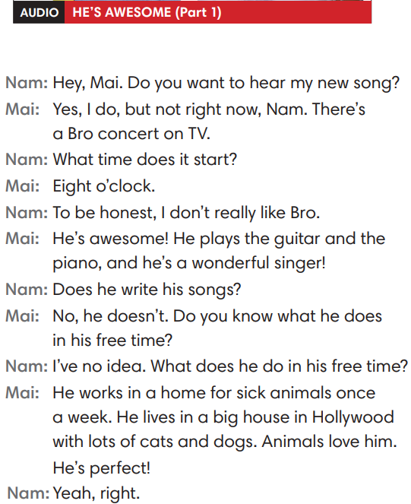
3. PRESENTATION (14’)
ACTIVITY 1 + 2:
*Aim:
- To present the grammar point in context.
- To lead into the next activity.
- To provide Ss with chances to spot the questions and answers in the Present Simple tense.
- To help Ss recognize the form of questions and answers in the Present Simple form.
- To provide Ss with chances to work cooperatively.
- To explain the grammar point for Ss.
- To introduce the everyday phrases and expressions pulled out from the conversation shortly.
* Content: To practice using the present simple in context, practice using adverbs of frequency in context by choosing the correct answer.
* Outcome: Practicing the use of the present simple by writing the correct form of the verbs, using adverbs of frequency in context.
* Organisation: T_Ss …

Teacher’s & Student’s activities |  | Content
1. Listen to part 1. Answer the questions below.  (Ex 1, p.14)  - T asks Ss to open their SB page 14, look at exercise 1.  - T calls a student to read the instruction then checks Ss’ understanding of it.  - T calls four students to read for questions.  - T tells Ss that they are going to listen to a conversation between Mai and Nam.  - Ss work individually, listen and note down the answers to the given questions.  - T calls some Ss to give answers then shows the answers on the slide.  - T asks Ss to look at the highlighted verbs in the above answers and elicits the tense of those from Ss (in the Present Simple tense). |  | Answer keys:  (1) It starts at eight o’clock.  (2) Mai thinks that Bro is awesome.  (3) He plays the guitar and the piano.  (4) He works in a home for sick animals once a week.
2. Find more Present Simple questions and answers in the dialogue.  (Ex 2, p.14)  - T asks Ss to look at exercise 2.  - T calls a student to read the instruction then checks Ss’ understanding of it.  - T asks Ss to work in groups of three to read the complete the activity.  - T calls groups to give answers then shows the answers on the slide to check as the whole class.  - T shows the interrogative form of the Present Simple tense (short questions / WH- questions) with missing words then elicits information from Ss.  - T explains the grammar points and tells Ss that they’re going to use the questions and answers in the Present Simple tense to talk about habits and routines. |  | 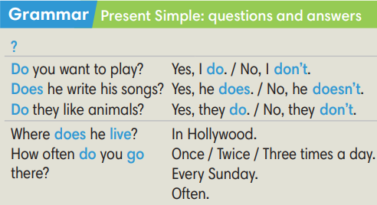
Extra activity 3: Read the phrases aloud. What do they mean? Use the dialogue to help you.  (Out of class box)  - T asks Ss to look at the Out of class box, find and underline the phrases in the dialogue.  - T calls students to read the phrases and asks for meaning based on the conversation.  - T corrects Ss’ pronunciation if any.  - T confirms the answers. |  | 
4. PRACTICE (13’)
ACTIVITY 3:
* Aims:
- To help Ss identify singular/plural subjects and use auxiliary verbs (do/does) correctly.
- To help students practice making questions and answers in the Present Simple tense for habits and routines.
* Content: Making questions; Listen to the audio track partners to answer the questions.
* Outcome: Making questions correctly. Then listen to choose the correct answers.
* Organisation: T_ Ss , Individual, Pair work, …
Teacher’s & Student’s activities | Content
Extra activity 4: Lucky stars game.  (Adapted from ex3 WB p.10)  - T explains the game rules then checks instructions.  - Ss join in the game individually.  - T corrects Ss if any. | Game rules:  - Read the sentence  - Fill in the blank with “do / does / don’t / doesn’t.”  - Raise your hand to give answers.  - 1 correct answer => choose a lucky star for points.
3. Make questions in the Present Simple. Listen to part 2 to answer the questions.  (Ex 3 SB p.14)  - T asks Ss to look at exercise 3.  - T calls a student to read the instruction then checks Ss’ understanding of it.  Step 1:  - T asks Ss to work in individually to read the written questions.  - T calls students to give answers then shows them on the slide to check with the whole class.  - T corrects Ss if any.  Step 2:  - T asks Ss to listen to part 2 of the dialogue to answer questions.  - T asks Ss to work in pairs, compare their answers with their partners.  - T calls students to give answers then shows the answers on the slide to check with the whole class.  - T corrects students if any. | 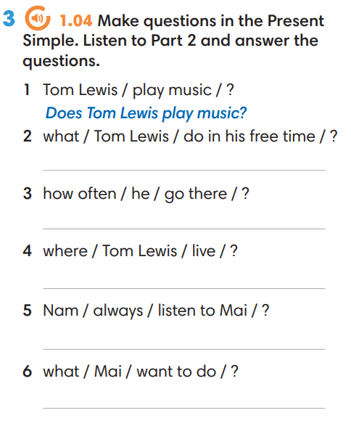
4. Production (7’)
ACTIVITY 4:
* Aims: To let Ss make conversations to ask and answer about habits and routines.
* Content: Making questions; Interview partners using the cues words.
* Outcome: Making questions correctly. Then Interview partners.
* Organisation: T_ Ss , Individual, Pair work, …

Teacher’s & Student’s activities | Content
4. In pairs, ask and answer questions about the activities below.  (Ex 4, p.14)  - T asks Ss to look at excersise 4 (SB page 14).  - T calls a student to read the instruction then checks Ss’ understanding of it.  - T models the activity in front of the class.  - T divides Ss into new pairs, asks them to make conversations to ask and answer about habits and routines.  - T gives a signal for Ss to change partners after every 3 minutes.  - T walk around to listen and notes down common mistakes for delayed feedback.  - T calls some groups to come to the front of the class, make conversations.  - T asks the rest to give comments on their classmates’ performance.  - T gives feedback on Ss’ work. | 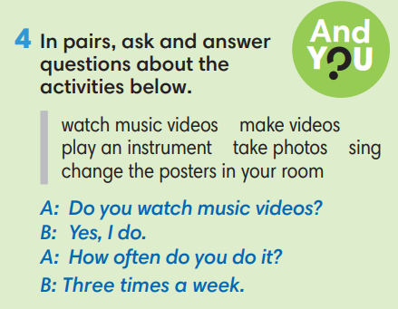
WRAP-UP & HOME WORK (3’)
- T asks Ss to talk about what they have learnt in the lesson.
✔ The present simple tense: questions and answers.
* HOME WORK
- Do exercises in the workbook page 10.
- Prepare for Lesson 1.5: Listening and vocabulary.

