Period 11  Date of planning:  Date of teaching: | UNIT 1: CULTURE INTERESTS  Lesson 1.5: Listening and Vocabulary
I. OBJECTIVES:
By the end of the lesson student will be able to:
- identify specific details in a conversation and talk about media habits.
1. Knowledge:
* Vocabulary: use vocabulary of types of media to talk about media habits.
* Grammar: make sentences in the Present Simple with different personal pronouns correctly.
2. Competence: Understand and use the vocabulary of types of media and TV programs, do the tasks assigned in the textbook. Listen and identify specific details in a conversation and talk about media habits.
3. Quality/ behavior: To teach Ss to be hard-working and attentive in class. Ss have a positive attitude to working in groups, individual work, pair work, cooperative learning and working.
II. TEACHING AIDS:
- Teacher: Grade 7 textbook, Unit 1 (SB p. 15, WB p.11), laptop/computer connected to the Internet, loudspeaker, projector/TV, PPT slides …
- Students: Text books, studying equipment …
- Method: Active teach, T-WC; group works; individual …
III. PROCEDURE:
1. WARM UP + LEAD-IN (7’)
ACTIVITY 1:
* Aim:
- To create a positive classroom atmosphere to start a new lesson.
- To lead into the topic.
- To get students to think about the topic.
- To provide Ss with reasons for more discussions
* Content: Ss do the survey about the type of media that they’re using.
* Outcome: Name some types of media. Know more information about the media habits.
* Organisation: T_ Ss …
Teacher’s &Student’s activities | Content
1. (4’) Class Vote (SB p.15 - Ex 1)  - Set the scene: T tells Ss to look at the girl in Student book page 15. T asks some questions to elicit that the girl is going to do an interview about types of media.  - Teacher introduces the Vote and the survey questions in the student book.  - T explains How-to-vote steps then checks instructions.  - Ss join in the survey in pairs or in small groups.  - T sets the scene for the new lesson: T tells Ss that they are going to learn more words of media by doing a listening task.  - T writes the title on the board Unit 1: Cultural interests / Lesson 1.5: Listening and Vocabulary | How to vote:  - Read the questions  - Ask your classmates questions from 1-6  - Put a dot next to the type of media that you hear  - Answer your classmate questions if you are asked
Extra activity 1: (3’) Count and Announce  - T writes 4 types of media on the board: Newspaper, The Radio, The TV, and The Internet  - T asks students to count the number of the dots next to the name of media in their book.  - Ss work in pairs to count and tell teacher the answer.  - T asks some students to help with working out the most popular type of media in the class.  - T tells Ss that they’re going to learn more words of media in the next steps of the lesson. | 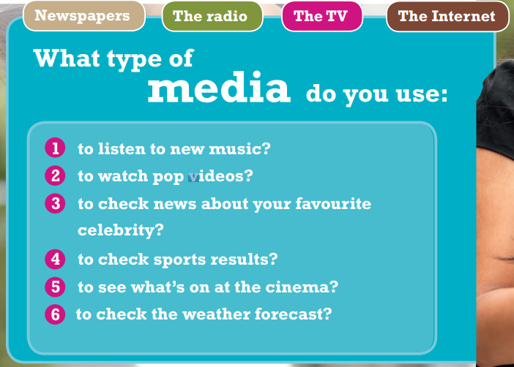
2. PRE-LISTENING (20’)
ACTIVITY 2 + 3:
*Aim:
- To activate Ss’ prior knowledge of the topic.
- To pre-teach words of news and entertainment
- To check Ss’ answers in “Think and Share” activity.
- To reinforce words of programs
* Content: Some brief notes; vocabulary about news and entertainment. Use them to complete the exercise.
* Outcome: Know some more new words about news and entertainment. Chose the correct words to answer the questions.
* Organisation: T_ Ss …
Teacher’s &Student’s activities | Content
Extra activity 2: (10’) Multiple Choice Game  (pre-teach vocabulary)  - Teacher introduces that Ss will learn more words of media by joining a game.  - T explains the game rules then checks instructions.  - Ss join the game in team. Ss take turns to answer each question.  - Teacher leads the game and asks students to read aloud each word or phrase.  - When the game ends, teacher shows all the new words again for students to read. | How to play:  - Look at the pictures and read the definitions  - Read the words of programs  - Choose 1, 2, or 3 to match the word with the picture  - 1 correct answer = 1 point
2. (4’) Think and Share.  (SB p.15 – Ex 2)  - T asks Ss to look at exercise 2.  - T calls a student to read the instruction then checks Ss’ understanding of it.  - T asks Ss to work in groups of three to read then complete the activity.  - T calls groups to give answers to check as the whole class. | 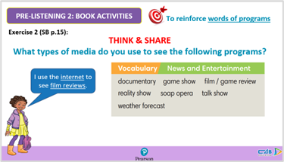
3. (3’) Use the Vocabulary box to complete the sentences. Change the words if necessary.  (SB p.15 - Ex 3)  - T asks Ss to look at exercise 3.  - T calls a student to read the instruction then checks Ss’ understanding of it.  - T asks Ss to work in pairs to read then complete the activity.  - T checks as the whole class. | Answer keys:  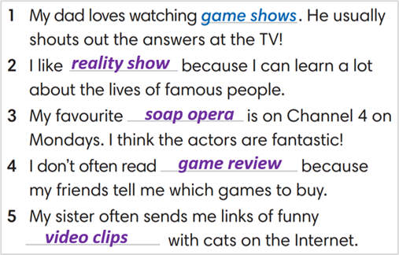
Extra activity 3: (3’) Match comments 1-6 with the types of media.  (WB p.11 - Ex 2)  - T asks Ss to look at exercise 2 in workbook page 11.  - T calls a student to read the instruction then checks Ss’ understanding of it.  - T asks Ss to work in pairs to read then complete the activity.  - T checks as the whole class. | Answer keys:  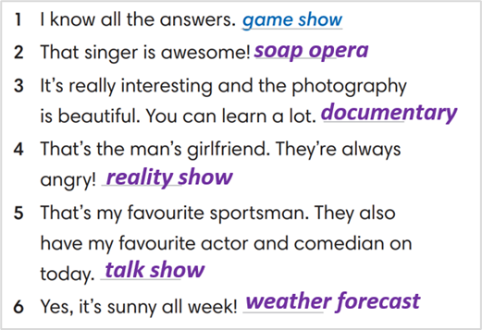
3. WHILE-LISTENING (8’)
ACTIVITY 4:
* Aim:
- To help Ss identify specific details in a conversation
- To provide Ss with chances to think and talk about personal media habits
* Content: Listen and understand to the audio track and complete the exercise.
* Outcome: Understanding the types of radio programs by matching the correct answers.
* Organisation : T_ Ss …
Teacher’s &Student’s activities | Content
4. Listen and match speakers 1-4 with the type of program they like a-e.  (SB p.15 - Exercise 4)  - T asks Ss to look at exercise 4 in student book page 15.  - T calls a student to read the instruction then checks Ss’ understanding of it.  - T asks students to look at the different kinds of programs and think of reasons why people might like these kinds of show.  - T asks Ss to work in pairs to listen then complete the activity and peer check for the first listening.  - T plays the audio again and checks as the whole class.  - Teacher asks students to give the evidence that they hear from the audio track to prove their answer. | Answer keys: 1-c, 2-e, 3-b, 4-a
4. POST-LISTENING (6’)
ACTIVITY 5:
*Aim: To help students applying the vocabulary items related to the topic in communicating.
* Content: Complete the sentences about the specific habits of each student. Share with partners their habits.
* Outcome: Think and share about individual habits.
* Organisation : T_ Ss ..
Teacher’s &Student’s activities |  | Content
5. Complete the following sentences to make them true for you. Then share with your partner  (SB p.15 - Exercise 5a & 5b)  - T asks Ss to look at exercise 5a in student book page 15.  - T calls a student to read the instruction then checks Ss’ understanding of it.  - T asks Ss to work in pairs to read then complete the activity.  - T sets a time limit for student.  - Students work in pair to think and share.  - Teacher invites different students to talk about their partner. | 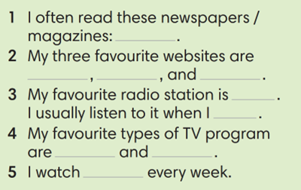
WRAP-UP & HOME WORK ( 2’)

- T asks Ss to talk about what they have learnt in the lesson.
- Vocabulary of types of media
* HOME WORK
- Do exercises in the workbook page 11.
- Prepare for Lesson 1.6: Speaking.

=====================

