Period 13  Date of planning:  Date of teaching: | UNIT 1: CULTURE INTERESTS  Lesson 7: Writing
I. OBJECTIVES:
By the end of the lesson, Ss are able to:
- write a personal introduction to a webpage.
1. Knowledge:
* Vocabulary: use vocabulary of common topics (age / school / places / subjects / foods, etc.) to write about personal information.
* Grammar: make sentences in the Present Simple tense correctly.
2. Competence: Ss understand and use the vocabulary of common topics (age / school / places / subjects / foods, etc.), do the tasks assigned in the textbook. Write a personal introduction for a webpage.
3. Quality/behavior: To teach Ss to be hard-working and attentive in class. Ss have a positive attitude to working in groups, individual work, pair work, cooperative learning and working.
II. TEACHING AIDS:
- Teacher: Grade 7 textbook, Unit 1 (SB p. 17, WB p.13), laptop/computer connected to the Internet, loudspeaker, projector/TV, PPT slides …
- Students: Text books, studying equipment …
- Method: Active teach, T-WC; group works; individual …
III. PROCEDURE:
1. WARM UP (4’)
* Aim:
- To create a positive classroom atmosphere to start a new lesson.
- To lead into the sample writing.
* Content: Game: Telepathy Game (about friends)
* Outcome: Ss guess and choose the correct picture.
* Organization of implementation:
Teacher’s & Student’s activities |  | Content
Extra activity 1: Telepathy Game  - Set the scene: T tells Ss that she / he’s going to give some sentences about her / his friends. Ss are going to play this game to find which friend she / he is talking about.  - T explains the game rules then checks instructions.  - Ss join in the game individually.  - T set the scene for the new lesson: T tells Ss that they are going to read and write about personal information in this lesson.  - T writes the title on the board Unit 1: Cultural interests / Lesson 1.7: Writing. |  | Game rules:  - Read the sentence  - Make guesses and choose A or B as the correct picture.  - 1 correct answer = 1 point.
2. LEAD-IN (3’)
* Aim:
- To get students to think about the topic.
- To provide Ss with reasons for reading the sample writing in exercise 1 (SB p.17).
* Content: Discuss groups and give the answer about the boy in the picture.
* Outcome: Guess the correct answers to the questions.
* Organisation: T_ Ss ..….
Teacher’s & Student’s activities | Content
Extra activity 2: See – think – wonder.  - T shows a picture of a boy on the slide then asks students four questions.  (1) How old is he?  (2) Which grade is he in?  (3) Where is he from?  (4) What’s his favorite subject?  - T sets a time limit for Ss’ quick discussion.  - Ss work in pairs to make guesses about the picture then give answers.  - T calls some Ss to give answers then note them down on the board for checking later.  - T tells Ss that they’re going to read the conversation in exercise 1 (SB p.17) to check all the answers. | 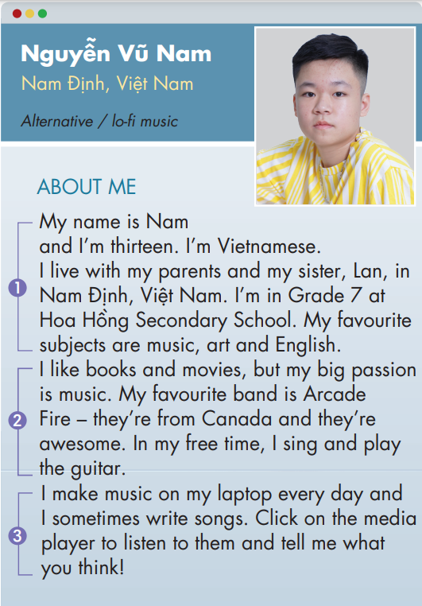
3. PRE-WRITING (13’)
ACTIVITY 1 + 2 + 3:
Aim:
- To activate Ss’ prior knowledge of the topic.
- To lead into the next activity.
- To check Ss’ answers in the “See – think – wonder” activity.
- To help Ss understand the sample writing.
- To help Ss focus on personal information while reading the sample.
- To provide Ss with useful expressions for writing a personal introduction.
* Content: Read Nam’s webpage to get used to writing skills
* Outcome: Do the exercise to improve writing skills.
* Organisation: T_ Ss ..….
Teacher’s & Student’s activities |  | Content
1. (3’) Class vote. Have you got a personal webpage?  (Ex 1, p.17)  - T calls a student to read the instruction then checks Ss’ understanding of it.  - T asks Ss if they’ve got a personal webpage.  - T shows slides to provide Ss with some clues.  - T names some types of social media and asks Ss to raise their hands if they’ve got accounts on one or some of them.  - T encourages Ss to name more webpages that they’ve joined.  - T tells Ss that they are going to look at Nam’s personal webpage in the next activity. |  | 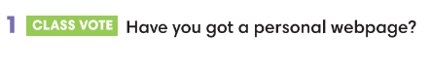  Some types of social media:  
2. (4’) Read Nam’s webpage.  Step 1: Check your answers.  (Extra activity 3)  - T asks Ss to look at Nam’s webpage, read and compare with their answers in “See – think – wonder” activity.  - T checks with the whole class on the board.  Step 2: Which of the sentences are true. Write T.  (Ex 2, p.17)  - T asks Ss to look at exercise 2.  - T calls a student to read the instruction then checks Ss’ understanding of it.  - T asks Ss to work in groups of three to read then complete the activity.  - T calls groups to give answers then shows the answers on the slide to check as the whole class. |  | 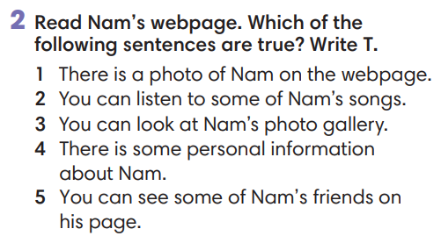
3. (3’) In pairs, read Nam’s personal information. Tick the things he writes about.  (Ex 3, p.17)  - T asks Ss to look at exercise 3.  - T calls a student to read the instruction then checks Ss’ understanding of it.  - T asks Ss to work in pairs to read then complete the activity.  - T checks as the whole class. |  | 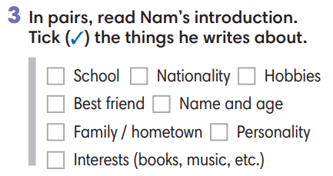
Extra activity 4: Look at the writing box. Which structures did Nam use? Underline.  - T asks Ss to look at the writing box and the sample writing again.  - T asks Ss to work individually, underlined the useful structures Nam used in his writing.  - T sets a time limit for the activity.  - T shows the slide and check as the whole class.
  Writing a personal introduction
  1. Personal details | My name is ….  I’m … years old.  I come from … [place] / I’m … [nationality]  I live with my family. / My hometown is …  I’m in Grade … at … school.
  2. Interests / Hobbies | I like / I’m into / I’m a big fan of ...  I’m interested in ... / My big passion is ...  My favorite is ...  In my free time, I ... / After school, I ...  I often ...
  3. Routines | I often / sometimes / usually ...  I ... once a week / every day.
4. WHILE-WRITING (17’)
ACTIVITY 4:
Aim:
- To help Ss identify correct personal information.
- To provide Ss with chances to think and write about their personal information.
- To help student practice writing a personal introduction for a webpage.
* Content: Use the writing box and Nam’s page to practice writing skills.
* Outcome: Write a personal introduction.
* Organisation: T_ Ss.. ….

Teacher’s & Student’s activities |  |  | Content
Extra activity 5: (4’) Mole hunt game.  (Adapted from ex3 WB p.13)  - T explains the game rules then checks instructions.  - Ss think and write individually then check sentences in pairs.  - T corrects Ss if any. |  |  | Game rules:  - Read the sentence  - Fill in the blank with A, B or C.  - Write the sentence in your notebook.  - 1 correct answer = 2 points.  - Check answers in pairs.
Extra activity 6: (5’) Write about you. Complete the sentences about you.  - T calls a student to read the instruction on the slide then checks Ss’ understanding of it.  - T asks Ss to work individually to complete the exercise.  - T sets a time limit for the task.  - T asks students to sit in pairs, compare their answers with partners.  - T calls some Ss to read their sentences.  - T corrects Ss if any. |  |  | 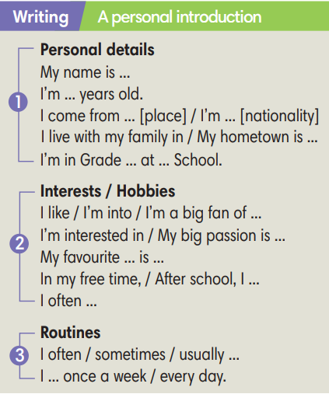
4. (8’) Write a personal introduction (60-80 words) for a webpage. Use the writing box and Nam’s page to help you.  (Ex 4 SB p.17)  - T asks Ss to look at exercise 4.  - T calls a student to read the instruction then checks Ss’ understanding of it.  - T asks Ss to work individually to write basing on the writing box and Nam’s page.  - T sets a time limits and walk around as a monitor while Ss are writing. |  |  | 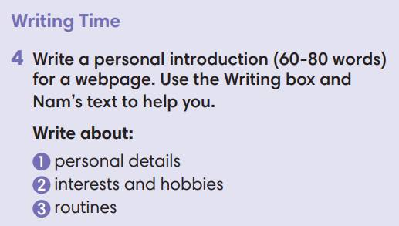
5. POST-WRITING (6’)
*Aim:
- To let Ss do peer-check.
- To give general comments on Ss’ writing pieces.
* Content: Ss swapping their writing in pairs.
* Outcome: Cross-check writing pieces and follow the writing rubric.
* Organisation: T_ Ss .…….

Teacher’s & Student’s activities |  |  | Content
Extra activity 7: In pairs, swap your writing then check.  (Ex 4, p.14)  - T explains the writing rubric before checking.  - T asks Ss to swap their writing pieces, use the given writing rubric then do cross-check.  - T gives feedback on common mistakes of Ss’ work.  - T may collect Ss’ writing for detailed comments. |  |  | Writing rubric:  (1) Does the writing include personal details, interests and hobbies, routines?  (2) Does the writing meet word limit (60-80 words)?  (3) Does the writing make any vocabulary and grammar mistakes?
WRAP-UP & HOME WORK (2’)
- T asks Ss to talk about what they have learnt in the lesson.
- A personal introduction for a webpage.
* HOME WORK:
- Do exercises in the workbook page 13.
- Prepare for Lesson 1.8: Self-check.

======================

