Date of planning:  Date of teaching: | UNIT 2: FAMILY AND FRIENDS  Period 18: Lesson 2.2: Grammar

I. OBJECTIVES
By the end of the lesson, Ss are able to:
1. Knowledge
- Grammar:
- write affirmative, negative and question forms of the Present Continuous tense correctly.
- use the Present Continuous tense to talk about present activities and describe friends in class.
2. Core competences
- General competences: form and / or improve such competencies as group work, independent working, pair work, linguistic competence, and cooperative learning.
- Specific competences:
Improve communicative competence related to the use of language (vocabulary, phonetics, grammar):
For a language lesson: Ss are expected to use vocabulary about activities, and understand the main grammatical points, then do the tasks assigned in the textbook.
For a skills lesson: Ss are expected to use the Present Continuous tense to talk about present activities and describe friends in class.
3. Personal qualities
- Being hard-working and attentive in class.
- Have a positive attitude towards the lesson.
II. TEACHING AIDS
- Grade 7 textbook, Unit 2 (SB p. 22)
- Computer (connected to the Internet is the best
III. PROCEDURES
I. WARM UP
* Aims
- To activate students’ prior knowledge and get students involved in the lesson.
- To set the context for introducing new structures.
* Content: Play Guessing Game to get ss involved in the lesson and to set the context for the lesson
* Outcome: Students will learn more structures to describe people and present activities.
* Organisation: Teacher’s instructions…

Teacher’s & Student’s activities | Content
Activity 1: Guessing Game  - T divides Ss into 2 teams. Team boys and team girls.  - T explains the game rules then checks instructions.  - T corrects Ss if necessary.  - T set the scene for the new lesson: T tells Ss that they can describe what Dr Strange is doing by looking at the pictures.  They will learn more structures to describe people and present activities.  - T writes the title on the board Unit 2: Family and Friends / Lesson 2.2: Grammar  - To lead into the new lesson.  Activity 2: See – think – wonder.  - T shows a picture on the slide then asks students three questions.  (1) What do you see in the picture?  (2) Who are they?  (3) What are they doing?  - T sets a time limit for Ss’ quick discussion.  - T calls some Ss to give answers then note them down on the board.  - T tells Ss that they’re going to read a dialogue in exercise 1 (SB p.22) to check all the answers. | Game rules:  - Look at the pictures.  - Choose A – B - C  - 1 correct answer = 1 point.  - Ss work in pairs to make guesses about the picture then give answers.
II. PRESENTATION
* Aims
- To present the grammar point in context.
- To lead into the next activity.
- To help Ss recognize all the forms of Present Continuous Tense.
- To provide Ss with chances to work cooperatively.
- To explain the grammar point for Ss.
* Content: Some brief notes; the forms of Present Continuous Tense.
* Outcome: recognize all the forms of Present Continuous Tense.
* Organisation: Teacher’s instructions….

Teacher’s & Student’s activities | Content
Activity 4: Exercise 2 – SB p.  Find more examples of Present Continuous in the dialogue in Exercise 1.  - T asks Ss to look at exercise 2.  - T calls a student to read the instruction then checks Ss’ understanding of it.  - T asks Ss to work in groups of three to complete the activity.  - T calls groups to give answers then shows the answers on the slide to check as the whole class.  THE GRAMMAR NOTES  - T shows the Grammar Notes for all forms of the Present Continuous tense then elicits information from Ss.  - T explains the grammar points and tells Ss that they’re going to use the Present Continuous tense to talk about things that happening now.  - T shows the grammar notes again, then Ss can read aloud | T-Ss  Group work  Ss-T
III. PRACTICE

* Aims
- To help students practice completing the correct forms of the verbs with corresponding singular/plural subjects.
* Content: - To help students identify the correct form of the verbs in present continuous tense.
* Outcome: practice the verbs in present continuous tense.
* Organisation: Teacher’s instructions….
Teacher’s & Student’s activities | Content
Activity 5: Space Mission Game  - T explains the game rules then checks instructions.  - Ss join in the game individually or in teams.  - T corrects Ss if any.  Activity 6: Exercise 3 – SB p.22  Make affirmative and negative sentences in Present Continuous.  - T asks Ss to look at exercise 3.  - T calls a student to read the instruction then checks Ss’ understanding of it.  - T asks Ss to work in individually.  - T calls students to give answers then shows them on the slide to check as the whole class.  - T corrects Ss if any.  Activity 7: Exercise 4 – SB p.22  Make questions in Present Continuous. In pairs, look at the photo and answer the questions.  - T asks Ss to look at exercise 4.  - T calls a student to read the instruction then checks Ss’ understanding of it.  - T asks Ss to work in in pairs.  - T calls some pairs to give answers then shows them on the slide to check as the whole class.  - T corrects Ss if any. | Game rules:  - Read the sentence  - Put the correct verbs in the brackets.  - Raise your hand to give answers.  - Get points.  Answer keys:  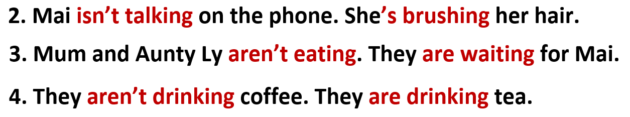  Answer key:  *Extra Activity: Teacher can get some exercises from Workbook page 17 for Ss to practice in class.  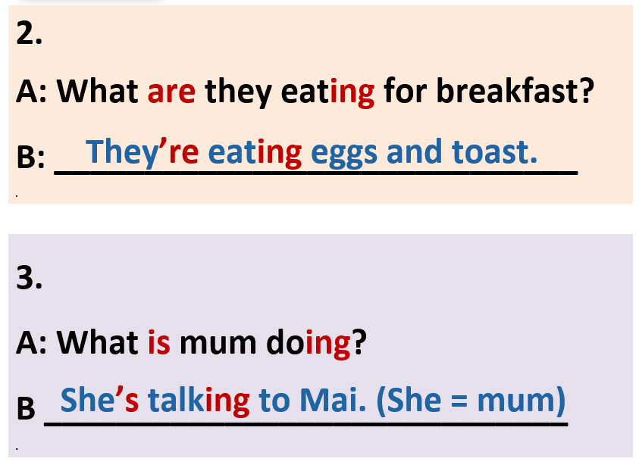
IV. PRODUCTION

ACTIVITY 4:
* Aims: To help students applying the vocabulary items and grammar points related to the topic in communicating.
* Content: Ss work in groups to ask and answer about what your friends are doing or wearing.
* Outcome: Ss ask and answer about what your friends are doing or wearing.
using vocabulary and grammar points.
* Organisation: Teacher’s instructions…..

Teacher’s & Student’s activities |  | Content
Activity 8: Exercise 5 – SB p.22  Ask and answer about what your friends are doing or wearing.  - T asks Ss to look at exercise 5 (SB page 22).  - T calls a student to read the instruction then checks Ss’ understanding of it.  - T models the activity in front of the class.  - T divides Ss into new pairs, asks them to make conversations to ask and answer about their classmates.  - T walk around to listen and notes down common mistakes for delayed feedback.  - T calls some groups to come to the front of the class, make conversations.  - T asks the rest to give comments on their classmates’ performance.  - T gives feedback on Ss’ work. |  | T-Ss  Pair work
WRAP-UP & HOMEWORK
- T asks Ss to talk about what they have learnt in the lesson.
- The present continuous tense: all forms
HOMEWORK
- Do exercises in the workbook page 17.
- Prepare for Lesson 1.3: Reading.

