Date of planning:  Date of teaching: | UNIT 3: ANIMALS’ MAGIC  Period 32:Lesson 3.4- Grammar
I. OBJECTIVES:
By the end of the lesson students will be able to:
- use Past Simple of regular verbs to talk about the past.
1. Knowledge:
* Grammar:
- remember the forms of regular verbs in Past Simple.
- write past simple forms of regular verbs.
- use past simple forms of regular verbs to talk about the past.
2. Competence: Understand and use verbs to talk about activities in the past, and understand the main grammatical points, then do the tasks assigned in the textbook; use the questions and answers in past simple correctly to talk about the past.
3. Quality/ behavior: To teach Ss to be hard-working and attentive in class. Ss have a positive attitude to working in groups, individual work, pair work, cooperative learning and working.
II. TEACHING AIDS:
- Teacher: Grade 7 textbook, Unit 3 (SB p. 34), laptop/computer connected to the Internet, loudspeaker, projector/TV, PPT slides…
- Students: Textbooks, studying equipment…
- Method: Active teach, T-WC; group works; individual ……
III. PROCEDURE:

1. WARM UP (4’)
* Aim:
- To create a positive classroom atmosphere to start a new lesson.
- To help Ss review the vocabulary they have learnt in Lesson 3.3.
* Content: Game: Minion Game (with the past simple tense)
* Outcome: Ss use the correct form of the verb in the Past Simple tense.
* Organisation: T, Ss ..….

Teacher’s & Student’s activities |  | Content
Extra activity 1: Minion Game  - T explains the game rules then checks instructions.  - Ss join in the game individually.  - T corrects Ss if necessary. |  | Game rules:  - Read the sentence carefully.  - Choose A or B to fill in the blank.  - 1 correct answer = 1 point.
2. LEAD-IN (2’)
*Aim:
- To lead into the new lesson.
- To provide Ss with reasons for listening to the dialogue in exercise 1 (SB p.34).
* Content: Ss answer the questions about Nam.
* Outcome: Get the right answers on time.
* Organisation: T_ Ss ..….

Teacher’s & Student’s activities |  |  | Content
Extra activity 2: See – think – wonder.  - T shows a picture on the slide then asks students four questions.  (1) What do you see in the picture?  (2) What is he doing?  (3) Where is he?  (4) How does he feel?  - T sets a time limit for Ss’ quick discussion.  - Ss work in pairs to make guesses about the picture then give answers.  - T calls some Ss to give answers then note them down on the board.  - T tells Ss that they’re going to read the conversation in exercise 1 (SB p.34) to check all the answers. |  |  | 
3. PRESENTATION (13’)
(Questions and answers in the Present Simple tense)
ACTIVITY 1 + 2:
*Aim:
- To present the grammar point in context.
- To lead into the next activity.
- To introduce the forms of regular verbs in Past Simple.
- To introduce the everyday phrases and expressions pulled out from the conversation shortly.
* Content: To practice using the past simple in context by choosing the correct answer.
* Outcome: Practicing the use of the past simple by writing the correct form of the verbs.
* Organisation: T, Ss ..….
Teacher’s & Student’s activities |  |  | Content
1. (5’) Listen. Why is Nam worried?  (Ex 1, p.34)  - T asks Ss to open their SB page 34, look at exercise 1.  - T calls a student to read the instruction then checks Ss’ understanding of it.  - T tells Ss that they are going to listen to a conversation between Mai and Nam.  - Ss work individually, listen and note down the answers to the given questions.  - T calls some Ss to give answers then shows the answers on the slide.  Answer keys:  Nam is worried because he can’t find Kim’s dog.  - T set the scene for the new lesson: T tells Ss that they are going to read a conversation to see what happened with him in the past.  - T writes the title on the board Unit 3: Animals’ Magic / Lesson 3.4: Grammar 2. |  |  | 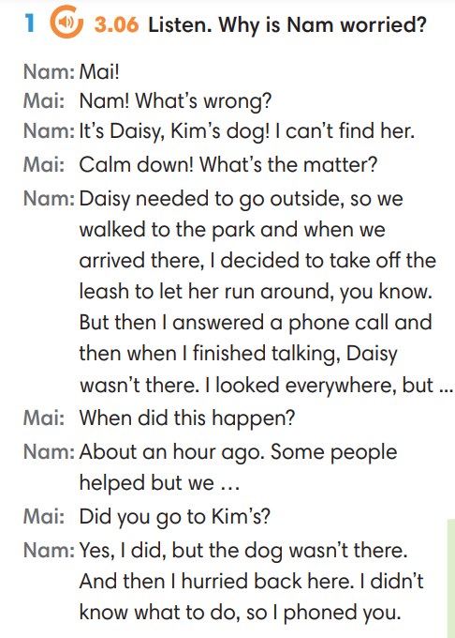
2. (4’) Find more example of the Past Simple in the dialogue.  (Ex 2, p.34)  - T asks Ss to look at exercise 2.  - T calls a student to read the instruction then checks Ss’ understanding of it.  - T asks Ss to work in groups of three to read the complete the activity.  - T calls groups to give answers then shows the answers on the slide to check as the whole class. |  |  | 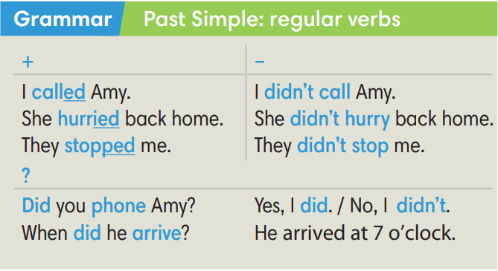
Extra activity 3 (4’): Find and underline the phrases below in the dialogue.  (Out of class box)  - T asks Ss to look at the Out of class box, find and underline the phrases in the dialogue.  - T calls students to read the phrases and asks for meaning basing on the conversation.  - T corrects Ss’ pronunciation if any.  - T shows the grammar notes, explains the grammar points and tells Ss that they’re going to use them to talk about the past. |  |  | 
4. PRACTICE (17’)
ACTIVITY 3:
* Aims:
- To help Ss practice writing form of regular verbs in Past Simple.
- To help Ss practice pronouncing verbs with -ed ending then classify them.
- To help Ss practice writing form of regular verbs in Past Simple in context.
* Content: Choose the correct form of the verb in the past simple tense.
* Outcome: Choose the form correctly in grammar and use the past simple to explain their options.
* Organisation: T, Ss, ….
Teacher’s & Student’s activities | Content
Extra activity 4 (6’): Tom and Jerry Game.  (Adapted from ex3 SB p.34)  - T explains the game rules then checks instructions.  - Ss join in the game individually.  - T corrects Ss’ pronunciation if any. | Game rules:  - Read the questions carefully.  - Choose A, B or C.  - Check answers with Tom and Jerry.  - 1 correct answer = 2 points.
3. (7’) Write past simple form of the verb below then put them in the correct column. Listen and check.  (Ex 3 SB p.34)  - T asks Ss to look at exercise 3.  - T calls a student to read the instruction then checks Ss’ understanding of it.  - T sets a time limit for Ss to complete the exercise in groups of four.  - T calls groups to give answers then checks as the whole class.  - T corrects Ss’ pronunciation if any. | Answer keys:  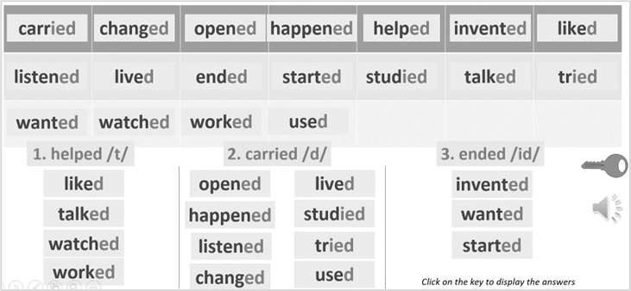
4. (4’) Write past simple form of the verb below then put them in the correct column. Listen and check.  (Ex 4 SB p.34)  - T asks Ss to look at exercise 4.  - T calls a student to read the instruction then checks Ss’ understanding of it.  - T sets a time limit for Ss to complete the exercise in pairs.  - T calls groups to give answers then checks as the whole class.  - T corrects Ss’ pronunciation if any. | Answer keys:
  2. didn’t want | 4. agreed | 6. shouted | 8. walked
  3. needed | 5. decided | 7. suggested | 9. didn’t like
4. PRODUCTION (7’)
ACTIVITY 5:
* Aims: To let Ss make questions and answers about the past.
* Content: Interview partners using the cues words.
* Outcome: Use vocabulary items and grammar points related to the topic to interview partners.
* Organisation: T. Ss , Individual, Pair work, ….

Teacher’s & Student’s activities | Content
5. In pairs, make questions from the promts. The go to page 101 to find answers.  (Ex 5, p.34)  - T asks Ss to look at excersise 5 (SB page 34).  - T calls a student to read the instruction then checks Ss’ understanding of it.  - T divides Ss into new pairs, then sets a time limit for them to complete the activity.  - T asks pairs to ask and answer questions.  - T walk around to listen and notes down common mistakes for delayed feedback.  - T calls some pairs to come to the front of the class, make conversations.  - T asks the rest to give comments on their classmates’ performance.  - T gives feedback on Ss’ work. | 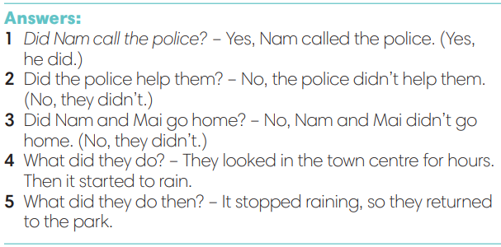
WRAP-UP & HOME WORK (3’)
- T asks Ss to talk about what they have learnt in the lesson.
- The past simple tense with regular verbs.
* HOME WORK
- Do exercises in the workbook page 28.
- Prepare for Lesson 3.5: Listening and vocabulary.
=========================

