Date of planning:  Date of teaching: | UNIT 3: ANIMALS’ MAGIC  Period 35:Lesson 7-Writing
I. OBJECTIVES:
By the end of the lesson, Ss are able to:
- write a biography.
1. Knowledge:
* Vocabulary: use vocabulary of common topics (age / jobs / places / family, etc.) to write a biography (of a famous person).
* Grammar: make sentences in the Past Simple tense correctly.
2. Competence: Ss understand and use the vocabulary of common topics (age / jobs / places / family, etc.), do the tasks assigned in the textbook. Write a biography of a famous person.
3. Quality/ behavior: To teach Ss to be hard-working and attentive in class. Ss have a positive attitude to working in groups, individual work, pair work, cooperative learning and working.
II. TEACHING AIDS:
- Teacher: Grade 7 textbook, Unit 3 (SB p. 47, WB p.31), laptop/computer connected to the Internet, loudspeaker, projector/TV, PPT slides…
- Students: Text books, studying equipment…
- Method: Active teach, T-WC; group works; individual ……
III. PROCEDURE:
1. WARM UP (4’)
* Aim:
- To create a positive classroom atmosphere to start a new lesson.
- To lead in to the sample writing.
- To early introduce some information about Steve Irwin
* Content: Game: Telepathy Game (about an expert called Steve Irwin)
* Outcome: Ss guess and choose the correct picture.
* Organization of implementation
Teacher’s & Student’s activities | Content
Extra activity 1: Telepathy Game  - Set the scene: T tells Ss that she / he’s going to give some sentences about an expert called Steve Irwin.  - T explains the game rules then checks instructions.  - Ss join in the game individually.  - T set the scene for the new lesson: T tells Ss that they are going to read and write a biography in this lesson.  - T writes the title on the board Unit 3: Animals’ Magic / Lesson 3.7: Writing. | Game rules:  - Read the sentence  - Make guesses and choose A or B as the correct picture.  - 1 correct answer = 1 point.
2. LEAD-IN (3’)
* Aim:
- To get students to think about the topic.
- To provide Ss with reasons for reading the sample writing in exercise 1 (SB p.37).
* Content: Discuss in groups and give the answer about the an expert called Steve Irwin in the picture.
* Outcome: Guess the correct answers to the questions.
* Organisation: T_ Ss ..….
Teacher’s & Student’s activities | Content
Extra activity 2: See – think – wonder.  - T shows a picture of Steve Irwin on the slide then asks students four questions.  (1) How old was he?  (2) Where was he from?  (4) What was his job?  - T sets a time limit for Ss’ quick discussion.  - Ss work in pairs to make guesses about the picture then give answers.  - T calls some Ss to give answers then note them down on the board for checking later.  - T tells Ss that they’re going to read the conversation in exercise 1 (SB p.37) to check all the answers. | 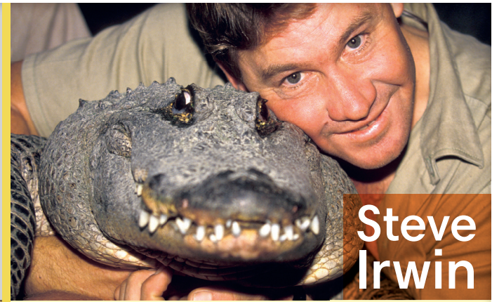
3. PRE-WRITING (13’)
ACTIVITY 1 + 2 + 3 + 4:
* Aim:
- To activate Ss’ prior knowledge of the topic.
- To lead in to the next activitiy.
- To study the Writing Box.

- To help Ss focus on personal information while reading the sample.
- To provide Ss the localized content to write about.
- To practice sentence building by filling in the blanks before Ss can write a complete text.
* Outcome: Do the exercise to improve grammar.
* Organisation : T_ Ss ..….
Teacher’s & Student’s activities |  |  | Content
1. (3’) Read Steve Irwin’s biography and  answer the questions.  (Exercise 1 – SB p.37)  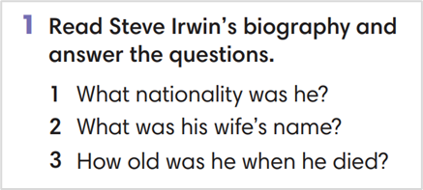  - T calls a student to read the instruction then checks Ss’ understanding of it.  - T has Ss work in pair and find the answers for the questions  - T encourages Ss to underlines the key sentences in the reading.  - T calls some volunteer students to give their answers then checks for the whole class. |  |  | Answer key:  1. Australian  2. Terri  3. forty-four years old (although he could have been forty-three if his birthday was after September)
2. (4’) Look at Steve’s biography again.
Find all the examples of Past Simple.
(Exercise 2 – SB p.37)
- T asks Ss to look at exercise 2.
- T calls a student to read the instruction then checks Ss’ understanding of it.
- T asks Ss to work in groups of three to read then complete the activity.
- T calls groups to give answers then shows the answers on the slide to check as the whole class.
3. (3’) Study the Writing box. Which of the phrases can you find in Steve’s biography?  (Exercise 3 – SB p.37)  - T asks Ss to look at exercise 3.  - T calls a student to read the instruction then checks Ss’ understanding of it.  - T asks Ss to work in pairs to read then complete the activity.  - T checks as the whole class. |  |  | 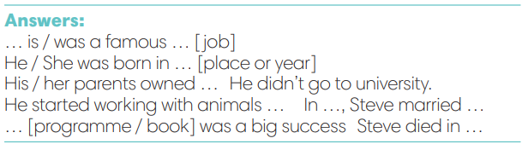
4. (3’) What do you know about Trinh Công Son?  Read the fact box and complete it with Past Simple form of the verbs in brackets.  (Exercise 4 – SB p.37)  - T asks Ss to look at the writing box and the sample writing again.  - T asks Ss to work individually, complete the facts about Trinh Cong Son  - T sets a time limit for the activity.  - T tells Ss to pair, share, and compare the answers.  - T shows the slides and check as the whole class. |  |  | 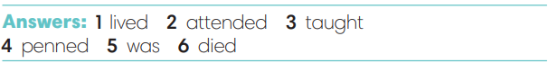
4. WHILE-WRITING (8’)
ACTIVITY 5:
* Aim: To provide students task to apply useful expressions from Writing Box in writing sentences with Past Simple tense.
* Content: Use the past simple tense to write a short biography.
* Outcome: Write a short biography of a famous people using the vocabulary and grammar points of the unit.
* Organisation : T_ Ss.. ….

Teacher’s & Student’s activities |  |  | Content
5. Write a short biography (60-80 words) of Trinh Cong Son. Use the fact box and the Writing Box from Exercise 4  (Exercise 5 – SB p.37)  - T calls a student to read the instructions then checks Ss’ understanding of it.  - T asks Ss to work individually to write a biography of Trinh Cong Son base on the Fact box and Writing Box  - T sets a time limit for the task and walk around as a monitor while Ss are writing. |  |  | 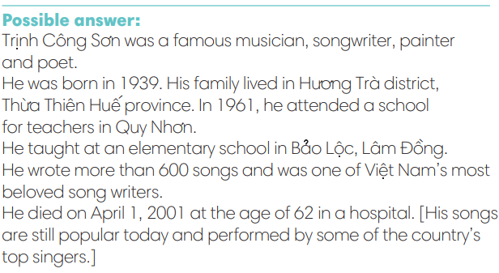
5. POST-WRITING (6’)
* Aim:
- To let Ss do peer-check.
- To give general comments on Ss’ writing pieces.
* Content: Ss swap their writing and check.
* Outcome: Ss’s biography is followed the writing rubric.
* Organisation : T_ Ss.. ….

Teacher’s & Student’s activities |  | Content
Extra activity 3: In pairs, swap your writing then check.  - T explains the writing rubric before checking.  - T asks Ss to swap their writing pieces, use the given writing rubric then do cross-check.  - T gives feedback on common mistakes of Ss’ work.  - T may collect Ss’ writing for detailed comments. |  | Writing rubric:  (1) Does the writing include details?  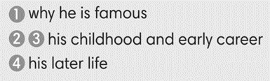  (2) Does the writing meet word limit (60-80 words)?  (3) Does the writing make any vocabulary and grammar mistakes?
WRAP-UP & HOME WORK (2’)
- T asks Ss to talk about what they have learnt in the lesson.
- A biography of a famous person
* HOME WORK:
- Do exercises in the workbook page 31.
- Prepare for Lesson 3.8

======================

