Date of planning:  Date of teaching: | UNIT 4: HEALTH AND FITNESS  Period 40: Lesson 2: Grammar
I. OBJECTIVES:
By the end of the lesson, students will be able to:
- talk about quantities of food.
1. Knowledge:
* Grammar:
- Identify and understand how to use quantifiers
- Talk about quantifiers of food with countable and uncountable nouns
- Use adverbs of frequency and quantifiers to talk about eating routines
2. Competence: Students use vocabulary about food, quantifiers, and understand the main grammatical points, then do the tasks assigned in the textbook; to use the Present simple, adverbs of frequency to talk about eating routines and quantities of food.
3. Quality/ behavior: To teach Ss to be hard-working and attentive in class. Ss have a positive attitude to working in groups, individual work, pair work, cooperative learning and working.
II. TEACHING AIDS:
- Teacher: Grade 7 textbook, Unit 4 (SB p. 42), laptop/computer connected to the Internet, loudspeaker, projector/TV, PPT slides…
- Students: Text books, studying equipment…
- Method: T-WC; group works; individual ……
III. PROCEDURE:

1. WARM UP (4’)
* Aims:
- To activate students’ prior knowledge and get students involved in the lesson.
- To set the context for introducing new structures.
* Content: Play game: Guessing Game to get students involved in the lesson and to set the context for the lesson.
* Outcome: Students know the context of the lesson.
* Organisation : T_ Ss , …
Teacher’s Student’s activities | Content
Extra activity 1: Guessing Game  - T divides Ss into 2 teams. Team boys and team girls.  - T introduces OTTO from the cartoon Minions  - T explains the game rules then checks instructions.  - T uses the slides to lead the game  - Ss raise up to give the guessing. T corrects Ss if necessary.  - T sets the scene for the new lesson: T tells Ss that they’ve just guess what OTTO usually eat at school.  They will learn more of food and models to talk about food.  - T writes the title on the board Unit 4: Health and Fitness / Lesson 4.2: Grammar | Game rules:  - Look at the hint.  - Guess the food  - 1 correct answer = 1 point.
2. REVIEW (4’)
ACTIVITY 1:
* Aims:
- To reinforce the vocabulary of food Ss already know
- To elicit the new words if needed
* Content: Some brief notes about the common snacks.
* Outcome: Have a vocabulary about snacks; know how to talk about their snacks and eating habbits.
* Organisation: T_ Ss , …
Teacher’s Student’s activities | Content
1. Class vote: Which snack do you usually eat at school?  (Exercise 1 – SB p. 42)  - T asks Ss to open their SB page 42, look at exercise 1.  - T calls a student to read the instruction then checks Ss’ understanding of it.  - T plays the audio for the Ss to listen and read the Vocabulary Box.  - T goes through the Vocabulary Box with the whole class, elicits the words if needed.  - Ss work individually to think of their own answer.  - T moderates the class from pair work to group work so that Ss could share their answers to as many friends as they can. | 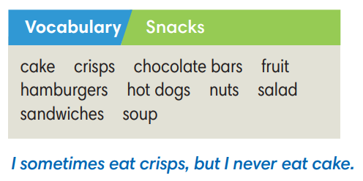
3. LEAD-IN (3’)
* Aims: To lead into the dialogue
* Content: Describe the picture on the slide.
* Outcome: Make guesses about the picture (what are they talking about?) then give answers.
* Organisation: T_ Ss , …
Teacher’s Student’s activities | Content
Extra Activity 2: See – think – wonder.  - T shows a picture on the slide then asks students three questions.  (1) What do you see in the picture?  (2) Who are they?  (3) What are they doing?  - T sets a time limit for Ss’ quick discussion.  - Ss work in pairs to make guesses about the picture then give answers.  - T calls some Ss to give answers then note them down on the board.  - T tells Ss that they’re going to read a dialogue in exercise 2 (SB p.42) to check all the answers. | 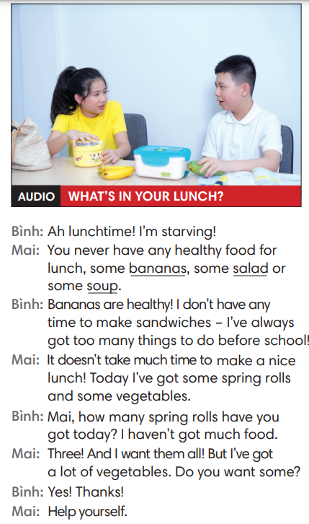
4. PRESENTATION (11’)
ACTIVITY 2 + 3:
Aims:
- To present the grammar point in context.
- To lead into the next activity.
- To introduce the Grammar Box
- To provide Ss with chances to work cooperatively.
- To explain the grammar point for Ss.
* Content: Read the conversation between Kyle and Zadie and find out new words. Learn the Past Simple.
* Outcome: Know more new words. Understanding the reading document; the topic of the lesson, grammar points…
* Organisation: T_ Ss , ..
Teacher’s Student’s activities | Content
2. (4’) Listen and answer the questions below  (Exercise 2 – SB p.42)  - T asks Ss to open their SB page 42, look at exercise 2.  - T calls a student to read the instruction then checks Ss’ understanding of it.  - T asks Ss to listen to and read the dialogue to find the answer for the questions.  - Ss work individually.  - T calls some Ss to give answers then shows the answers on the slide.  - T asks Ss to look at the sentences about Mai and elicits SOME – A LOT OF - ANY for Ss. | Answer keys:  1. No, he isn’t.  2. Today, Mai’s having some spring rolls and some vegetables.
3. (7’) Find more quantifiers with nouns in the dialogue.  (Exercise 3 – SB p42)  STEP 1: Introduce the Grammar Box  - T goes through the Grammar Box with Ss  - T reminds students that the uncountable nouns refer to things  we can’t count and that they don’t have a plural form.  - T explains to students that the words/ phrases in blue are  quantifiers.  STEP 2: Exercise 3  - T asks Ss to look at exercise 3.  - T calls a student to read the instruction then checks Ss’ understanding of it.  - T asks Ss to work in groups of three to complete the activity.  - T calls groups to give answers then shows the answers on the slide to check as the whole class.  *The grammar note  - T shows the Grammar Notes with all cases of quantifiers.  - T tells Ss to read the notes carefully. | 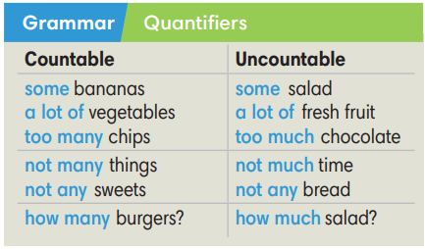
5. PRACTICE (13’)
ACTIVITY 4 + 5:
*Aim:
- To help Ss classify the countable and uncountable nouns
- To provide Ss grammar exercises to practice using quantifiers
* Content: Complete the text/sentences with the suitable quantifiers.
Understand the text; grammar points; quantifiers.
* Outcome: Know how to form a sentence with the suitable quantifiers. Understand the conversation; the topic of the lesson, vocabulary, grammar points…
* Organisation: T_ Ss .…..
Teacher’s Student’s activities | Content
4. (4’) Read what Mai and Binh eat for lunch in one week. Complete the sentences with suitable quantifiers. There is often more than one possible answer.  (Exercise 4 – SB p.42)  - T asks Ss to look at exercise 6.  - T calls a student to read the instruction then checks Ss’ understanding of it.  - T asks Ss to work in individually.  - T calls students to give answers then shows them on the slide to check as the whole class. | 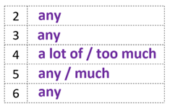
3. (4’) Cross out the incorrect quantifiers in each sentence.  (Exercise 5 – SB p.42)  - T asks Ss to look at exercise 5.  - T calls a student to read the instructions then checks Ss’ understanding of it.  - T asks Ss to work in individually.  - T encourages Ss to provide the reason for their choices.  - Ss read the sentences and think of the possible answers.  - T calls students to give answers then shows them on the slide to check as the whole class.  - T corrects Ss if any. | Answer key:  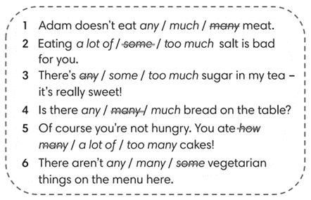
Extra activity 3 (5’): STREET GAME – The mix practice.  - T asks Ss to review quickly the vocabulary and grammar box  - T introduces the game and how to play rules  - T uses slides to lead the game.  - T allows Ss to say their answer massively to encourage the confidence and time challenge.  - T confirms the answers.  - T corrects Ss if any.  *Extra Activity: Teacher can get some exercises from Workbook page 35 for Ss to practice in class. | Game rules:  - Read the sentence carefully.  - Choose a word to fill in the blank.  - 1 correct answer = 3 points.
4. PRODUCTION (7’)
ACTIVITY 6:
*Aim: To help students applying the vocabulary items and grammar points related to the topic in communicating.
* Content: Ss make conversation about animals (where and when they were).
* Outcome: Ss know how to use past simple tense to make a conversations about their place and activities in the past.
* Organisation: T_Ss…

Teacher’s Student’s activities |  | Content
6. In pairs, say how much of these things you eat/drink.  (Exercise 6 – SB p.42)  - T asks Ss to look at exercise 6 (SB page 42).  - T calls a student to read the instruction then checks Ss’ understanding of it.  - T models the activity in front of the class.  - T divides Ss into new pairs, asks them to make conversations: share – ask - respond  - T walk around to listen and notes down common mistakes for delayed feedback.  - T calls some groups to come to the front of the class, make conversations.  - T asks the rest to give comments on their classmates’ performance.  - T gives feedback on Ss’ work. |  | 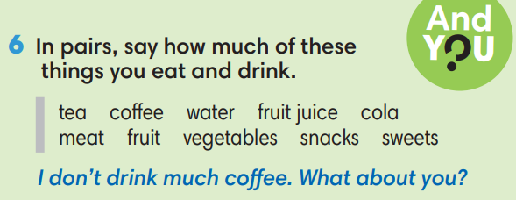
WRAP-UP & HOME WORK (3’)

- T asks Ss to talk about what they have learnt in the lesson.
- Countable and Uncountable nouns, quantifiers
* HOME WORK
- Do exercises in the workbook page 35.
- Prepare for Lesson 4.3: Reading.

