Date of planning:  Date of teaching: | UNIT 5: FOOD AND DRINK  Period 58 : Lesson 4: Grammar 2
I. OBJECTIVES:
By the end of the lesson students will be able to:
- use a, an, the correctly to talk about food and drink.
1. Knowledge:
* Vocabulary: about food and drink
* Grammar:
- Understand usage of articles: a, an, the.
- Use a, an, the to talk about food and drink.
2. Competence: Understand the main grammatical points, then do the tasks assigned in the textbook. Use a, an, the correctly to talk about food and drink.
3. Quality/ behavior: To teach Ss to be hard-working and attentive in class. Ss have a positive attitude to working in groups, individual work, pair work, cooperative learning and working.
II. TEACHING AIDS:
- Teacher: Grade 7 textbook, Unit 5 (SB p.54), laptop/computer connected to the Internet, loudspeaker, projector/TV, PPT slides…
- Students: Text books, studying equipment…
- Method: Active teach, T-WC; group works; individual ……
III. PROCEDURE:

1. WARM UP (3’)
* Aim:
- To create a positive classroom atmosphere to start a new lesson.
- To review the use of a, an, the and food and drink vocabulary.
* Content: Game: Word Jumble
* Outcome: Ss understand how to use a, an, the and revise food and drink vocabulary.
* Organisation: T-Ss.

Teacher’s & Student’s activities |  | Content
Extra activity 1: Word Jumble Game  - T explains the game rules then checks instructions.  - T shows on slides 5 sentences with word jumble.  - Ss join in the game individually.  - T corrects Ss if necessary.  - T tells Ss that, today they will learn about article a, an, the.  - T writes the title on the board Unit 5: Food and drink / Lesson 5.4: Grammar 2. |  | Game rules:  - Read the sentence carefully.  - Arrange the words to make sentences.  - 1 correct answer = 1 point.
2. LEAD-IN (3’)
*Aim:
- To lead into the new lesson.
* Content: Ss look at the picture and guess.
* Outcome: Ss understand the context of the following dialogue.
* Organisation: T-Ss, Ss-Ss, T-Ss.
Teacher’s & Student’s activities | Content
Extra activity 2: See – think – wonder.  - T shows a picture on the slide then asks students four questions.  (1) What can you see in the picture?  (2) What is she doing?  - T sets a time limit for Ss’ quick discussion.  - Ss work in pairs to make guesses about the picture then give answers.  - T calls some Ss to give answers then checks with the whole class. | Answer keys:  1- A girl and a smart phone.  2- The girl is ordering some food and drink.
3. PRESENTATION (13’)
ACTIVITY 1 + 2:
*Aim:
- To present the grammar point in context.
- To lead into the next activity.
- To introduce the Grammar Notes and explain the grammar point.
* Content:
- Ss discuss with each other which food they order online.
- Ss find the articles a, an, the in the dialogue.
* Outcome: Ss understand how to use a, an, the in contexts.
* Organisation: T-Ss, Ss-T, Ss-Ss.

Teacher’s & Student’s activities | Content
1. (7’) Class vote: What kinds of food do you order online?
(Ex 1, SB p.54)
- T asks Ss questions:
(1) Have you ever ordered food online?
(2) Which application / website did you use?
(3) Which food did you order?
- T writes Ss’ answers on the board and Ss do a class vote.
2. (6’) Study the Grammar box. Find examples of articles in the dialogue.  (Ex 2, SB p.54)  - T asks Ss to work in pairs, read the dialogue and underline all a, an, the.  - T asks 2 Ss to read the dialogue out loud. While they are reading, other Ss say “stop” when they find a, an, the.  - T asks Ss to look at the Grammar Box in SB p.54.  - T uses slide to display the Language Note.  - T encourages Ss to make sentences using a, an, the.  - Each S makes sentences using a, an, the.  - T asks 3 to 5 Ss to give examples and check. | 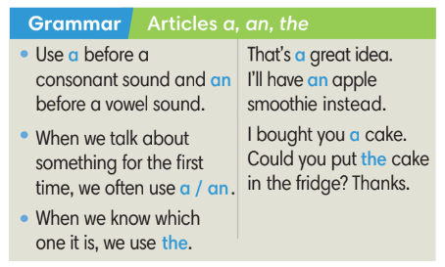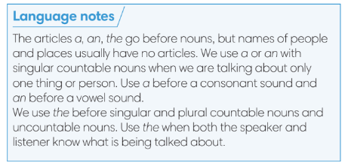
4. PRACTICE (16’)
ACTIVITY 3:
* Aims:
- To help Ss practise using a, an, the.
- To help Ss practise the new grammar points in contexts.
- To practise solving some types of grammar exercises.
* Content:
- Game: Find the mistake.
- Fill in the blanks with a, an, the.
- Match two parts of the sentences.
* Outcome: Ss can use a, an, the correctly and can make sentences using these articles.
* Organisation: T-Ss, Ss-T, Ss-Ss.
Teacher’s & Student’s activities | Content
(3’) Extra activity 3: Find the mistake game.  - T explains the game rules then checks instructions.  - Ss work in 4 groups.  - T collects Ss answer and checks. | Game rules:  - Read the paragraph carefully. (The paragraph has some mistakes of using a, an, the).  - Find all mistakes from the paragraph.  - 1 correct answer = 1 point.
(3’) 3. Fill in the blanks with the correct articles.  (Ex 3 SB p.54)  - T elicits the direction with Ss.  - T encourages Ss to finish Exercise 3 individually and find the reasons for the answers.  - T calls some Ss to share their answers and the reasons. | Answer key:  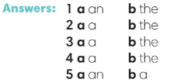
(3’) Match the two parts of the sentences 1-8 with a-h.  (Ex 3 WB p.46)  - T asks Ss to read the instructions and checks their understanding.  - Ss work in pairs to finish Exercise 3.  - T checks Ss’ answers. | Answer keys:  1 h 2 g 3 a 4 b  5 e 6 c 7 d 8 f
(3’) Extra activity 4: Sentence making.
- T asks Ss to work in groups of 3. 1 student makes sentences with a, another makes sentences with an and the last one uses the.
- T sets time limit. After 30 seconds, Ss change the role.
(4’) Extra activity 5: Hot potato game.  - T explains the game rules then checks instructions.  - T collects Ss answer and checks. | Game rules:  ✔ The student has the ball needs to make a sentence with one article.  ✔ The next student receives the ball and article from the previous student.  ✔ 1 correct answer = 1 point.
5. PRODUCTION (7’)
ACTIVITY 4:
* Aims: To help Ss applying the vocabulary items and grammar points related to the topic in communicating.
* Content: Ss ask and answer about food.
* Outcome: Ss can use the articles a, an, the and vocabulary about food in conversation.
* Organisation: T-Ss, Ss-T, Ss-Ss, Pair work.

Teacher’s & Student’s activities | Content
4. Uses the ideas in Exercise 3 to ask and answer questions about food with your partner.  (Ex 4, SB p.54)  - T asks Ss to look at Exercise 4 (SB p.54).  - T calls a student to read the instructions and example.  - T explains to Ss that they are going to do the task in pairs.  - T asks 3 groups to model the activity in front of the class.  - T asks the other Ss to give comments on their classmates’ performance.  - T asks Ss to line up into 2 lines, facing each other. Ss work in pair with the opposite Ss.  - After each 20 seconds, T says “switch”, Ss move one step to change partners.  - T walks around to note down any mistakes for later feedback. | 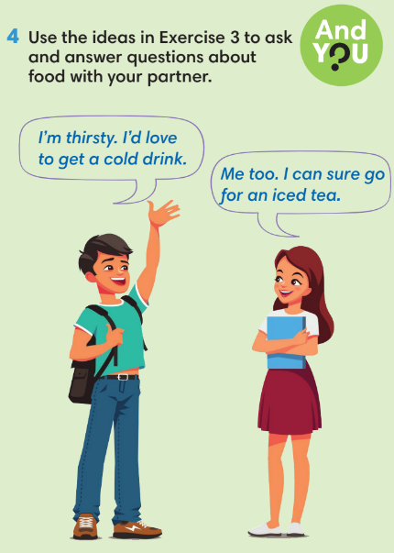
WRAP-UP & HOME WORK (3’)
- T asks Ss to talk about what they have learnt in the lesson.
✔ Articles: a, an, the.
* HOME WORK
- Do exercises in the workbook page 46.
- Prepare for Lesson 5.5: Listening and vocabulary.

