Date of planning:  Date of teaching: | UNIT 5: FOOD AND DRINK  Period 63-Lesson 9: Revision
I. OBJECTIVES:
By the end of the lesson, Ss are able to:
1. Knowledge:
* Vocabulary: Review vocabulary and grammar in the unit.
* Grammar: Review quantifiers and articles.
2. Competence: Ss understand and use the vocabulary of the unit to do the tasks assigned in the textbook. Ss can talk about their favourite food and write an invitation email.
3. Quality/ behavior : To teach Ss to be hard-working and attentive in class. Ss have a positive attitude to working in groups, individual work, pair work, cooperative learning and working.
II. TEACHING AIDS:
- Teacher: Grade 7 textbook, Unit 5 (SB p.59, WB p.50), laptop/computer connected to the Internet, loudspeaker, projector/TV, PPT slides …
- Students: Textbooks, studying equipment …
III. PROCEDURE:

- WARM-UP (4’)
*Aims:
- To create a positive classroom atmosphere to start a new lesson.
- To lead into the review lesson.
* Organisation: Teacher’s instructions …
Teacher’s & Student’s activities | Content
Extra activity 1: SUPER EYES  - Set the scene: T asks Ss to do quick exercises for eyes such as look up and down, look left and right, row the eyes  - T tells Ss that they are going to play a game called SUPER EYES  - T explains the game rules then checks instructions.  - T uses the slides to show the collages.  - Ss join in the game in pairs or in small groups.  - T shows the collage again with displayed answers to check for the whole class.  - T tells Ss that they are going to review Unit 5. | Game rules:  - Look carefully at a collage of different small pictures  - The collage will disappear in a few seconds.  - Recall as many words about the collage as you can remember.
- REVIEW VOCABULARY (21’)

ACTIVITIES 1 + 2 + 3:
* Aims:
- To help students reviews vocabulary and word friends from the unit.
- To review vocabulary in contexts.
* Organisation : Teacher’s instructions….
Teacher’s & Student’s activities | Content
Extra activity 2: (4’) Game - Hangman  - T asks Ss to look at vocabulary of Unit 5 from the Glossary box SB p.58.  - T introduces the game rules. | Game rules:  - T shows the letter number of an unknown word.  - Ss guess by saying one letter.  - If the answer is wrong, teacher starts drawing the hang man.
1. (4’) Put the words into the correct column.  (Ex 1 – SB p.59)  - T asks Ss to look at Exercise 1 in student book page 59.  - T calls a S to read the instruction then checks Ss’ understanding of it.  - T asks Ss to work in pairs to read then complete the activity.  - T encourages Ss to give the reason for their answers.  - T checks as the whole class. | Answer keys:  - Containers: carton, sack, tin.  - Food: pancake, pasta, cereal.  - Flavours: sour, spicy, mild.  - Drinks: smoothie, sake, bubble tea.
2. (4’) In pairs, describe the food and drinks below that you have regularly. Choose two things you like best.  (Ex 2 – SB p.59)  - T asks Ss to look at Exercise 2 in student book page 59  - T calls a S to read the instruction then checks Ss’ understanding of it.  - T asks Ss to work in pairs to discuss which food and drinks they like best and describe them to each other.  - T corrects pronunciation if needed. | 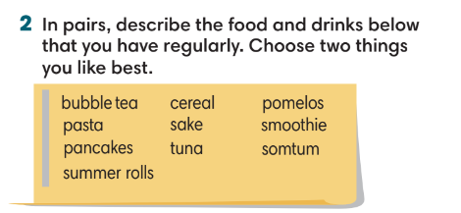
3. (4’) Take turns to tell your partner about your favorite food. Use these ideas.  (Ex 3 – SB p.59)  - T asks Ss to look at Exercise 3 in student book page 59  - T calls a S to read the instruction then checks Ss’ understanding of it.  - Ss work in groups of 4 to share their ideas.  - T checks as the whole class. | 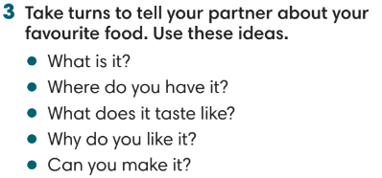
Extra activity 3: (5’) Game – Unscramble words  - T divides the class into 4 teams and explains game rule.  - T prepares a few sentences using word friends in Unit 5. | Game rules:  - Ss receive 10 bags with unscramble words of 10 sentences (words are written and cut into pieces).  - 1 correct sentence = 1 point.
3. REVIEW GRAMMAR ( 10’)
ACTIVITIES 4 + 5:
*Aims:
- To reinforce the grammar of Unit 5.
* Organisation: T-Ss, Ss-T, Pair work.
Teacher’s & Student’s activities | Content
4. (3’) Complete the text with the missing articles.  (Ex 4 – SB p.59)  - T helps Ss to review grammar before doing this task.  - Ss work individually.  - T checks Ss answers. | Answer keys:  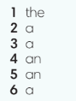
5. (3’) Match the quantifiers (1-4) with the food (a-d). Then match with the pictures.  (Ex 5 – SB p.59)  - T asks Ss to look at Exercise 5 in student book page 59  - T calls a S to read the instruction then checks Ss’ understanding of it.  - T asks Ss to work individually and then share the answers in pairs.  - T checks as the whole class, asks Ss for the reasons of their answers. | Answer keys:  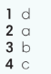
Extra activity 4: (4’) Game – Whisper.  - T divides the class into 4 teams and explains game rule.  - T prepares a recipe with a number of sentences. | Game rules:  - T gives sentence one by one.  - Ss take turn to whisper until the last S of the team get it and write on the board.  - 1 correct sentence = 1 point.  - Guess the dish name correctly = 3 points.
4. WRITING (7’)
ACTIVITY 6:
*Aims:
- To help student practise writing an invitation email.
* Organisation: T-Ss, Ss-T.
Teacher’s & Student’s activities | Content
6. Your family is holding a house-warming party this weekend. Write an email (60-80 words) to invite your best friend to come to the party.  (Ex 6 – SB p.59)  - T asks Ss to look at exercise 6.  - T calls a S to read the instruction then checks Ss’ understanding of it.  - Ss finish writing individually.  - T goes around to give feedback while Ss are writing.  - T invites some Ss to share their email. | 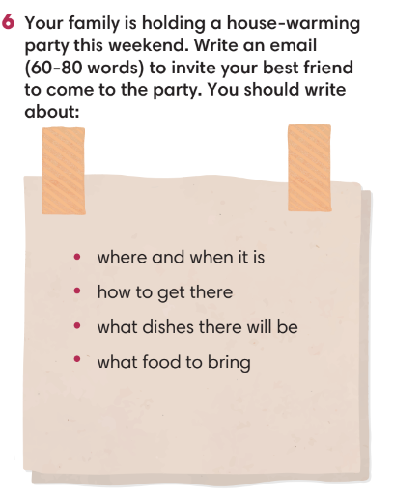
WRAP-UP & HOME WORK ( 3’)
- T asks Ss to talk about what they have learned in the lesson.
- Review vocabulary and grammar of Unit 5.
- An email of invitation.
* HOMEWORK
- Do exercises in the workbook page 13.
- Prepare for Unit 6/Lesson 6.1: Vocabulary

