Date of planning:  Date of teaching: | UNIT 6: SCHOOLS  Period 64-Lesson 1: Vocabulary
I. OBJECTIVES:
By the end of the lesson, Ss will be able to:
- know the meaning of the new words and talk about favorite subjects
- use the targeted language to practice talking about favorite school activities.
1. Competence:
- To know the meaning of the new words and talk about favorite subject, then do the tasks assigned in the textbook.
- To use the targeted language to practice talking about favorite school activities.
2. Quality/Behavior: To teach Ss to be hard-working and attentive in class. Ss have a positive attitude to working in groups, individual work, pair work, cooperative learning and working.
II. TEACHING AIDS:
- Teacher: Grade 7 textbook, Unit 6 (SB p.60-61, WB p.51-52), laptop/computer connected to the Internet, loudspeaker, projector/TV, PPT slides…
III. PROCEDURE:
1. WARM UP( 5’)
* Aims:
- To review previous lesson vocabulary.
* Organisation: T-Ss, Ss-T, Group work.
Teacher’s & Student’s activities |  | Content
Extra activity 1: Game - Word Jumble Race:  - T divides the class into 4 teams, explains the game rules then checks instructions.  - T corrects grammar and pronunciation mistakes while Ss take part in the game |  | Game rules:  - T give 10 sentences (using vocabulary from Unit 5) for each team. Each sentence is written and cut into words. Remember to keep the sentences separately.  - All teams arrange the sentences.  - The first team to finish is the winner.
2. PRESENTATION 1 (9’)
ACTIVITY 1:
* Aims:
- To teach new words.
- To lead in to next activity.
* Organisation: T-Ss, Ss-T, Pair work.
Teacher’s & Student’s activities | Content
1. Complete the table below using the words in the box.  (Ex 1 – SB p.60)  - T reads all new words and asks Ss to repeat.  - T checks Ss’ pronunciation. Have 3 to 5 Ss to read in front of the class.  - T checks meaning of each word with Ss, explain what these subjects are about: e.g. Biology – the scientific study of the natural processes of living things.  - T asks Ss to open their SB page 60, look at Exercise 1.  - T calls a S to read the instruction then checks Ss’ understanding of it.  - Ss work in pairs to check which subject they like/ don’t like and which day they study that subject.  - T conducts a survey to find out the most liked/ least liked subjects and their positions in the timetable. | 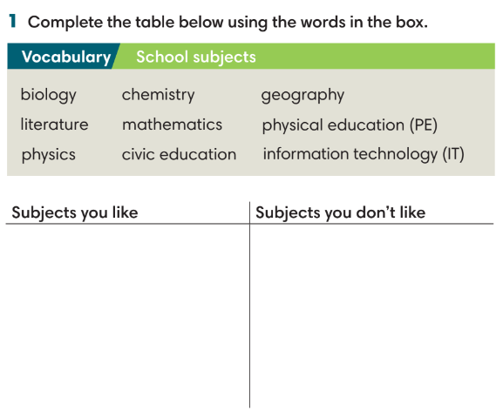
3. PRESENTATION 2 (9’)
ACTIVITIES 2 & 3:
* Aims:
- To teach Ss about school timetable.
- To learn collocations.
- To help Ss use the new vocabulary in context.
* Organisation: T-Ss, Ss-T, Individual work, Group work.
Teacher’s & Student’s activities |  | Content
2. (5’) Listen to Nam talking about his school timetable. Answer the following questions.  (Ex 2 – SB p.60)  - T asks Ss to look at Exercise 2 on page 60, read all 3 questions, underline key words.  - Ss guess the answers before listening:  1. a number: 8, 9, 10  2 and 3. days of the weeks: Monday, Tuesday, etc.  - T play the recording, Ss listen and finish Exercise 2. |  | Answer keys:  1 – 9.  2 – everyday in the morning.  3 – Wednesday.
3. (4’) Fill in the gaps with do, take or have to make Word Friends. Some gaps can be filled with two words.  (Ex 3 – SB p.60)  - Ss finish Exercise 3.  - T check Ss answers and explain the meaning if needed.  - Ss work in groups of to make 8 sentences using 8 collocations. The first team to finish is the winner. |  | Answer keys:  1. do/ take 2. have 3. have 4. take/ have  5. do/ take 6. take/ have 7.take 8. take/ have
4. PRACTICE (11’)
ACTIVITY 4:
* Aims:
- To find out activities of each subject.
- To provide more words related to the topic.
* Organisation: T-Ss, Ss-T, Individual work.
Teacher’s & Student’s activities |  | Content
4. (6’) Match the subjects with the activities.  (Ex 4 – SB p.61)  - T asks Ss to look at Exercise 4 (SB p.61).  - T calls a S to read the instruction then checks Ss’ understanding of it.  - T gives Ss 2 minutes to complete.  - T checks Ss’ answers. |  | Answer keys:  1. chemistry 2. art 3. physical education  4. information technology 5. mathematics  6. geography
(5’) Extra activity 2: Game – Hangman.  (Adapted from Exercise 3 – WB p.52)  - T gives the clue and total letter quantity of the words.  - Ss guess it by suggesting letters within a certain number of guesses. |  | Answer keys:  1. (vertical): compete.  2. equation  3. build  4. flag  5. draw  6. experiment  7. paint
5. PRODUCTION (8’)
ACTIVITY 5:
* Aims: To help Ss practice applying the vocabulary items and grammar points related to the topic in speaking.
* Organisation: T-Ss, Pair work, Group work.
Teacher’s & Student’s activities |  | Content
5. Work in pairs. Tell your friend about the subject and the activities in that subject that you like most.  (Ex 5 – SB p.61)  - T asks Ss to look at Exercise 5 (SB page 61).  - T calls a S to read the instruction then checks Ss’ understanding of it.  - T asks Ss to work in pairs following examples.  Extra activity 3: Game – Guessing game.  - T divides the class into 2 groups.  - Change the representative in the following turn. |  | Game rules:  - 2 Ss from each group receive a secret subject.  - These students need to describe activities of that subject for the team to guess.  - The faster team is the winner.  Example:  We study new words, practice listening, reading, writing and speaking.  English

WRAP-UP & HOME WORK (3’)
T asks Ss to talk about what they have learnt in the lesson.
- Vocabulary subjects and activities.
- Grammar points: School activities with do, make and have.
* HOME WORK
- Do exercises in the workbook page 51-52.
- Prepare for Lesson 6.2: Grammar 1.

