Date of planning:  Date of teaching: | UNIT 6: SCHOOLS  Period 65-Lesson 2: Grammar 1
I. OBJECTIVES:
By the end of the lesson, Ss will be able to:
- Use vocabulary about school activities.
- Use must, mustn’t, should and shouldn’t to talk about things at school and at home.
1. Competence: Ss know to use vocabulary about school activities, and understand the main grammatical points, then do the tasks assigned in the textbook; use must, mustn’t, should and shouldn’t to talk about things at school and at home.
2. Quality / behavior: To teach Ss to be hard-working and attentive in class. Ss have a positive attitude to working in groups, individual work, pair work, cooperative learning and working.
II. TEACHING AIDS:
- Teacher: Grade 7 textbook, Unit 6 (SB p.62), laptop/computer connected to the Internet, loudspeaker, projector/TV, PPT slides…
III. PROCEDURE:
1. WARM UP (4’)
* Aims:
- To activate students’ prior knowledge and get students involved in the lesson.
- To set the context for introducing new structures.
* Organisation: T-Ss, Ss-T
Teacher’s and Student’s activities |  |  | Content
Extra activity 1: Game  - T divides Ss into 2 teams, board into 2 columns:  + Column A: Activities Ss are allowed to do at school  + Column B: Activities Ss are not allowed at school  - T explains the game rules then checks instructions.  - T sets the scene for the new lesson: T tells Ss that they are going to learn how to use modal verbs.  - T writes the title on the board: Unit 6: Schools  Lesson 6.2: Grammar 1 |  |  | Game rules:  ✔ 1 minute to list all activities.  ✔ Ss take turns to write activities into 2 columns.  ✔ 1 correct answer = 1 point.
2. LEAD-IN (6’)
* Aims: To lead into the dialogue.
* Organisation : T-Ss, Ss-T.
Teacher’s and Student’s activities |  |  | Content
Extra activity 2: Vocabulary box.  (SB p.62)  - T asks Ss to work in pairs, list habits of good students and the opposite ones.  - T shows the vocabulary box, pronounces words and asks Ss to repeat.  - T explains meaning of new words.  - T asks Ss to make sentences with these words and then check. |  |  | 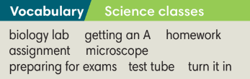
3. PRESENTATION (11’)
ACTIVITIES 1 + 2:
* Aims:
- To introduce the Grammar Box.
- To present the grammar point in context.
- To provide Ss with chances to work cooperatively.
- To lead into the next activity.
* Organisation: T-Ss, Ss-T, Group work.
Teacher’s Student’s activities | Content
1. (4’) Listen. Which rules are Mai and Nam talking about?  (Ex 1 – SB p.62)  - T divides the class into 4 groups.  - Each group needs to note down the sentence with must, mustn’t, should and shouldn’t.  - T plays the recording and check Ss answers. | Answer keys:  They are talking about rules of studying.
2. (7’) Study the Grammar box. Listen to the dialogue again and complete sentences with must, mustn’t, should and shouldn’t.  (Ex 2 – SB p.62)  STEP 1: Introduce the Grammar Box  - T goes through the Grammar Box with Ss  - T reminds Ss that the should/ shouldn’t refers to advice or an opinion whereas must/ mustn’t is used for obligation and rules.  STEP 2: Exercise 2  - T asks Ss to look at exercise 2.  - T calls a S to read the instruction then checks Ss’ understanding of it.  - T asks Ss to finish Exercise 2 before listening to the recording.  - T plays the recording for Ss to check answers.  *The grammar note  - T shows the Grammar Notes.  - T tells Ss to read the notes carefully. | 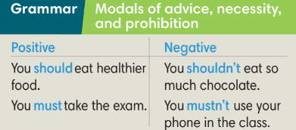  Answer keys:  1 must 2 shouldn’t 3 must  4 musn’t
5. PRACTICE (14’)
ACTIVITIES 3 and 4:
* Aim:
- To help Ss understand the difference between should/ shouldn’t, must/ mustn’t.
- To provide Ss grammar exercises to practice using the above modal verbs.
* Organisation : T-Ss, Ss-T, Pair work
Teacher’s and Student’s activities |  | Content
3. (5’) Look at the rules in the classroom poster from Linda’s classroom. Write a sentence for each picture. Use must, mustn’t, should or shouldn’t.  (Ex 3 – SB p.62)  - T asks Ss to look at Exercise 3.  - T calls a S to read the instruction then checks Ss’ understanding of it.  - T and Ss discuss the example and analyze why ‘must’ is used.  - T asks Ss to work in individually to finish Exercise 3 and find out which rule is same for their school.  - T calls Ss to give answers then shows them on the slide to check as the whole class. |  | Answer keys: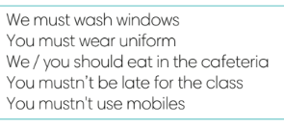
4. (5’) Class vote: Which three classroom rules are the most important?  (Ex 4 – SB p.62)  - T asks Ss work in pairs and list classroom rules.  - T collects Ss answers and write on the board.  - T conducts class vote to find three rules are considered to be the most important and reasons.  - T asks Ss if they could change one rule, what would they change? |  | 
(4’) Extra activity 3.
- T gives Ss the topic “Taking a test”
- T divides class into 4 groups to make sentences using must, mustn’t, should or shouldn’t
- T asks Ss to give answers in front of the class and give feedback.
6. PRODUCTION ( 7’)
ACTIVITY 5:
*Aim: To help students applying the vocabulary items and grammar points related to the topic in communicating.
* Organisation: T-Ss, Ss-Ss, Pair work
Teacher’s Student’s activities | Content
5. In pairs, discuss Linda’ school rules. Compare your classroom rule with Linda’s.  (Ex 5 – SB p.62)  - T asks Ss to look at Exercise 5 (SB page 62).  - T calls a student to read the instruction then checks Ss’ understanding of it.  - T models the activity in front of the class.  - T asks Ss to work in pairs, find the similarities and differences between their classroom rules with Linda’s.  - T walks around to listen and notes down common mistakes for later feedback.  - T calls some groups to come to the front of the class and make conversations.  - T asks the rest to give comments on their classmates’ performance.  - T gives feedback on Ss’ work. | 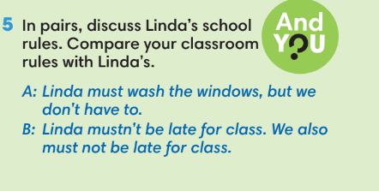
WRAP-UP & HOME WORK (3’)
T asks Ss to talk about what they have learnt in the lesson.
✔ Must, mustn’t, should, shouldn’t.
* HOME WORK
- Do exercises in the workbook page 53.
- Prepare for Lesson 6.3: Reading and Vocabulary.

