Date of planning:  Date of teaching: | UNIT 6: SCHOOLS  Period 66-Lesson 3: Reading and Vocabulary
I. OBJECTIVES:
By the end of the lesson, Ss will be able to:
- locate information and find specific details in a text (scanning skill).
- identify the main ideas of the paragraphs in the text or the text itself (skimming).
1. Competence: Understand the meaning of the keywords used to talk about school system in Việt Nam, then do the tasks assigned in the textbook; locate information and find specific details in a text (scanning skill); identify the main ideas of the paragraphs in the text or the text itself (skimming skill).
2. Quality/behavior: To teach Ss to be hard-working and attentive in class. Ss have a positive attitude to working in groups, individual work, pair work, cooperative learning and working.
II. TEACHING AIDS:
- Teacher: Grade 7 textbook, Unit 6 (SB p.63, WB p.54), laptop/computer connected to the Internet, loudspeaker, projector/TV, PPT slides …
III. PROCEDURE:
1. WARM-UP (5’)
* Aim:
- To help Ss review grammar they have learnt.
- To lead into the next activity.
* Organisation: T-Ss, Ss-T.
Teacher’s & Student’s activities |  | Content
Extra activity 1: Lucky number  - T explains the game rules then checks instructions.  - T uses slide to lead the game.  - Ss raise their hands if they have the answer.  - T tells Ss that they are going to read about school system in Vietnam.  - T writes the title for the new lesson:  Unit 6/Lesson 3: Reading and vocabulary. |  | Game rules:  - T shows key words on the slide.  - Ss make sentences using must, mustn’t, should, shouldn’t.  - Choose randomly one number (1-9) to see your score.
2. PRE-READING (5’)
ACTIVITY 1:
* Aim:
- To activate Ss’ background knowledge of the topic.
- To get Ss think about their schools.
* Organisation: T-Ss, Ss-T, Pair work.
Teacher’s & Student’s activities | Content
1. Change the statements so that they are true about your school.  (Ex 1 – SB p.63)  - T asks Ss to work in pairs and find statements that are not true and change them.  - T collects Ss answer and discuss with the whole class. | 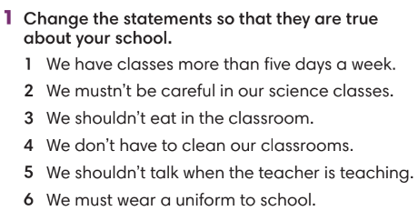
3. WHILE-READING (15’)
ACTIVITY 2 + 3:
*Aim:
- To read two texts and do reading tasks.
- To help students practise finding main ideas of the text.
- To help students practice reading for specific information in a text.
* Organisation: T-Ss, Ss-T.
2. (4’) Read the text and choose the best title  (Ex 2 – SB p.63)  Step 1: Scan the text  - T asks Ss to look at Exercise 2 (SB page 63).  - T explains to Ss that they need to do skimming and find main ideas.  - T sets time limit for Ss to find main ideas and finish Exercise 2.  - T asks Ss to check answers with their partners before checking with the whole class and explain reasons for their answers. | Answer keys:  Subjects Vietnamese student study
3. (6’) Read the text again and fill in the gaps to complete the sentences.  (Ex 3 – p.63)  Step 1: Scanning  - T asks Ss to read the text again, underline key information and try to remember.  - T sets time limitation such as 3 minutes.  - T explains any new words if needed.  - T asks Ss to close the book and answer some questions about the text basing on memory.  1. Which subject is listed first?  2. What do students learn in maths lessons?  3. List one subject that requires Ss to do experiment.  4. Which language is the most common in the school system?  5. What do students learn in information technology class?  Step 2: Exercise 3  - T asks Ss to look at Exercise 3 (SB page 63).  - T asks Ss to predict what types of words might fill in the gap such as adjectives, verbs, nouns, etc.  - T tells Ss to read the text again individually to  complete Exercise 3.  - T asks Ss to underline these sentences in the text and check Ss’ answers. | Answer keys:  1 secondary  2 Vietnamese  3 algebra; geometry  4 chemistry  5 geography  6 English
4. POST-READING (17’)
ACTIVITIES 4 & 5:
* Aim:
- To study the Vocabulary box.
- To use words from Vocabulary box in contexts.
* Organisation: T-Ss, Ss-T, Ss-Ss, Group work, Pair work.
4. (5’) Find the phrases below in the text. How do you say them in your language?  (Ex 4 – SB p.63)  - T asks Ss to work in pairs, find these phrases in the text and explain the meaning.  - T collects and checks Ss answers. | 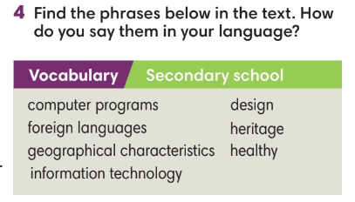
(5’) Tic-tac-toe game.  - T tells Ss that they are going to play a game to use words from Vocabulary box in the context by making sentences.  - T tells Ss the game rules.  - T corrects Ss’ answers if needed. | Game rules:  - T divides the class into 2 teams.  - T gives one keyword (in the Vocabulary box from Exercise 4).  - Each team takes turns to make a sentence with these words. If the answer is correct, that team places one X or O.
5. (7’) Work in groups of three or four. Tell your friends about your favorite class.  (Ex 5 – SB p.63)  - T asks Ss to look at Exercise 5 (SB page 63).  - T calls a S to read the instruction then checks Ss’ understanding of it.  - T asks a S to read the example.  - T set time limitation for Ss to prepare and then share in groups of four.  - T invites some volunteers to present in front of the class and notes down useful or interesting sentences.  - T asks the rest to give comments on their classmates’ performance and then provides teacher’s feedback.  - T asks Ss to walk around the class, find the person with the same favorite class to share their ideas. | 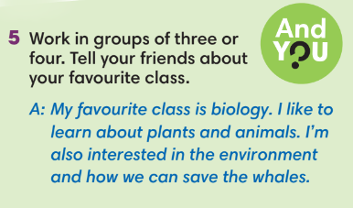
WRAP-UP & HOME WORK (3’)
- T asks Ss to talk about what they have learnt in the lesson.
- Vocabulary of school subjects.
- Reading a text about subjects Vietnamese students study.
- Group discussion.
* HOME WORK
- Do exercises in the workbook page 54.
- Prepare for Lesson 6.4: Grammar 2.

====================

