Date of planning:  Date of teaching: | UNIT 6: SCHOOLS  Period 67-Lesson 4: Grammar 2
I. OBJECTIVES:
By the end of the lesson, Ss will be able to:
- use “used to” to talk about routines and states that finished in the past and are no longer true.
1. Competence: Understand the main grammatical points, then do the tasks assigned in the textbook. Use “used to” correctly when talking about activities.
2. Quality/ behavior: To teach Ss to be hard-working and attentive in class. Ss have a positive attitude to working in groups, individual work, pair work, cooperative learning and working.
II. TEACHING AIDS:
- Teacher: Grade 7 textbook, Unit 6 (SB p.64), laptop/computer connected to the Internet, loudspeaker, projector/TV, PPT slides…
- Students: Text books, studying equipment…
- Method: Active teach, T-WC; group works; individual ……
III. PROCEDURE:

1. WARM UP (5’)
* Aim:
- To create a positive classroom atmosphere to start a new lesson.
- To review the use of vocabulary for school activities.
* Organisation: T-Ss, Ss-T.
Teacher’s & Student’s activities |  | Content
Extra activity 1: Game.  - T explains the game rules then checks instructions.  - T writes on the board names of subjects (maths, geography, language, physical education, information technology, etc.).  - T divides Ss into 4 groups. Each group receives some cards with school activities.  - T corrects Ss if necessary.  - T tells Ss that, today they will learn about used to to talk about school activities in the past. |  | Game rules:  - Read the school activities carefully.  - Put the cards into correct subject.  - The fastest team is the winner.
2. LEAD-IN (4’)
*Aim:
- To lead into the new lesson.
* Organisation: T-Ss, Ss-T.
Teacher’s & Student’s activities | Content
Extra activity 2
- T asks Ss to list activities they used to do when they are younger but don’t do them now.
- T divides the board into 2 to record all answers for following activities.
3. PRESENTATION (13’)
ACTIVITY 1 + 2:
*Aim:
- To present the grammar point in context.
- To lead into the next activity.
- To introduce the Grammar Notes and explain grammar points.
* Organisation: T-Ss, Ss-T, Pair work, Group work.
Teacher’s & Student’s activities | Content
1. (7’) In pairs, read the text, look at the pictures and discuss the primary school activities you used to do, but don’t do any longer.  (Ex 1 – SB p.64)  - T asks Ss to look and describe the activities in the pictures.  - T explains any new words if needed.  - Ss work in pairs to read the text.  - T calls volunteers to read in front of the class.  - T asks Ss to underline school activities in the text.  - Ss work in groups of 4 to discuss about their school activities which they used to do. | 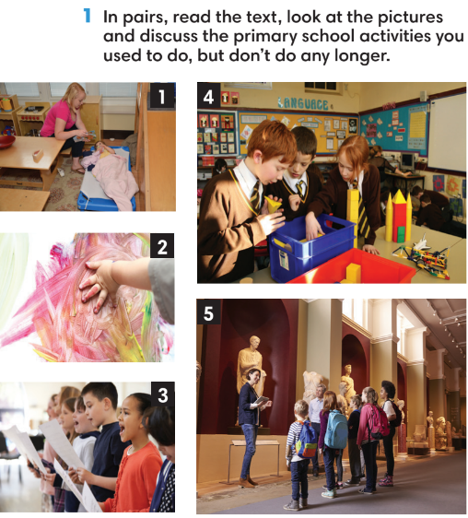
2. (6’) Study the Grammar box. Find examples of used to and didn’t use to in the dialogue.  (Ex 2 – SB p.64)  - T asks Ss to look at the Grammar Box in SB p.64 and explains the usage of “used to” to talk about activities used to do in the past but don’t do now.  - T asks Ss to read the dialogue again and underline used to and didn’t use to in the dialogue to finish Exercise 2.  - T checks Ss’ answers. | 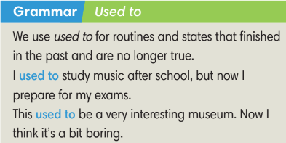
4. PRACTICE (15’)
ACTIVITIES 3:
* Aims:
- To provide Ss with language notes.
- To help Ss practice making negatives and questions with used to.
- To help Ss practice new grammar points in context.
- To practice solving some types of grammar exercises.
* Organisation: T-Ss, Ss-T, Ss-Ss.
Teacher’s & Student’s activities | Content
(6’) Extra activity 3: Language notes.  - T shows the Language notes on the slide.  - T asks Ss to provide examples of all three form of used to (positive, negative and question).  - T uses activities from Lead-in, divide the class into 3 groups to make sentences using 3 forms of used to. | 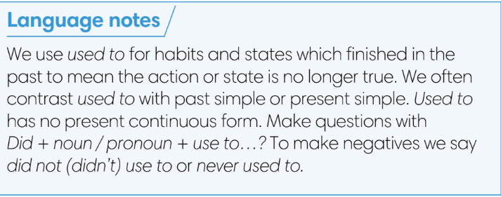
3. (4’) Peter does the following activities this year. Write about what Peter used to do and didn’t use to do last year.  (Ex 3 – SB p.64)  - T asks Ss to read the instructions and checks their understanding.  - Ss work individually to finish exercise 3.  - T checks Ss’ answers. | Answer keys:  1. He didn’t use to play football.  2. He used to paint pictures.  3. He didn’t use to build a website.  4. He used to compete in a game.  5. He didn’t use to study algebra.
(5’) Extra activity 4: Game – Hot potato.  - T explains the game rules then checks instructions.  - T collects Ss’ answers and checks. | Game rules:  ✔ The S who has the ball needs to make a sentence with used to (positives, negatives or questions).  ✔ The next S receives the ball and makes another sentence.  ✔ 1 correct answer = 1 point.
5. Production (5’)
ACTIVITY 4:
* Aims: To help Ss applying the vocabulary items and grammar points related to the topic in communicating.
* Organisation: T-Ss, Ss-T, Ss-Ss, Pair work.

Teacher’s & Student’s activities | Content
4. Think back to when you were in primary school or kindergarten. In pairs, tell your partner what you used to do.  (Ex 4 – SB p.64)  - T asks Ss to look at exercise 4 (SB page 64).  - T calls a S to read the instructions and example.  - T explains to Ss that they are going to do the task in pairs.  - T asks 3 groups to model the activity in front of the class.  - T asks the other Ss to give comments on their classmates’ performance.  - T asks Ss to line up into 2 lines, facing each other. Ss takes turn to say the sentence to their partner.  - After each 20 seconds, T say “switch”, Ss move one step to change partners.  - T walks around to note down any mistakes for later feedback. | 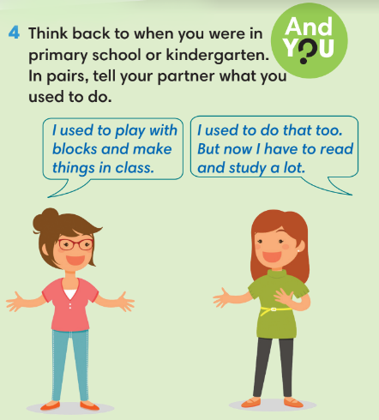
WRAP-UP & HOME WORK (3’)
- T asks Ss to talk about what they have learnt in the lesson.
✔ Used to.
* HOME WORK
- Do exercises in the workbook page 55.
- Prepare for Lesson 6.5: Listening and vocabulary.

