Date of planning:  Date of teaching: | UNIT 6: SCHOOLS  Period 70- Lesson 7: English in use
I. OBJECTIVES:
By the end of the lesson, Ss are able to:
- use conjunctions and time expressions to write a paragraph about what activities you like or do not like at school.
1. Competence: Ss can use conjunctions and time expressions in sentences, and do the tasks assigned in the textbook. Ss can write about their favourite activities at school.
2. Quality/behavior: To teach Ss to be hard-working and attentive in class. Ss have a positive attitude to working in groups, individual work, pair work, cooperative learning and working.
II. TEACHING AIDS:
- Teacher: Grade 7 textbook, Unit 6 (SB p.67, WB p.58), laptop/computer connected to the Internet, loudspeaker, projector/TV, PPT slides …
- Students: Text books, studying equipment …
- Method: Active teach, T-WC; group works; individual …
III. PROCEDURE:
1. WARM UP (5’)
* Aims:
- To create a positive classroom atmosphere to start a new lesson.
- To review words of school activities.
* Organization of implementation: T-Ss, Ss-T, Ss-Ss
Teacher’s & Student’s activities | Content
Extra activity 1: Game – After-school clubs.  - T asks Ss to provide a few examples of after-school clubs.  - T divides the class into 2 groups. Each group writes down 5 after-school clubs.  - T explains the game rules then checks Ss’ comprehension.  - T introduces the new lesson and writes the title on the board Unit 6/ Lesson 6.7: English in use. | Game rules:  ✔ Two groups swap lists of after-school clubs.  ✔ Time limitation: 2 minutes.  ✔ Each group needs to list all activities relating to these after-school clubs.  ✔ 1 correct phrase = 1 point.
2. LEAD-IN (4’)
* Aims:
- To lead into the new lesson.
- To provide Ss with reasons for reading the dialogue in Exercise 1 (SB p.67).
* Organisation: T-Ss, Pair work.
Teacher’s & Student’s activities | Content
Extra activity 2: See – think – wonder.  - T shows the pictures from the SB on the slide then asks Ss to describe these pictures and find out which subject is mentioned.  - T sets a time limit for Ss’ quick discussion.  - Ss work in pairs to make guesses about the pictures then give answers.  - T calls some Ss to answer then checks with the whole class. | 
3. PRESENTATION (10’)
ACTIVITIES 1 + 2:
Aim:
- To present conjunctions and time expressions through a context.
- To introduce the Language Box through the reading tasks.
* Organisation: T-Ss, Ss-T.
Teacher’s & Student’s activities | Content
1. (6’) Read the dialogue and complete the statements. Write Hương or Jasmin.  (Ex 1 – SB p.67)  - T asks Ss to open their SB page 67, look at Exercise 1.  - T calls a S to read the instruction then checks Ss’ understanding of it.  - T tells Ss that they are going to read the text to find the answers.  - Ss work individually, read, and note down the answers to the given questions.  - T calls some Ss to answer then shows the answers on the slide. | Answer keys:  1 Jasmin 2 Hương 3 Jasmin
2. (4’) Underline examples of conjunctions and time expressions in the dialogue.  (Ex 2 – SB p.67)  - T goes through the Language box with Ss and explains the meaning and usage of conjunctions and time expressions.  - T reminds Ss to use Present Simple with future time clauses.  - T asks Ss to read the dialogue again and underline conjunctions and time expressions. | 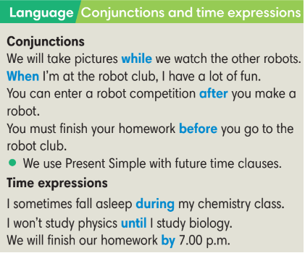  Answer keys:  1 while 2 after 3 until 4 when
4. PRACTICE (16’)
ACTIVITIES 3 + 4:
Aims:
- To reinforce the use of conjunctions and time expressions.
* Organisation: T-Ss, Ss-T, Individual work.
Teacher’s & Student’s activities | Content
3. (5’) Complete the sentences with the correct time expressions.  (Ex 3 – SB p.67)  - T asks Ss to open their SB page 67, look at Exercise 3.  - T calls a S to read the instruction then checks Ss’ understanding of it.  - T gives Ss a time limit to work individually.  - T allows Ss to share their answers before checking the final ones as the whole class.  - T provides the meanings of any new words if needed. | Answer keys:  1 for 2 before 3 by 4 during 5 when
4. (5’) Use the clues to complete the sentences.  (Ex 4 – SB p.67)  - T asks Ss to open their SB page 67, look at Exercise 4.  - T calls a S to read the instruction then checks Ss’ understanding of it.  - T gives Ss a time limit to work individually.  - T allows Ss to share their answers before checking the final ones as the whole class.  - T provides the meanings of any new words if needed. | Answer keys:  1 finishes school work  2 will have fun  3 finish your physics experiment  4 buys some parts  5 are buildings robots
(6’) Extra activity 3: Game.  - T tells Ss that they are playing a game with conjunctions and time expressions.  - T divides the class into 2 groups.  - T explains the game rules then checks instructions.  - T corrects Ss’s pronunciation and mistakes if necessary. | Game rules:  ✔ One S from team A makes a sentence with one conjunction or time expression.  ✔ After finishing, that S chooses randomly one S from team B and gives one conjunction or time expression.  ✔ 1 correct answer = 1 points.
5. PRODUCTION (7’)
ACTIVITY 5:
*Aims:
- To help students applying the vocabulary items and grammar points related to the topic in communicating.
* Organisation: T-S, Individual work, Pair work.
Teacher’s & Student’s activities | Content
5. Write a paragraph of 5-6 sentences about the activities you like or do not like at school. Use the conjunctions and time expressions.  (Ex 5 – SB p.67)  - T asks Ss to look at Exercise 5 (SB page 67).  - T calls a S to read the instructions then checks Ss’ understanding of it.  - T lets Ss work individually to write their paragraphs first.  - Then T pairs Ss up and asks them to share their paragraphs and feedback.  - T invites some volunteers to share the paragraphs and provides feedback. | 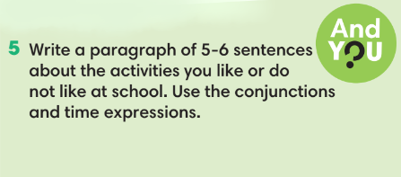
WRAP-UP & HOME WORK (3’)
T asks Ss to talk about what they have learnt in the lesson.
- Conjunctions and time expressions.
- Write about activities you like or do not like at school.
* HOME WORK:
- Do exercises in the workbook page 58.
- Prepare for Lesson 6.8: Vocabulary in action and pronuciation.

