Date of planning:  Date of teaching: | UNIT 8: FESTIVALS AROUND THE WORLD  Period 85: Grammar 1
I. OBJECTIVES:
By the end of the lesson, Ss will be able to:
- Identify and understand how to use adjectives ending in -ing and -ed.
- Use adjectives ending in -ing and -ed to describe festivals and reactions to festivals.
1. Competence:
- General competences: form and / or improve such competencies as group work, independent working, pair work, linguistic competence, and cooperative learning.
2. Quality / behavior:
- Being hard-working and attentive in class.
- Have a positive attitude towards the lesson.
II. TEACHING AIDS:
- Grade 7 textbook, Unit 8 (SB p. 82)
- Computer (connected to the Internet is the best)- Projector / TV/ PPT slides / Active teach
III. PROCEDURE:

1. WARM UP (5’)
* Aims:
- To activate students’ prior knowledge and get students involved in the lesson.
- To set the context for introducing new structures.
* Organisation: T-Ss, Ss-T
Teacher’s and Student’s activities |  |  | Content
Activity 1: Game  - T divides Ss into 2 teams:  - The topic is adjectives.  - T sets the scene for the new lesson: T tells Ss that they are going to learn about adjectives ending in -ed and -ing.  - T writes the title on the board: Unit 8: Festivals around the world  Lesson 8.2: Grammar |  |  | Game rules:  - Ss has 2 minutes to take turns and write as many adjectives as they can.  - 1 correct answer = 1 point.
2. LEAD-IN (4’)
* Aims: To lead into the text.
* Organisation : T-Ss, Ss-T.
Teacher’s and Student’s activities |  |  | Content
Activity 2: Exercise 1 – SB p.82  Read the results of a survey from 500 teenagers around the world. Do you find any of these surprising?  - T asks Ss to read the text and the table, invites some students to share the things that they find surprising.  - T asks Ss to pay attention to the blue words to see any differences.  - T checks if any Ss know the difference in usage of adjectives ending in -ing and -ed. |  |  | 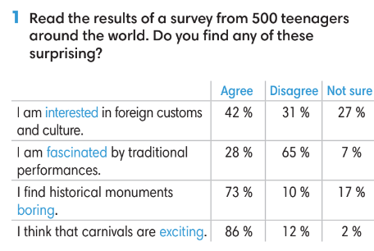
3. PRESENTATION (14’)
ACTIVITIES 3 + 4 + 5:
* Aims:
- To lead into the next activity.
- To introduce the Grammar Box
- To provide Ss with chances to practice the form of adjectives
* Organisation: T-Ss, Ss-T, Group work.
Teacher’s Student’s activities | Content
Activity 3: Exercise 2 – SB p.82  Find two more examples of each rule from the survey in Exercise 1.  - T asks Ss to read the grammar box and then explain the grammar rules to them.  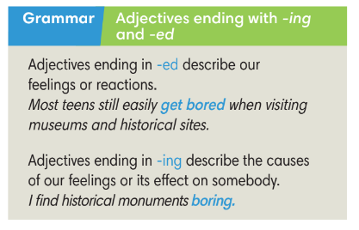 | - Ss find more examples from the survey in Exercise 1.  - T shows the language notes and explain to Ss.  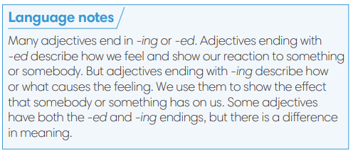
Activity 4: Exercise 3 – SB p82.  Complete the table below.  - T asks Ss to look at exercise 3.  - T calls a student to read the instruction then checks Ss’ understanding of it.  - T asks Ss to finish Exercise 3 individually and then check in pairs.  - T checks Ss answers.  Activity 5: Game.  - T divides the class into 4 groups. | Answer keys:    Game rules:  - Each team has 2 minutes to list all adjectives ending in -ing and -ed.  - After 2 minutes, Ss go to the board to write.  - 1 correct word = 1 point.
5. PRACTICE (13’)
ACTIVITIES 6, 7 and 8:
* Aim:
- To provide Ss grammar exercises to practice
* Organisation : T-Ss, Ss-T, Pair work, Ss-Ss
Teacher’s and Student’s activities |  | Content
Activity 6: Exercise 4 – SB p.82  Add an -ed or -ing ending to the adjectives in the conversation.  - T asks Ss to look at exercise 4.  - T calls a student to read the instruction then checks Ss’ understanding of it.  - Ss finish Exercise 4 individually and then check in pairs.  - T checks Ss answers and asks Ss to provide reasons for their answers.  - T asks some Ss to read the dialogue in front of the class.  Activity 7: Game  - T divides the class into 4 groups.  - T choose randomly 1 adjective from previous game. Ss need to make one sentence using this word.  - 1 correct answer = 1 point. |  | Answer keys: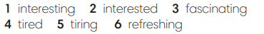
Activity 8: Exercise 5 – SB p.82  Make statements with the adjectives and clues given. Change the form of the adjectives if necessary.  - T asks Ss to look at exercise 5.  - T calls a student to read the instruction then checks Ss’ understanding of it.  - Ss finish Exercise 5 individually and then check in pairs.  - T asks some Ss to share the answers and then check. |  | Answer keys: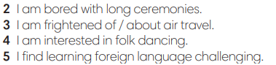
6. PRODUCTION ( 6’)
ACTIVITY 9:
*Aim: To help students applying the vocabulary items and grammar points related to the topic in communicating.
* Content: Ss discuss festivals.
* Outcome: Ss describe how he/ she feels about a festival.
* Organisation: T-Ss, Ss-Ss, Ss-T, Pair work
Teacher’s Student’s activities |  |  |  | Content
Activity 9: Exercise 6 – SB p.82  In pairs, name a festival and your partner will describe how he/ she feels about it. Use the adjectives in Exercise 3.  - T asks Ss to look at exercise 6 (SB page 82).  - T calls a student to read the instruction and example then checks Ss’ understanding of it.  - T models the activity in front of the class.  - T asks Ss to work in pairs to finish Exercise 6.  - T walk around to listen and notes down common mistakes for delayed feedback.  - T calls some groups to come to the front of the class, make conversations.  - T asks the rest to give comments on their classmates’ performance.  - T gives feedback on Ss’ work. |  |  |  | 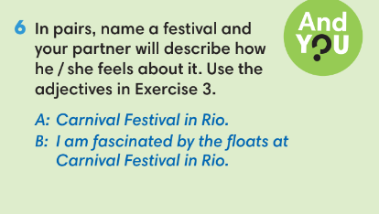
WRAP-UP & HOME WORK (3’)
- T asks Ss to talk about what they have learnt in the lesson.
Adjectives ending in -ing and -ed incorrectly.
* HOME WORK
- Do exercises in the workbook page 70.
- Prepare for test correction

