Date of planning:  Date of teaching: | UNIT 8: FESTIVALS AROUND THE WORLD  Period 87: Reading and Vocabulary

I. OBJECTIVES:
By the end of the lesson, Ss will be able to:
* Vocabulary: - an understanding of the vocabulary about festivals.
* Grammar:
- Reading skills: - Read for specific details about festivals.
1. Competence:
- General competences: form and / or improve such competencies as group work, independent working, pair work, linguistic competence, and cooperative learning.
- Specific competences:
- Improve communicative competence related to the use of language (vocabulary, phonetics, grammar):
2. Quality/behavior:
- Being hard-working and attentive in class
- Have a positive attitude towards the lesson
- Know more and respect the family time together.
II. TEACHING AIDS:
- Grade 7 textbook, Unit 8 (SB p.83, WB p.71).
- Computer (connected to the Internet is the best)
- Projector / TV/ PPT slides / Active teach
III. PROCEDURE:
1. WARM-UP (5’)
* Aim:
- To help Ss review grammar they have learnt.
- To lead into the next activity.
* Content: Game: Lucky number (about adjectives ending in -ing and -ed)
* Outcome: Ss recall adjectives ending in -ing and -ed from previous lesson.
* Organisation: T-Ss, Ss-T.
Teacher’s & Student’s activities |  | Content
Activity 1: Lucky number  - T explains the game rules then checks instructions.  - T uses slide to lead the game.  - Ss raise their hands if they have the answer.  - T tells students that they are going to read about festivals in Vietnam.  - T writes the title for the new lesson:  Unit 8/Lesson 3: Reading and vocabulary. |  | Game rules:  - T shows adjectives ending in -ing and -ed on the slide.  - Ss make sentences.  - Choose randomly one number (1-9) to see your score
2. PRE-READING (10’)
ACTIVITY 2:
* Aim:
- To activate Ss’ background knowledge of the topic.
* Content: Ss say the meanings of the words in Vietnamese.
* Outcome: Ss understand all new words.
* Organisation: T-Ss, Ss-T, Pair work.
Teacher’s & Student’s activities | Content
Activity 2: Exercise 1 – SB p.83  In pairs, look at the words below. Underline these words in the texts. What do they mean in your language?  - T shows the pictures on slide and ask Ss to describe what they can see and guess the name of this activity.  - Ss work in pairs to guess the meaning of the words and then underline these words in the text.  - T collects Ss answer and check.  - T provides pronunciation and meanings of all words.  - T asks some volunteers to read the words out loud to check pronunciation.  Activity 3: Game: Whisper  - T tells Ss that they are play a game to remember new words from the text.  - T tells the game rules. | 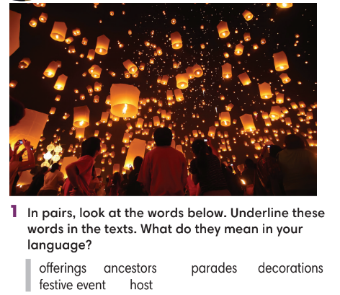  Game rules:  - T divides the class into 4 teams, 4 teams make 4 lines.  - T whispers one new word to the last student.  - Ss whisper until the student near the board goes and writes the word on the board.  1 correct answer = 1 point.
3. WHILE-READING (10’)
ACTIVITY 4 + 5:
*Aim:
- To read the text and do something reading tasks.
- To help students practice finding main ideas of the text.
- To help students practice reading for specific information in a text.
* Organisation: T-Ss, Ss-T.
Activity 4: Exercise 2 – SB p.83  Read the text. Where most likely can you find the information in the text?  - T asks some Ss to read the text out loud to check pronunciation.  - T lists all new words and provide the meaning.  - T asks Ss to look at Exercise 2 (SB page 83).  - T explain to Ss that they need to do skimming.  - T asks Ss to check answers with partner before checking with the whole class and explain reasons for their answers. |  |  | Answer keys:  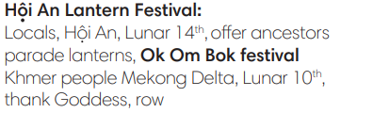
Activity 5: Exercise 3 – SB p.73  Read Texts 1 and 2 again. Mark the sentence (right), (wrong) or ? (doesn’t say)  - T asks Ss to look at exercise 3 (SB page 83).  - T tells student to read the text again individually to  complete Exercise 3.  - T asks students to underline the evidence for their answers. |  |  | 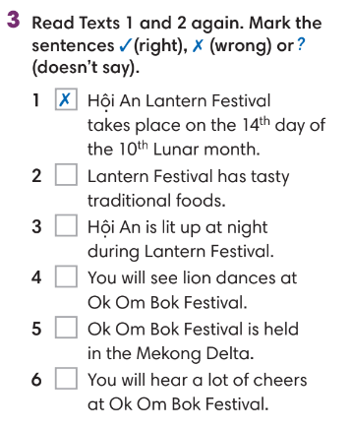Answer keys:
4. POST-READING (17’)
ACTIVITIES 6 + 7 + 8:
* Aim:
- To study Word Friends
- To review new words from the text.
- To reinforce word friends and practice talking festivals.
* Organisation: T-Ss, Ss-T, Ss-Ss, Group work, Pair work.
Activity 6: Exercise 4 – SB p.83  Look at the highlighted phrases in the text and complete the Word Friends.  - T asks Ss to look at exercise 4 (SB page 83).  - T tells student to read the text again individually to  complete Exercise 4.  - After finishing, Ss provide the meaning of Word friends. |  |  | 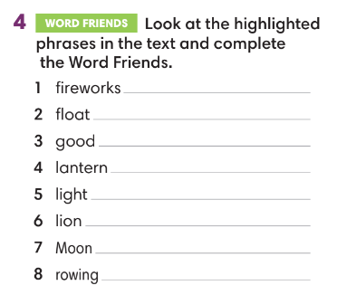
Activity 7: Hot seat game  - T tells Ss that they are play a game to remember new words from the text.  - T tells the game rules. |  |  | Game rules:  - T divides the class into 2 teams, each turn needs 2 representatives.  - T gives one new word (from the text).  - 2 representatives need to guess the word.  - 1 correct answer = 1 point.
Activity 8: Exercise 5 – SB p.83  In pairs, choose one festival that you both know. Decide what you like about it and what you don’t like about it.  - T asks Ss to look at exercise 5 (SB page 83).  - T calls a student to read the instruction then checks Ss’ understanding of it.  - T provides one example for Ss to understand.  - Ss work in pairs.  - T invites some volunteers to present in front of the class and notes down useful or interesting sentences.  - T asks the rest to give comments on their classmates’ performance and then provides teacher’s feedback. |  |  | 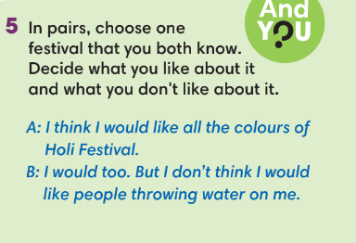
WRAP-UP & HOME WORK (3’)
- T asks Ss to talk about what they have learnt in the lesson.
- Read for specific details about festivals.
- Group discussion
* HOME WORK
- Do exercises in the workbook page 71.
- Prepare for Lesson 8.4: Grammar 2.

====================

