Date of planning:  Date of teaching: | UNIT 8: FESTIVALS AROUND THE WORLD  Period 88: Grammar 2
I. OBJECTIVES:
By the end of the lesson, Ss will be able to:
* Grammar: Contrast ideas using however and nevertheless.
1. Competence:
- General competences: form and / or improve such competencies as group work, independent working, pair work, linguistic competence, and cooperative learning.
- Specific competences:
- Improve communicative competence related to the use of language (vocabulary, phonetics, grammar):
2. Quality/ behavior:
- Being hard-working and attentive in class.
- Have a positive attitude towards the lesson.
II. TEACHING AIDS:
- Grade 7 textbook, Unit 8 (SB p. 84)
- Computer (connected to the Internet is the best)
- Projector / TV/ PPT slides / Active teach
III. PROCEDURE:

1. WARM UP (5’)
* Aim:
- To create a positive classroom atmosphere to start a new lesson.
- To review the previous lesson.
* Organisation: T-Ss, Ss-T.
Teacher’s & Student’s activities |  | Content
Activity 1: Game - A Jumble  - T explains the game rules then checks instructions.  - T divides Ss into 4 groups. Time limitation is 2 minutes.  - T tells Ss that, today they will learn about however and nevertheless to show contrast. |  | Game rules:  - T shows unscrambled letters of words in the slide (from previous lesson).  - Ss need to find and write as many words as they can.  - 1 correct answer = 1 point.  - T corrects Ss if necessary.
3. PRESENTATION (15’)
ACTIVITY 2 + 3:
*Aim:
- To present the grammar point in context.
- To lead into the next activity.
- To introduce the Grammar Notes and explain grammar points.
* Organisation: T-Ss, Ss-T,
Teacher’s & Student’s activities | Content
Activity 2: Exercise 1 - SB p84  Read the email and label the photos with the bold words.  - T asks Ss to look, describe the pictures.  - Ss read the email and find the bold words.  - Ss work in groups of 4 to discuss the meaning of these bold words.  - T asks answers from all groups and then check Ss answers. | Answer keys:  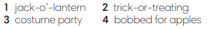  - T asks if any Ss has joined these activities.
Activity 3: Exercise 2 - SB p74  Find more examples of be going to and Present Continuous in the voicemail message.  - T asks Ss to look at the Grammar Box in SB p.74 and explain the usage of “be going to” and Present Continuous to talk about the future. | 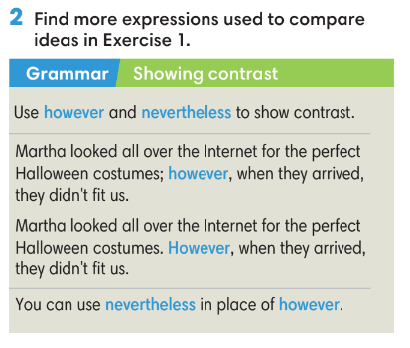  - T asks Ss to read the text again and underline however and nevertheless in Exercise 1.  - T checks Ss answers.
4. PRACTICE (13’)
ACTIVITIES 4 +5:
* Aims:
- To help Ss practice making sentences using however and nevertheless
- To help students practice making sentences with however and nevertheless
* Organisation: T-Ss, Ss-T, Ss-Ss.
Teacher’s & Student’s activities | Content
Activity 4: Exercise 3 - SB p84  Make one sentence from two. Use the word(s) in brackets in your sentences. Listen and check.  - T asks Ss to look at Exercise 3.  - T asks Ss to finish individually and then check in pairs.  - T plays the audio for Ss to check the answers. | Answer keys:  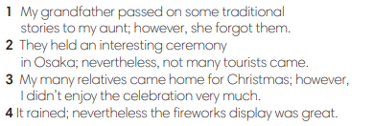
Activity 5: GAME: HOT POTATO  - T explains the game rules then checks instructions. | Game rules:  - The student has the ball needs to make a sentence with However and nevertheless to show contrast.  - The next student receives the ball and make another sentence.  - 1 correct answer = 1 point.  - T collects Ss answer and checks.
5. Production (9’)
ACTIVITY 6:
* Aims: To help Ss applying the vocabulary items and grammar points related to the topic in communicating.
* Organisation: T-Ss, Ss-T, Ss-Ss, Pair work.

Teacher’s & Student’s activities | Content
Activity 6: Exercise 4 – SB p.84  In pairs, compare your thoughts on a festival you both know of. Tell the class about it. You can use some of these words.  - T asks Ss to look at exercise 4 (SB page 84).  - T calls a student to read the instructions.  - T provides the meaning of any new words.  - T sets time limitation of 3 minutes for Ss to prepare and work in pairs.  - T asks 3 groups to model the activity in front of the class.  - T asks the other students to give comments on their classmates’ performance.  - T asks Ss to line up into 2 lines, facing each other. Ss takes turn to say the sentence to their partner.  - After each 20 seconds, T say “switch”, Ss move one step to change the partner.  - T walks around to note down any mistakes for delayed feedback. | 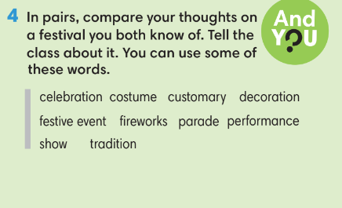
WRAP-UP & HOME WORK (3’)
- T asks Ss to talk about what they have learnt in the lesson.
- However and nevertheless
* HOME WORK
- Do exercises in the workbook page 72.
- Prepare for Lesson 8.5: Listening and vocabulary.

