Date of planning:  Date of teaching: | UNIT 8: FESTIVALS AROUND THE WORLD  Period 91:Lesson 7: English in use
I. OBJECTIVES:
By the end of the lesson, Ss are able to:
* Grammar:
- Use Wh-question words to ask questions.
- Write a paragraph about your favorite festival.
1. Competence:
- General competences: form and / or improve such competencies as group work, independent working, pair work, linguistic competence, and cooperative learning.
- Specific competences:
- Improve communicative competence related to the use of language (vocabulary, phonetics, grammar):
- For a language lesson: Ss are expected to use question words, then do the tasks assigned in the textbook.
- For a skills lesson: Ss are expected to use the correct tense of verbs, phrasal verbs and conjunctions to write about their favorite festival.
2. Quality/behavior:
- Being hard-working and attentive in class
- Have a positive attitude towards the lesson
II. TEACHING AIDS:
- Grade 7 textbook, Unit 8 (SB p. 87)
- Computer (connected to the Internet is the best)
- Projector / TV/ PPT slides / Active teach
III. PROCEDURE:
1. WARM UP (5’)
* Aims:
- To create a positive classroom atmosphere to start a new lesson.
- To review words of festival activities.
* Organization of implementation: T-Ss, Ss-T, Ss-Ss
Teacher’s & Student’s activities | Content
Activity 1: GAME  - T asks Ss to provide a few examples of festival activities.  - T divides the class into 2 groups. Each group writes down 5 festivals.  - T explains the game rules then checks instructions.  - T introduces the new lesson and writes on board:  Unit 8/ Lesson 7: English in use | Game rules:  - Two group swap list of festivals.  - Time limitation: 2 minutes.  - Each group needs to list all festival activities belong to those 5 items.  - 1 correct phrase = 1 point.
2. LEAD-IN (4’)
* Aims:
- To lead into the new lesson.
-To provide Ss with reasons for reading the dialogue in exercise 1 (SB p.87).
* Organisation: T-Ss, Ss-T, Pair work.
Teacher’s & Student’s activities | Content
Activity 2: See – think – wonder.
- T shows the pictures from the SB on the slide then asks students to describe the picture.
- T sets a time limit for Ss’ quick discussion.
- Ss work in pairs to make guesses about the pictures then give answers.
- T calls some Ss to give answers then checks with the whole class.
3. PRESENTATION (10’)
ACTIVITIES 3 + 4:
Aim:
-To present questions words through a context.
-To introduce the Language Box through the reading tasks.
* Organisation: T-Ss, Ss-T, Individual work.
Teacher’s & Student’s activities | Content
Activity 3: Exercise 1 – SB p87  Read the text and questions. Answer the questions.  - T asks Ss to open their SB page 87, look at exercise 1.  - T calls a student to read the instruction then checks Ss’ understanding of it.  - T tells Ss that they are going to read the text to find the answers.  - Ss work individually, read, and note down the answers to the given question.  - T calls some Ss to give answers then shows the answers on the slide. | Answer keys:  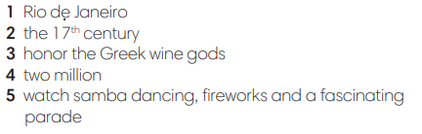
Activity 4: Exercise 2 – SB p87  Study the Language box and look at Exercise 1. Underline the Wh-question words in the text.  - T goes through language box with the Ss, explains the meaning and usage.  - T provides examples and check Ss understanding.  - T asks Ss to give examples using these words.  - T asks Ss to read the dialogue again and underline Wh-question words in the text. | 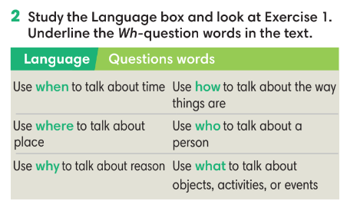
4. PRACTICE (16’)
ACTIVITIES 5 + 6 + 7:
Aims:
- To reinforce the use of question word.
* Organisation: T-Ss, Ss-T, Group work, Individual work.
Teacher’s & Student’s activities | Content
Activity 5: Exercise 3– SB p87  Write when, where, what, who, how or why to complete the questions. More than one can be used for each blank.  - T asks Ss to open their SB page 87, look at exercise 3.  - T calls a student to read the instruction then checks Ss’ understanding of it.  - T gives students a time limit to work individually.  - T allows Ss to share their answers massively before checking the final ones as the whole class.  - T provides the meanings of any new words if needed | Answer keys:
Activity 6: Exercise 4– SB p87  Make questions by putting the words in the correct order.  - T asks Ss to open their SB page 87, look at exercise 4.  - Ss finish Exercise 4 individually and then check the answers in pairs.  - T asks Ss to read the sentences out loud to check their answers. | Answer keys:  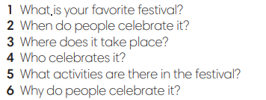
Activity 6: GAME  - T tells students that they are playing a game with question words.  - T explains the game rules then checks instructions. | Game rules:  - One student goes to the board to receive one word.  - Other Ss guess the words by asking question using question words.  - The first student to guess the right word gets 1 point.
5. PRODUCTION (7’)
ACTIVITY 7:
*Aims:
- To help students write about their favorite festival.
* Organisation: T-Ss, Ss-Ss.
Teacher’s & Student’s activities | Content
Activity 7: Exercise 5 – SB p.87  Use your answers from Exercise 4 to write 6-8 sentences about your favorite festival.  - T asks Ss to look at exercise 5 (SB page 87).  - T calls a student to read the instructions then checks Ss’ understanding of it.  - T lets students work individually to write their paragraphs first.  - Then T pairs students up and asks them to share their paragraphs and feedback.  - T invites some volunteers to share the paragraphs and provides feedback. | 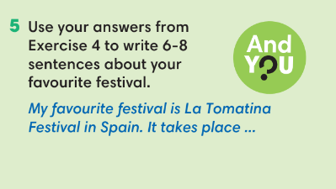
WRAP-UP & HOME WORK (3’)
T asks Ss to talk about what they have learnt in the lesson.
- Question words.
- Write about your favorite festival.
* HOME WORK:
Do exercises in the workbook page 75.
- Prepare for Lesson 8.8: Vocabulary in action and Pronunciation

======================

