Date of planning:  Date of teaching: | UNIT 8: FESTIVALS AROUND THE WORLD  Period 93:Lesson 9: Revision
I. OBJECTIVES:
By the end of the lesson, Ss are able to:
* Vocabulary: Review vocabulary and grammar in the unit.
* Grammar: practice speaking how to make a dish.
1. Competence:
- General competences: form and / or improve such competences as group work, independent working, pair work, linguistic competence, and cooperative learning.
- Specific competences:
- Improve communicative competence related to the use of language (vocabulary, phonetics, grammar)
- For a language lesson: Ss are expected to use vocabulary of the unit, do the tasks assigned in the textbook.
- For a skills lesson: Ss are expected to speak how to make a dish.
2.Quality/ behavior :
- Being hard-working and attentive in class
- Have a positive attitude towards the lesson
II. TEACHING AIDS:
- Grade 7 textbook, Unit 8 (SB p. 89, WB p.79)
- Computer (accessible to the Internet is the best)
- Projector / TV/ PPT slides / Active teach
III. PROCEDURE:

- WARM-UP (4’)
*Aims:
- To create a positive classroom atmosphere to start a new lesson.
- To lead into the review lesson.
* Organisation: T-Ss, Ss-Ss, Ss-T.
Teacher’s & Student’s activities | Content
Activity 1: SUPER EYES  - Set the scene: T asks students to do quick exercises for eyes such as look up and down, look left and right, row the eyes  - T tells students that they are going to play a game called SUPER EYES  - T explains the game rules then checks instructions.  - Teacher uses the slides to show the collages  - Ss join in the game pairs or in small groups.  - Teacher shows the collage again with displayed answers to check for the whole class.  - T tells Ss that they are going to review Unit 8 | Game rules:  - Look carefully at a collage of different small pictures  - The collage will disappear in a few seconds  - Recall as many words about the collage as you can remember.
- REVIEW VOCABULARY (20’)
ACTIVITIES 2, 3, 4, 5:
* Aims:
- To help students reviews topic words and word friends from the unit
- To review vocabulary in contexts.
- To review adjectives ending in -ing and -ed
* Organisation: T-Ss, Ss-Ss, Ss-T.
Teacher’s & Student’s activities | Content
Activity 2: Game  - T asks Ss to look at vocabulary of festivals and festival activities.  - T introduce the game rules | Game rules:  - T writes 2 word on the board.  - 2 Ss from 2 teams go to the board to guess the word by asking questions to their teams (how many letters? Is it in Vietnam? etc.)  - 1 correct answer = 1 point.
Activity 3: Exercise 1 – Student Book page 89  Complete the text with the words below.  - T asks Ss to look at exercise 1 in student book page 89.  - T calls a student to read the instruction then checks Ss’ understanding of it.  - T asks Ss to finish Exercise 1 individually and then check in pairs.  - T encourages students to give the reason for their answers.  - T checks as the whole class. | Answer keys:  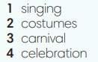
Activity 4: Exercise 2 – Student Book page 89  Complete the sentences below to make them true for you. In pairs, compare your answer.  - T asks Ss to look at exercise 2 in student book page 89  - T calls a student to read the instruction then checks Ss’ understanding of it.  - T helps Ss to review the usage of adjectives ending in -ing and -ed.  - T checks with Ss the meanings of all adjective in Exercise 2.  - Ss finish individually and then check in pairs | 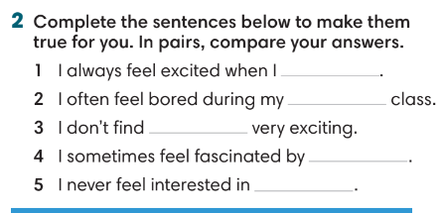
Activity 5: Exercise 3 – Student Book page 89  Complete the responses with the correct words.  - T asks Ss to look at exercise 3 in student book page 89  - T calls a student to read the instruction then checks Ss’ understanding of it.  - T asks Ss to work individually to complete the activity.  - T invites Ss to read the sentences in front of the class to check the answer. | Answer keys:  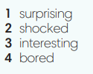
3. REVIEW GRAMMAR ( 12’)
ACTIVITIES 6 + 7:
*Aims:
- To reinforce the grammar of unit 7: although, despite, in spite of, unit 8: however, nevertheless
* Organisation: T-Ss, Ss-T, Pair work.
Teacher’s & Student’s activities | Content
Activity 6: Exercise 4 – Student Book page 89  Underline the correct option among the bold words.  - T helps Ss to review grammar before doing this task.  - Ss work individually.  - T checks Ss answers. | Answer keys:  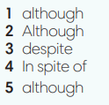
Activity 7: Game – Unscramble words.  - T divides the class into 4 teams and explains game rule.  - T prepare a few sentences using although, in spite of, despite. | Game rules:  - Ss receive 10 bags with unscramble words of 10 sentences. (Words are written and cut into pieces)  - 1 correct sentence = 1 point.
4. SPEAKING (6’)
ACTIVITY 8:
*Aims:
- To help student practice making a dialogue about steps to make a simple dish.
* Organisation: T-Ss, Ss-T, Pair work.
Teacher’s & Student’s activities | Content
Activity 8: Exercise 5 – Student Book page 89  Work in pairs. Student A, think of a type of food you know how to prepare. Follow these ideas to explain to Student B how to prepare it. Student B, go to page 102.  - T asks Ss to look at exercise 5.  - T calls a student to read the instruction then checks Ss’ understanding of it.  - T asks Ss to prepare a dialogue basing on given clues.  - T provides one example.  - Ss work in pairs for discussion.  - T walk around the class to note down any mistakes.  - T invites some pairs to share in front of the class, Ss listen and provide feedback. | 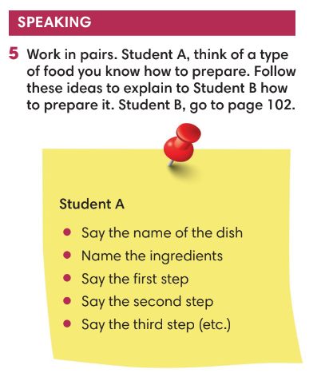
WRAP-UP & HOME WORK (3’)
- T asks Ss to talk about what they have learnt in the lesson.
- Review Unit 8 vocabulary and grammar.
- How to make a dish.
* HOMEWORK
- Do exercises in the workbook page 89
- Prepare for Unit 9 – Lesson 1: Vocabulary

