Date of planning:  Date of teaching: | UNIT 9: SCHOOLS  Period 102: Speaking
I. OBJECTIVES:
By the end of the lesson, Ss will be able to gain:
* Vocabulary: Use the vocabulary and phrases to talk about a means of transport and its advantages.
* Grammar: Use connecting words to list and connect ideas.
1. Competence: Ss can use vocabulary and phrases to talk about a means of transport and its advantages, and do the tasks assigned in the textbook.
2. Quality/behavior: To teach Ss to be hard-working and attentive in class. Ss have a positive attitude to working in groups, individual work, pair work, cooperative learning and working.
II. TEACHING AIDS:
- Teacher: Grade 7 textbook, Unit 9 (SB p.96, WB p.83), laptop/computer connected to the Internet, loudspeaker, projector/TV, PPT slides…
- Students: Text books, studying equipment…
- Method: Active teach, T-WC; group works; individual ……
III. PROCEDURE:
1. WARM UP + LEAD-IN (5’)
* Aim:
- To create a positive classroom atmosphere to start a new lesson.
- To lead into the topic.
* Content: Transport definition game.
* Outcome: Ss review vocabulary about means of transportation and prepare for the new lesson.
* Organization of implementation: T-Ss, Group work.
Teacher’s & Student’s activities |  | Content
Extra activity 1: Transport definition game.  - T prepares a set of words about different means of transport.  - T divides Ss into 3-4 teams.  - T explains the game rules and check the instruction.  - T can introduce some phrases can be used for describing:  I has … wheels.  It’s powered by …  It has enough room for ….. people.  It’s cheap/expensive/light/quick, etc.  It’s on the road/sea/tracks.  - When Ss finish the game, T tells Ss that they are going to talk about a means of transport and its advantages.  - T writes the title of new lesson: Unit 9  Lesson 9.6 – Speaking. |  | Game rules:  - Time limitation: 20 seconds for each round.  - T randomly chooses a S to pick up a word for describing.  - Each round, one S from each team stands in the front and tries to describe a means of transport for other team members guess the word.  - The quickest team says correct word = 1 points.
2. PRE-SPEAKING (14’)
ACTIVITIES 1, 2, 3:
* Aims:
- To activate Ss’ prior knowledge of the topic.
- To lead into the topic.
- To introduce the Speaking box.
* Content:
- Discuss which means of transport is the most popular.
- Identify the details in the talk.
- Find examples of connecting words in the talk.
* Outcome:
- Ss understand the topic of the lesson.
- Ss know how to use connecting words in context.
* Organisation: T-Ss, Ss-T, Individually.
Teacher’s & Student’s activities |  |  | Content
1. (5’) Class vote: What is the most popular means of transport?  (Ex 1 – SB p.96)  - Before taking a class vote, T elicits on the board some popular means of transport in Việt Nam.  - T asks some Ss to share their choice and explain why the means of transport they choose is the most popular. |  |  | 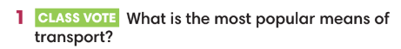
2. (6’) Read or listen. What type of transport does Nam think we should you? Why?  (Ex 2 – SB p.96)  - T asks Ss to close their book and listen to the recording, and write down the type of transport Nam thinks we should use and the reasons for that.  - T can play the recording twice if needed.  - Then, T asks Ss to open the book and read the text to check their answers.  - T asks Ss to work in pairs to brainstorm any other advantages of taking a bus.  - T invites some volunteers to express their ideas and write on the board. |  |  | Answer keys:  Nam thinks we should use bus because travelling by bus is cheaper than travelling by car. It also helps the environment and reduce traffic jams.
3. (3’) Study the Speaking box. Find examples of connecting words in the prepared talk.  (Ex 3 – SB p.96)  - T goes through the Speaking box and asks students to read the talk again to find all the examples of connecting words in the talk. Then check the answer with the whole class. |  |  | 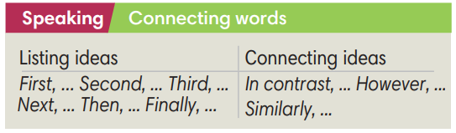
3. WHILE-SPEAKING (13’)
ACTIVITIES 4 & 5:
* Aims:
- To reinforce the use of Speaking box.
- To practise using the new expression in context.
* Content:
- Complete the sentences with words from the Speaking box.
- Underline the opening and ending expressions in a prepared talk in Exercise 2 and 4.
- Word to sentence game.
* Outcome: Ss understand how to use connecting words in context.
* Organisation: T-Ss, Ss-T, Pair work, Group work, Individually.
Teacher’s & Student’s activities |  |  | Content
4. (5’) Complete the sentences with words from the Speaking box.  (Ex 4 – SB p.96)  - T asks Ss to work individually before checking their answer with a partner.  - T asks Ss for their answers and explanation.  - T asks some Ss to read the text in Exercise 4 out loud and checks for their pronunciation if needed. |  |  | Answer keys:  1 First  2 Second  3 Finally
5. (3’) Underline the opening and ending expressions in a prepared talk in Exercise 2 and 4.
(Ex 5 – SB p.96)
- T asks Ss to underline the opening and ending expression in Exercise 2 and 4.
(5’) Word to sentence game.  - T explains the game rules and checks the instruction. |  |  | Game rules:  - Ss are divided into 4 teams.  - Each team member is assigned a number.  - T calls out a number and a word from the Speaking box.  - The 4 Ss with that number run to the board and try to make a sentence using the word.  - The first S to write a grammatically correct sentence containing the word scores 2 points for their team.  - Each correct sentence of other team = 1 point.
4. POST-SPEAKING (10’)
ACTIVITY 6:
*Aims: To help Ss applying the new language and skills related to the topic in communicating.
* Content: In pairs, Ss plan a talk about a means of transport and its advantages, using connecting words.
* Outcome: Ss can talk about a means of transport and its advantages.
* Organisation: T-Ss, Ss-Ss, Pairwork.
Teacher’s & Student’s activities | Content
6. In pairs, plan a talk about a means of transport and its advantages. Then tell the class. Use these ideas or your own. Use some connecting words too.  (Ex 6 - SB p.96)  - T asks Ss to work in pairs to make notes about advantages of a means of transport of their choice.  - T reminds S to use connecting words.  - T suggests Ss to use opening and ending expression that they underlined in Exercise 5 when they talk about their means of transport.  - T walk around the class to listen and provide feedback.  - T asks some Ss to talk about their ideas.  - T invites some good pairs to deliver their talk in front of the class.  - T asks other Ss for their questions and peer-feedback. | 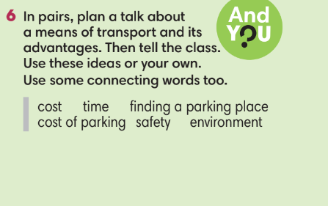
WRAP-UP & HOME WORK (3’)
- T asks Ss to talk about what they have learnt in the lesson.
- Use connecting words to talk about a means of transport and its advantages.
* HOME WORK
- Do exercises in the workbook page 83.
- Prepare for Lesson 9.7: English in use.

=====================

