Date of planning:  Date of teaching: | UNIT 9: FUTURE TRANSPORT  Period 94 : Vocabulary
I. OBJECTIVES:
By the end of the lesson, Ss will be able to:
- know the meaning of the keywords used to talk about present and future means of transport.
- use the targeted language to practice talking about present and future means of transport.
New words |  | Pronunciation | Vietnamese meaning
bullet train | (n) | /ˈbʊlɪt treɪn/ | tàu cao tốc
e-bus | (n) | /iː bʌs/ | xe buýt điện
electric car | (n) | /ɪˈlektrɪk kɑː(r)/ | ô tô điện
flying car | (n) | /ˈflaɪɪŋ kɑː(r)/ | ô tô bay
hot air balloon | (n) | /ˌhɒt ˈeə bəluːn/ | khinh khí cầu
jetpack | (n) | /ˈdʒetpæk/ | phương tiện bay cất cánh thẳng đứng
self-driving car | (n) | /ˌself ˈdraɪvɪŋ kɑː(r)/ | xe tự lái
sky train | (n) | /skaɪ treɪn/ | tàu điện trên cao
accident | (n) | /ˈæksɪdənt/ | tai nạn
drive | (v) | /draɪv/ | lái
passenger | (n) | /ˈpæs.ən.dʒər/ | hành khách
road | (n) | /rəʊd/ | đường
traffic jam | (n) | /ˈtræfɪk dʒæm/ | tắc đường
vehicle | (n) | /ˈviːəkl/ or /ˈviːhɪkl/ | phương tiện giao thông

* Grammar: expressions to talk about present and future means of transport. This is a … It can carry … It will use …
1. Competence:
- To know the meaning of the keywords used to talk about present and future means of transport, then do the tasks assigned in the textbook.
- To use the targeted language to practise present and future means of transport.
2. Quality/Behavior: To teach Ss to be hard-working and attentive in class. Ss have a positive attitude to working in groups, individual work, pair work, cooperative learning and working.
II. TEACHING AIDS:
- Teacher: Grade 7 textbook, Unit 9 (SB p.90-91, WB p.77-78), laptop/computer connected to the Internet, loudspeaker, projector/TV, PPT slides…
- Students: Text books, studying equipment…
- Method: Active teach, T-WC; group works; individual ……
III. PROCEDURE:
1. WARM UP (6’)
* Aims:
- To activate Ss’ prior knowledge and get Ss involved in the lesson.
- To set the context for introducing new words.
* Organisation: T-Ss, Ss-T, Ss-Ss, Pair work.
Teacher’s & Student’s activities |  | Content
Extra activity 1: Name 4 Game  - T explains the game rules then check instructions.  - T can either use PPT slides or write on the board to lead the game.  - For each category, T asks some Ss to name the things and asks some follow-up questions.  - The last category that T mentions is Means of Transport to lead in the lesson.  - After finishing the game, T writes the title on the board:  Unit 9: Means of Transport / Lesson 9.1: Vocabulary |  | Game rules:  - Ss work in pairs to write down 4 things of a category given by T.  - The fastest pair is given 1 bonus point.  - Pairs crosscheck each other and give 1 point for each correct word.
2. PRESENTATION (8’)
ACTIVITY 1:
* Aims:
- To reinforce the words of means of transport that Ss have already known.
- To teach more new words.
* Organisation: T-Ss, Individually/ Pair work.
Teacher’s & Student’s activities | Content
1. Match the pictures 1-8 with the names.  (Ex 1 – SB p.90)  - T asks Ss to open their SB page 90, look at Exercise 1.  - T calls a S to read the instruction then checks Ss’ understanding.  - T elicits the meaning of words in the Vocabulary Box and quickly checks Ss’ understanding of vocabulary by randomly showing pictures of means of transport and asking them to name its means of transport.  - Then, T asks students to look at exercise 1 and complete.  - Ss can work individually or in pairs to finish the task.  - After Ss have finished, T asks Ss to classify the means of transport into some of the following categories:  Travels on land / Travels in air  Present type of transport / future type of transport  Slow / fast | Answer keys:  1 flying car  2 e-bus  3 hot air balloon  4 electric car  5 bullet train  6 sky train  7 jetpack  8 self-driving car
  New words | Pronunciation |  | Vietnamese meaning
  bullet train | (n) | /ˈbʊlɪt treɪn/ | tàu cao tốc
  e-bus | (n) | /iː bʌs/ | xe buýt điện
  electric car | (n) | /ɪˈlektrɪk kɑː(r)/ | ô tô điện
  flying car | (n) | /ˈflaɪɪŋ kɑː(r)/ | ô tô bay
  hot air balloon | (n) | /ˌhɒt ˈeə bəluːn/ | khinh khí cầu
  jetpack | (n) | /ˈdʒetpæk/ | phương tiện bay cất cánh thẳng đứng
  self-driving car | (n) | /ˌself ˈdraɪvɪŋ kɑː(r)/ | xe tự lái
  sky train | (n) | /skaɪ treɪn/ | tàu điện trên cao
  accident | (n) | /ˈæksɪdənt/ | tai nạn
  drive | (v) | /draɪv/ | lái
  passenger | (n) | /ˈpæs.ən.dʒər/ | hành khách
  road | (n) | /rəʊd/ | đường
  traffic jam | (n) | /ˈtræfɪk dʒæm/ | tắc đường
  vehicle | (n) | /ˈviːəkl/ or /ˈviːhɪkl/ | phương tiện giao thông
3. PRACTICE (23’)
ACTIVITIES 2, 3, 4, 5:
* Aims:
- To predict what future means of transport look like.
- To help Ss understand words in context and find other words of the same meaning.
- To provide more words related to the topic.
- To help Ss reinforce the studied vocabulary in collocations
* Organisation: T-Ss, Ss-T, Individual work, Group work, Pair work.
Teacher’s & Student’s activities |  | Content
2. (7’) Choose the option (A or B) that can best replace the underlined word(s).  (Ex 2 – SB p.91)  - T shows some pictures of means of transport in the past and at the present, asks Ss to put them into two categories: In the past and at the present and invites some volunteers to tell why they know that.  - Then, T asks Ss to work in groups to predict what they think a future mode of transport will be like.  - T invites some Ss to share their thought with the class.  - T asks Ss to look at the predictions on page 91, elicits the meaning of any unknown words and may provide further explanations of the words in Vietnamese.  - Ss can work individually or in pairs to complete the exercise.  - T asks Ss to read the predictions with the replaced word again, check pronunciation if needed. |  | Answer keys:
3. (6’) Listen about future means of transportation and complete the gaps.  (Ex 3 – SB p.91)  - T calls a S to read the instruction then checks Ss’ understanding of it.  - T asks Ss to look at Vocabulary B (SB page 91) and check their understanding of the words.  - T asks Ss to predict what can be filled in the gap.  - T plays the audio for the whole class to listen and do the exercise individually  - T sets a time limit and asks Ss to work in groups to compare their answer and complete the exercise together.  - T calls groups to give answers then checks as the whole class.  - T corrects Ss’ pronunciation if any. |  | Answer keys:  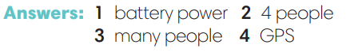
4. (4’) Listen again and complete the phrases with the words given.  (Ex 4 – SB p.91)  - T asks Ss to look at Exercise 4 (SB page 91).  - T calls a S to read the instruction then checks Ss’ understanding of it.  - T asks Ss to quickly complete the phrases individually.  - T calls pairs to give answers then checks as the whole class.  - T corrects Ss’ pronunciation if any. |  | Answer keys:  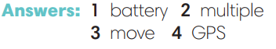
5. (6’) In pairs, choose one means of transport from Exercise 1. Tell your partner about it.  (Ex 5 – SB p.91)  - T asks Ss to work in pairs and asks each of them to choose one means of transport in Exercise 1 and tell their partner about it using the expression: This is a … It can carry … It will use …  Then, T calls some Ss to talk about their partner’s means of transport. |  | 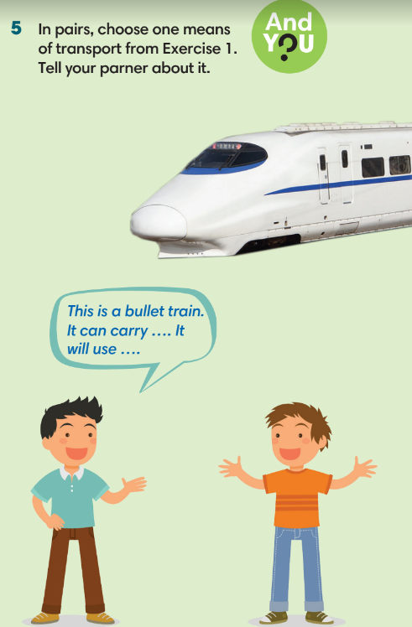
4. PRODUCTION (5’)
HOT SEAT GAME
* Aims: To help Ss practice applying the vocabulary and grammar points related to the topic in speaking.
* Content: Hot seat game
* Outcome: Ss practise using the vocabulary and grammar points related to the topic in speaking.
* Organisation: T-Ss, Ss-Ss
Teacher’s & Student’s activities |  | Content
Extra activity 2: Hot seat game.  - T explains the game rules then check instructions. |  | Game rules:  - T divides the class into 2 teams, one S from each team for each turn.  - Two Ss sit/stand in front of the class, back to the board.  - T shows pictures of means of transport on the slide.  - Teammates give description of the given means of transport for their team’s player to guess what it is.  - 1 correct answer = 1 point.
WRAP-UP & HOME WORK (3’)

T asks Ss to talk about what they have learnt in the lesson.
- Vocabulary of means of transports and on the road.
- Grammar points: Future tense to talk about future means of transport

* HOME WORK
- Do exercises in the workbook page 77-78.
- Prepare for Lesson 9.2: Grammar 1.

