Date of planning:  Date of teaching: | UNIT 9: FUTURE TRANSPORT  Period 95 : Grammar 1
I. OBJECTIVES:
By the end of the lesson, Ss will be able to:
- Identify and understand how to use the future simple tense will / will not.
- Use will / will not to talk about future means of transportation.
1. Competence: Ss know how to use vocabulary about means of transportation, and understand the main grammatical points, then do the tasks assigned in the textbook; use the future tense will / will not to talk about future means of transportation.
2. Quality / behavior: To teach Ss to be hard-working and attentive in class. Ss have a positive attitude to working in groups, individual work, pair work, cooperative learning and working.
II. TEACHING AIDS:
- Teacher: Grade 7 textbook, Unit 9 (SB p.92), laptop/computer connected to the Internet, loudspeaker, projector/TV, PPT slides…
- Students: Text books, studying equipment…
- Method: Active teach, T-WC; group works; individual ……
III. PROCEDURE:

1. WARM UP (5’)
SENTENCE SCRAMBLE GAME
* Aims:
- To activate students’ prior knowledge and get students involved in the lesson.
- To set the context for introducing new structures.
* Organisation: T-Ss, Group work
Teacher’s and Student’s activities | Content
Extra activity 1: Sentence scramble game  - T explains the game rules then check instructions.  - T gives few unscrambled sentences about future means of transportation using will / will not.  - T sets the scene for the new lesson: T elicits the meaning of will / will not and tells Ss that they are going to learn how to use will / will not to talk about future means of transportation.  - T writes the title on the board: Unit 9: Future transport - Lesson 9.2: Grammar. | Game rules:  ✔ Ss work in groups of 3-4 to put the given words into the correct order to make meaningful sentences.  ✔ Three quickest groups are given 1 bonus point.  ✔ Each correct sentence = 1 point.
2. PRESENTATION (14’)
ACTIVITIES 1 + 2:
* Aims:
- To present the grammar point in context.
- To lead into the next activity.
- To introduce the Grammar box.
- To explain the grammar point to Ss.
* Organisation: T-Ss, Ss-T, Pair work, Individually.
Teacher’s & Student’s activities | Content
1. (7’) Read the text. Find the bold words in the text that match the definitions below.  (Ex 1 – SB p.92)  - T asks Ss to look at the 2 pictures and elicits what they think about flying cars.  - Ss work in pairs to discuss their thought.  - T invites some volunteers to share their partner’s thought with the class.  - T asks Ss to complete the exercise individually.  - T checks Ss’ answers, explains the meaning and checks Ss’ understanding. | Answer keys:  1 take-off  2 aircrafts  3 engines  4 rush hour
2. (7’) Study the Grammar box. Find more examples of will / will not in the text in Exercise 1.  (Ex 2 – SB p.92)  - T goes through the Grammar box with Ss.  - T stresses that the short form ’ll is mainly used with pronouns and in speaking, and Ss should use think / hope to show their opinions.  - Ss underline all sentences that contain will / will not in the text in Exercise 1.  - T invites some volunteers to say sentences containing will / will not in the text and check pronunciation if needed.  - T divides Ss in pairs to make a sentence with will / won’t.  - T goes around to help, asks some volunteers to say their sentences and check Ss’ understanding. | 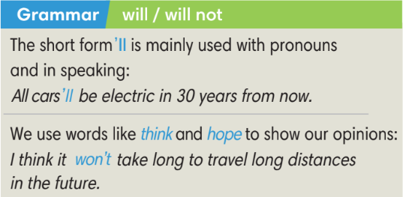  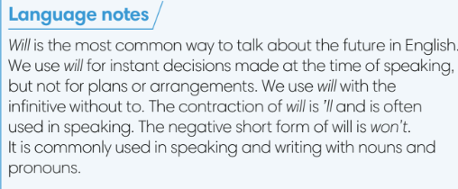
3. PRACTICE (13’)
ACTIVITY 3 + Workbook activity 3:
* Aims:
- To provide Ss with grammar exercises to practise.
* Organisation : T-Ss, Ss-T, Pair work
Teacher’s & Student’s activities | Content
3. (7’) Read the advertisement for the JetPack Model X87. Complete the following sentences with will and will not.  (Ex 3 – SB p.92)  - T calls a S to read the instruction then checks Ss’ understanding.  - T asks Ss to work in pairs to finish Exercise 3 and then share answers with other pairs.  - T checks Ss’ answers and corrects if needed.  - T asks Ss to work in groups of 4 to write 2-3 additional sentences about the JetPack Model X87 using the advertisement. | Answer keys:  1 will  2 will  3 will not  4 will  5 will not
(6’) Extra activity 2: Exercise 3 - WB p.79. Use will and one of the verbs below to complete the following paragraph.  - T calls a S to read the instruction then checks Ss’ understanding.  - T asks for any new words in the text, check for Ss’ understanding and explains if needed.  - Ss work individually to complete the exercise, then crosscheck the answer with a partner.  - T calls some Ss to give answers with the text, corrects the answers and gives feedback. | Answer keys:  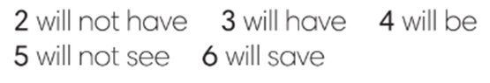
4. PRODUCTION (10’)
ACTIVITY 4:
*Aims:
- To help Ss understand more about the flying cars in the text in Exercise 1.
- To help Ss applying the vocabulary items and grammar points related to the topic in speaking.
* Organisation: T-Ss, Ss-Ss, Ss-T
Teacher’s & Student’s activities | Content
4. (5’) In pairs, ask and answer questions about the flying cars in Exercise 1. Use the following words.  (Ex 4 – SB p.92)  - T calls a S to read the instruction then checks Ss’ understanding.  - T checks Ss’ understanding of given words, explains if needed.  - T asks Ss to work in pairs to ask and answer questions using the given words.  - T calls 2 good Ss to model the question and answer.  - T walks around to help and give feedback.  - T calls some pairs to practise asking and answering in front of the class. | 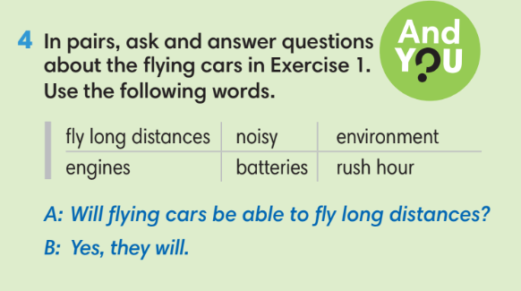
Extra activity 3 (5’): Pictionary game  - T prepares pictures of common objects such as: eraser, pen, battery, egg, orange, bottle, etc.  - T explains the game rules then check instructions.  - T can either model the activity or invite one good S to start the game. | Game rules:  - One S chooses a picture and makes sentences about that object using will / will not for the class to guess what the object is.  - Other Ss can make questions using will to clarify.
WRAP-UP & HOME WORK (3’)
T asks Ss to talk about what they have learnt in the lesson.
- Will and will not
* HOME WORK
- Do exercises in the workbook page 79.
- Prepare for Lesson 9.3: Reading and Vocabulary.

