Date of planning:  Date of teaching: | UNIT 9: FUTURE TRANSPORT  Period 96: Reading and Vocabulary
I. OBJECTIVES:
By the end of the lesson, Ss will be able to learrn:
Vocabulary: an understanding of the vocabulary about future means of transport.
Grammar:
- Reading skills: Find main ideas and specific details in a text about a means of transport.
1. Competence: Understand the meaning of the keywords used to talk about future means of transport, then do the tasks assigned in the textbook; match titles to correct paragraphs (scanning skill); identify information in the text and answer right, wrong, doesn’t say questions ( (skimming skill).
2. Quality/behavior: To teach Ss to be hard-working and attentive in class. Ss have a positive attitude to working in groups, individual work, pair work, cooperative learning and working.
II. TEACHING AIDS:
- Teacher: Grade 7 textbook, Unit 9 (SB p.93, WB p.80), laptop/computer connected to the Internet, loudspeaker, projector/TV, PPT slides …
- Students: Text books, studying equipment …
- Method: Active teach, T-WC; group works; individual …
III. PROCEDURE:
1. WARM-UP (5’)
* Aim:
- To help Ss review grammar they have learnt.
- To lead into the next activity.
* Organisation: T-Ss, Ss-T, Ss-Ss, Group work.
Teacher’s & Student’s activities | Content
Extra activity 1: Prediction about future transportation.  - T explains the rules then checks instructions.  - T uses slide to lead the game.  - Groups raise their hands to share their prediction.  - T records on the board some of Ss’ predictions using will / will not.  - T tells Ss that they are going to read about future means of transport.  - T writes the title for the new lesson:  Unit 9/Lesson 3: Reading and vocabulary. | Rules:  - T divides Ss into 2-3 groups.  - Groups choose a number which reveals an aspect of transport such as: speed, cost, energy use, convenience, etc.  - Groups make prediction sentences using will / will not.  - Each prediction sentence = 2 points.
2. PRE-READING (7’)
ACTIVITY 1:
* Aim:
- To activate Ss’ background knowledge of the topic.
* Organisation: T-Ss, Ss-T, Pair work.
Teacher’s & Student’s activities |  | Content
1. In pairs, look at the photos. What do you think they are?  (Ex 1 – SB p.93)  - T shows the three pictures on slide and elicits the type of transport in each photo.  - T asks Ss to work in pairs to compare these three types of transport in terms of their safety, speed and convenience.  - T calls some Ss to share their thought and check. |  | 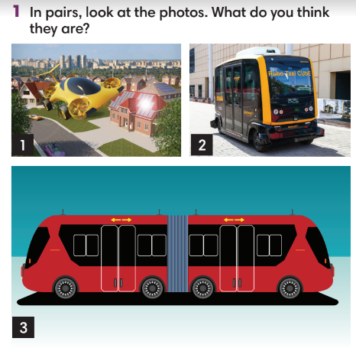
3. WHILE-READING (18’)
ACTIVITY 2 + 3:
*Aim:
- To read the text and do some reading tasks.
- To help Ss practise finding main ideas of the text.
- To help Ss practise reading for specific details in the text.
* Organisation: T-Ss, Ss-T, Individually, Pair work.
2. (9’) Read the text and match them with the titles below. Write the titles in the blanks.  (Ex 2 – SB p.93)  - T asks Ss to look at Exercise 2 – SB p. 93.  - T explains that Ss need to do skimming for main ideas.  - T sets a time limit for Ss to skim the text just to find the main ideas, 30 seconds for each paragraph and finish the exercise.  - T asks Ss to check answers with a partner before checking with the whole class and explain reasons for their answers. |  | Answer keys:  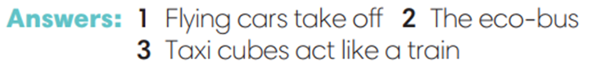
3. (9’) Read the text again. Mark the sentences right, wrong or doesn’t say.  (Ex 3 – p.93)  - T asks Ss to read the text again and complete Exercise 3 individually before comparing their answer in pairs.  - T reminds Ss to underline the key words in Exercise 3 before reading.  - T set time limitation such as 3 minutes.  - T checks the answers with the whole class and asks them to explain their choices.  - After Ss have finished the exercise, T asks some Ss to read the text out loud to check pronunciation.  - T lists all new words and provide the meaning.  - T asks Ss which of the three types of future modes of transport they like the most and explain their answer. |  | Answer keys:
4. POST-READING (15’)
ACTIVITIES 4 & 5:
* Aim:
- To study the vocabulary.
- To review new words from the text.
- To reinforce word friends and practise asking and answering about future means of transport.
* Organisation: T-Ss, Ss-Ss, Pair work, Group work, Individually.
4. (5’) Complete the sentences with the verbs in Group A and the prepositions in Group B. Use the text in Exercise 2 to help you.  (Ex 4 – SB p.93)  - T calls a S to read the instruction then check for Ss’ understanding.  - T asks Ss to complete Exercise 4 individually before comparing their answers in pairs.  - T checks the answers with the whole class. |  | Answer keys:  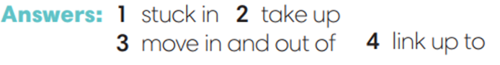
(5’) Sentence Race Game.
- T divides Ss into groups of 3-4 to create their own sentences using the learnt phrasal verbs.
- T sets time limitation such as 3 minutes.
- Groups crosscheck each other’s sentences.
- Each correct sentence = 1 point.
- T invites some volunteers to read their sentences then other Ss shadow their classmate’s sentence.
5. (5’) In pairs, complete the table. Then ask your partner questions about one means of transport.  (Ex 5 – SB p.93)  - T asks Ss to look at the three categories in the left column and elicits from the class questions that they can use for each of these.  - T asks Ss to work in pairs to complete the table, then ask and answer questions about one means of transport in the table.  - T invites some good Ss to model the activity.  - T asks some pairs to practise asking and answering questions in front of the class.  - T asks the whole class to listen and give feedback. |  | 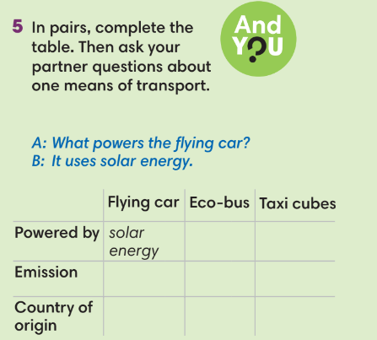
WRAP-UP & HOME WORK (3’)

